English First Peoples 11

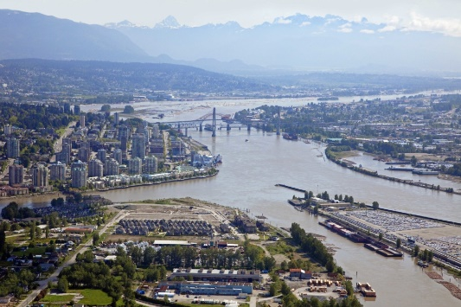
The relationship between nature and modernity: a walk Around Riverside

Part A: Things to work on as we walk to the river:

Think about the following 2 quotes. Which one do you personally agree with more. Discuss with your partner and be prepared to explain why you picked the quote you did.

Quote 1: “The earth was made for [businesses to make money], and the sun and moon were made to give them light. Rivers and seas were formed to float their ships" (natural resources are there to benefit people)

Quote 2: “We cultivated our land, but in a way different from the [other people]. We endeavour to live with the land; they seemed to live off it”

- On the walk to the river please observe the following with your partner:

Name 4 plants that you see (the actual name of the plant, not just “tree”)

a.

b.

c.

d.

Record 5 different examples of mankind overpowering nature (building something or using industry that destroys the natural environment).

a.

b.

c.

AT THE RIVER: Write down one important quote from the story and why it is important OR a connection you made to the quote.

Listening: Write down 3 different sounds that you heard that were not natural to the environment.

Lesson Wrap Up: Reflect back to the quotes we discussed at the beginning of the lesson. Think about the positive and negative results of the way we interact with the environment. Write down as many positive and negative impacts of modernization as you can.

Gain from Industry/Technology Lose from Industry/Technology

Lesson Wrap Up: Choose ONE of the following prompts in which to write a short paragraph reflecting on your experience. Choose ONE of your photos from the walk to reinforce your ideas. Place it in the document.
- Reflect on the quotes we discussed at the beginning of the lesson. Think about the positive and negative results of the way we interact with the environment.
  - Write down as many positive and negative impacts of modernization as you can in the chart below.
  - Choose one of the quotes to discuss in more length in a persuasive paragraph. Begin the paragraph with an opinion statement: Eg. Dickens was correct in his philosophy…
Gains from Industry/Technology | Loss from Industry/Technology

- Based on what you learned about the five concepts of place for many First Nations, how has this walk expanded your understanding of the importance of nature in their culture? Write a expository paragraph in which you explain your understanding. Remember to have a strong topic sentence and provide evidence from the walk to support your ideas.
- Imagery: using the five senses to create imagery in writing, write a descriptive paragraph that encapsulates our journey to the river. What did you see, hear, smell, feel, taste? “First, consider the goal of your descriptive paragraph. The details you choose to include in the paragraph, as well as the details you choose to exclude, signal to the reader how you feel about the topic. What message, if any, do you want the description to convey? Which details best convey that message?”

Criteria:
- Your formatting should be in MLA formatting: 12 font size, times new roman, double spaced
- Your best grammar and sentence structure skills. Approximately 5-8 sentences.
- Handed in on TEAMS
- Photo connects to your ideas in the writing

Assessment
Curricular  Competency | Extending 10/9 | Proficient 8.5/7.5 | Developing 7/6 | Emerging 5.5/0
I can use Canadian spelling, grammar, and punctuation proficiently and appropriately to the context. | I make no errors in my spelling, grammar, and punctuation. My points are clear in my writing.  Strong command of the English language. | I make some errors in my spelling, grammar, and punctuation. It does not hinder the message in my writing.  Shows some command of the English language. | I make a lot of errors in my spelling, grammar, and punctuation. It does hinder the message in my writing, but my overall message is clear in my writing. | I make errors in my spelling, grammar, and punctuation. My points are difficult to understand because my writing is not clear.
Persuasive Paragraph  Express and support an opinion with evidence | I can express and support my opinion with strong and insightful evidence that reflect the thesis and answer the question  Evidence may be unique or new | I can express and support my opinion with evidence that reflect the thesis and answer the question | I can express my opinion, but I struggle supporting my ideas with strong evidence. I may not have fully answered the question with my evidence | I struggle to express my opinion. I struggle to find evidence to support my opinions and/or answer the question
Descriptive Paragraph  Respond to text in personal and creative way | The message is shown in vivid details and imagery  Shown NOT told  Purpose/message is sophisticated | The message is shown with sensory details  Some showing as opposed to telling  Purpose/message is evident | Some vivid language is used but may be overused or simple.  Story is told, not shown  Weak or non-existent purpose | Little or no attempt at vivid language is used.  Story is told, not shown  No overall purpose
Expository Paragraph  Transform ideas and information to create original texts | Explanations are clear and insightful  Evidence is reliable and relevant and supports the topic sentence | Explanations are clear.  Evidence is relevant and supports topic sentence | Explanations are general and could use more detail or insight  Evidence generally supports topic sentence | Explanations need more insight and reliable evidence.  Remember to connect to the topic sentence

