English Language Arts 9 Course Outline
Ms. Nelson
jenelson@sd43.bc.ca
Curriculum:
Language is fundamental to thinking, learning, and communicating in all cultures. The skilled use of language is associated with many opportunities in life, including further education, work, and social interaction. As students come to understand and use language more fully, they are able to enjoy the benefits and pleasures of language in all its forms-from reading and writing, to literature, theatre, public speaking, film, and other media.
Big Ideas:
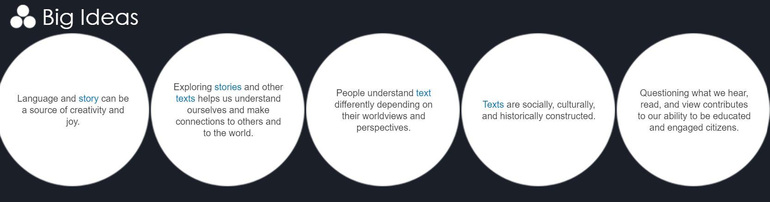

The redesigned English Language Arts 9 curriculum provides students with the opportunity to develop strong communication skills, an understanding and appreciation of language and literature, and the capacity to engage fully as literate and responsible citizens in a digital age. Students are guided in their learning to think critically, creatively, and reflectively; to construct a sense of personal and cultural identity; and to be respectful of a range of perspectives and worldviews. The English Language Arts curriculum is a foundational component of education in British Columbia schools. Students are presented with a window into the past, a complex portrayal of the present, and questions about the future. They also come to understand language as a human system of communication: dynamic and evolving, but also systematic and governed by rules.
Source: BC Ministry of Education Website

Course Objectives
- Practice the Core Competencies of Communication, Critical/Creative thinking, and Personal and Social
- Appreciate the Big Ideas of each unit
- Use oral, visual, and digital texts to comprehend and connect, and then create and communicate
- Continue to develop strategies and processes for improving and extending reading, writing, viewing and speaking skills.
- Develop an understanding of self and individual learning styles
- Engage with a variety of literature and develop responses in different compositions.
- Enjoy books!

Materials and Units
Students will be working on their own, in small groups, and with the whole class on a variety of topics and subjects. The following are some of the materials or units which may be done during the course:
- Short Stories
- Novel Study
- Grammar
- Poetry
- Digital presentations

Due Dates, Attendance and Assessment
All assignments have due dates. If a due date is impossible to meet, it is the student’s responsibility to discuss with the teacher prior to the due date.
Prompt attendance is mandatory. All missed assignments are due on the student’s return to class. As we implement this new hybrid/online/cohort model, students must check teams and my blog to ensure they are getting instruction. Student progress will be continually assessed, and you must demonstrate personal responsibility.
Academic Dishonesty and Plagiarism
Plagiarism is to take use the thoughts, writings, or inventions of another and present them as your own. The following are examples of academic dishonesty or plagiarism:
- Failure to cite or document quoted or paraphrased material from another source
- Submitting as one’s original work, essays, presentations, or assignments which were purchased or otherwise acquired from another source
- Cheating on an examination by either sharing material, use of unauthorized course notes or any aids not approved by the teacher
- Submitting identical or virtually identical assignments unless authorized by the teacher
Source: SFU Academic Dishonesty Policy

Classroom-Digital and Face to Face
Students are expected to demonstrate respect, acceptance, and dignity for each other. The learning environment should be comfortable for everyone and students must accept one another as unique and individual learners. Students are expected to be:
- Punctual and in the classroom/Teams classroom at the designated time
- Prepared with all the necessary materials (device & charger, textbook, binder, pen, etc.)
- Productive and use their time effectively
- Respectful of the physical environment of the classroom and COVID-19 protocol
Evaluation
Your mark will be based on tests, quizzes, writing assignments, oral communication skills, and group work.

40% Quizzes/Tests

Students will write a test at the completion of each unit.

60% Assignments/Participation/Homework

Students will be required to complete a variety of assignments such as journals, essays, presentations, projects, etc.
Riverside resides in the unsurrendered territories of the Coast Salish peoples of the kʷikʷəƛ̓əm (Kwikwetlem), Səlil̓wətaɬ (Tsleil-Waututh), Skwxwú7mesh (Squamish), and xʷməθkwəy̓əm (Musqueam) Nations.

