Name ______________________________________ Date ___________________
English 12
Connection Based Novel Project (Identity and Conflict) We learn best when we are at the center of our own learning. Inquiry-based learning is a learning process through questions generated from the interests, curiosities, and perspectives/experiences of the learner. When investigations grow from our own questions, curiosities, and experiences, learning is an organic and motivating process that is intrinsically enjoyable. (http://www.inquirylearn.com/Inquirydef.htm)
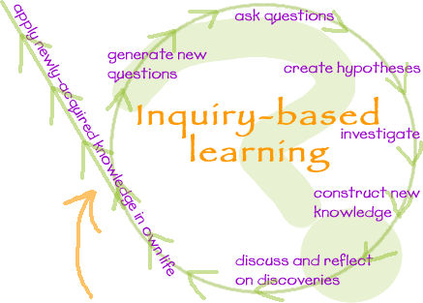

Specific learning processes that people engage in during inquiry-learning include]
- Creating questions of their own
- Obtaining supporting evidence to answer the question(s)
- Explaining the evidence collected
- Connecting the explanation to the knowledge obtained from the investigative process
- Creating an argument and justification for the explanation. (http://en.wikipedia.org/wiki/Inquiry-based_learning)
You are to create a presentation that will demonstrate your learning of the grade 12 novel that you chose:
- An in-depth understanding and analysis of your novel on a literary level –including plot, character, theme, symbol, conflict, setting, point of view, etc.
- An in-depth analysis of any prior learning (literature), cross-curricular connections, and connections to other sources (primary and secondary).

In our literature circles, we have been focusing on the themes of identity and/or conflict. Both themes of Identity and Conflict have significantly shaped the world that we live in today. For this assignment, you will present on one of the following guiding questions:

How does one’s identity shape their role within the global community?
0r
How does conflict impact people within our society?

The guiding question you choose will depend upon what novel you chose to read.

You must use this question to guide your presentation. In addition, you must also use other literature you have studied including short stories, poetry/music, essays, novels, plays, children’s books, digital media or any other that you have studied and learned (including from another class/grade). Reaching out to a community member for information is also a useful tool.

Task One
You must first come up with a proposal. In your proposal, you must outline what your specific inquiry question will be. In addition, you must also make clear what medium you are going to choose to present on the guiding question (this includes what program/software etc you will use). You will also need to outline what literature you are going to use to support your question. Please refer to English 12 Novel Study Planning Sheet.

Task Two
After your proposal has been approved, you will then have to come up with a way to present on the guiding question. These are some of the various mediums that you can choose from:

Mediums of presentations:
Print (magazine, editorial)
Public speaking (speeches)
Visual (street art, photography, paintings, posters, videos, comics, cartoons)
Media (film, computer graphics, PowerPoint slideshows, talk shows, internet blogs, monologues)
Music (song lyrics)

You must pick one form but if you have a different idea, you can propose it on your proposal form.

Task Three
Solution

In your presentation, you must research your question as well as suggest a solution to a problem you determined from your guiding question. What are some of the things that we can do to help those that have been impacted by a current or previous conflict for example? This is a key component of your presentation.

It is YOUR presentation and I want to see your work and your work only. Your project must reflect thoughtfulness and effort. Your project must make clear your position on the issue and be powerful persuasive and possibly innovative.
If your project is a written project (speech, editorial, song lyric, monologue, etc.) it must address the question that was posed and your solution to the question. (i.e. What is the message you’re trying to get across? What did you do to try to persuade the audience to agree with your position?)

If your project is a visual project (video) you must address the question that was posed and your solution to the question. (i.e. What is the message you’re trying to get across? What did you do to try to persuade the audience to agree with your position?)

Your proposal is due on: _________.

Your presentation due date is _____.

