Eisenstaedt, 1945
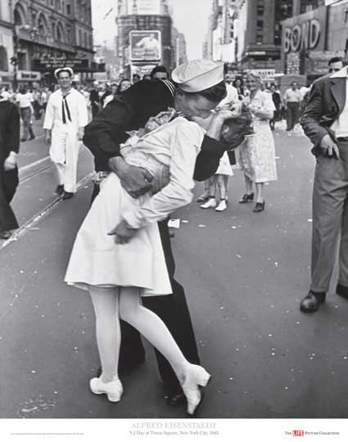
On August 14, 1945, the news of Japan’s surrender was announced in the United States, signaling the end of World War II. Riotous celebrations erupted in the streets, but perhaps none were more relieved than those in uniform. Although many of them had recently returned from victory in
Europe, they faced the prospect of having to ship out yet again, this time to the bloody Pacific.
Among the overjoyed masses gathered in Times Square that day was one of the most talented photojournalists of the 20th century, a German immigrant named Alfred Eisenstaedt. While snapping pictures of the celebration, he spotted a sailor "running along the street grabbing any and every girl in sight." He later explained that, "whether she was a grandmother, stout, thin, old, didn’t make any difference."

There is a fee for any use. This is not a source of free images.
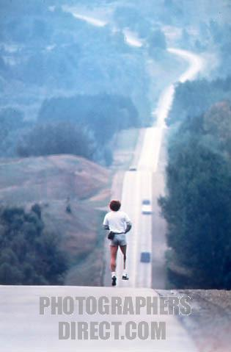

Oka Crisis legacy questioned

Sunday marks 20th anniversary of start of 78-day standoff

Last Updated: Sunday, July 11, 2010 | 8:05 AM ET

CBC News
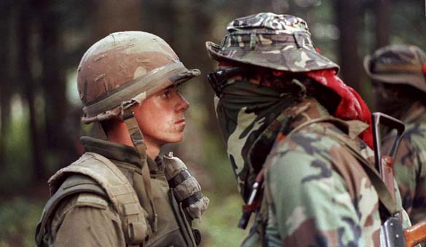
Read more: http://www.cbc.ca/canada/montreal/story/2010/07/10/oka-crisis-20th-anniversary.html#ixzz105FuyNzd

