English 12
One Minute Film Project

Throughout this entire semester, we have looked at a variety of literary works through short stories, poems, and novels. For this assignment, you will either work on your own or in a group to create a one-minute film for one of the literary works that we have studied in class. Your live action film or animation should tell the story and the story must capture the key elements of the plot for the literary work that you have selected for your project. You will need to include the following on your Edublog:

- The Screenplay/Storyboard: For every film you need a screenplay. In your screenplay, think about what are the key elements of the story? Who are the key characters? How can you replicate the mood and tone of the story? What is the most efficient way to convey the story in one minute?
Helpful hint: One page of script is equal to one minute of screen time. If in doubt, read it out loud and time how long it will take you to read it.

- Film: Include the final product and embed the film onto your blog.

- Reflection: In your reflection, explain the rationale for why you selected those scenes that are represented in your film. Ask yourself, why are these the most important aspects of the story? What did you learn from going through this process? Your paragraph should be 250 words and it should be in MLA format.

The viewing of the one minute films will be on June 12th 2019

The tag for your assignment is: #omf12

One Minute Film Rubric
 | Meeting | Approaching | Beginning
Connection to story | Clear and distinct connection to the theme. | General connection to the theme. | Little to no connection
 | Plot matches the sort story well.  Basic technique  Few or irrelevant details  Random or confusing event sequences | Some plot holes but the story is told effectively. | ome plot holes that do not effectively tell the story well.
Creativity | Presented the story in an interesting and creative way. | Presented the story in a creative way | Presented the story
Reflection/Storyboard | Well thought out and excellent plan and reflection | Have a good plan and a good reflection | Have a plan and a reflection

Here is a website with examples of one- minute films:
https://blog.musicbed.com/articles/6-exceptional-one-minute-short-films/182
Plot summary
Most trailers have a three-act structure similar to a feature-length film. They start with a beginning (act 1) that lays out the premise of the story. The middle (act 2) drives the story further and usually ends with a dramatic climax. Act 3 usually features a strong piece of "signature music" (either a recognizable song or a powerful, sweeping orchestral piece). This last act often consists of a visual montage of powerful and emotional moments of the film and can contain a cast run if there are noteworthy stars that could help sell the movie.
Music and Location
Music helps set the tone and mood of the trailer. You need to choose the best location that would best connect with your vision for the trailer and the story. You need to think about that connection to ensure that the story and your trailer emphasis your overall objective.

Record in Landscape Mode

As mobile phones have gotten bigger, portrait seems like the best way to record your video. While that can work on a mobile devise, keep in mind that videos are best viewed on a larger screen. The best way to film is in landscape mode.

Lighting

Lighting plays a bigger role in videography, so make sure that your subject is illuminated by a bright source of light that is ideally behind you. Use your smartphone’s flashlight only as an absolute last resort.

Add a Grid

The only thing worse than watching a video recorded in portrait mode is watching a video taken at a wrong angle. Adding a grid lets you use your background as a point of reference to ensure that your recording is always straight. Some devices do not have this option. One the ones that do have this option it is a setting that you may need to enable within your camera app.
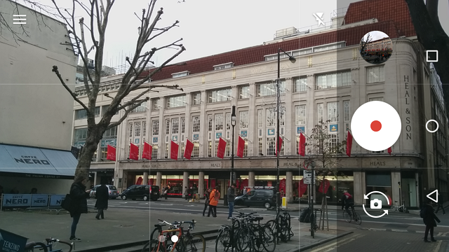
The grid helps you align your video against a line in the background to ensure you are recording straight videos. If you are recording people, then position their eyes in level with the top grid line.
Information found on June 13th 2017
http://www.makeuseof.com/tag/10-simple-tips-to-record-great-looking-home-videos/

Story Board Template
Use this template for planning your trailer. You must pitch your movie trailer before you start filming.

_Weaver looking for a place where he can stay for a night. _______________________________________________________________________________________________________________________________________________________________________________________________________________________________________

__find a place looking cozy and warm with cheap price ________________________________________________________________________________________________________________________________________________________________________________________________________________________________________

__rings a bell to call out the manager? Or owner? ________________________________________________________________________________________________________________________________________________________________________________________________________________________________________

_the landlady comes out right after weaver rings a bell and weaver is surprised on how fast the landlady comes out ________________________________________________________________________________________________________________________________________________________________________________________________________________________________________

_weaver looks at the guest-list to write his information, but there are two name Christopher and Gregory which are familiar and there names have been written 2 years ago and there is no more name after those two. _________________________________________________________________________________________________________________________________________________________________________________________________________________________________________

_weaver starts wondering about the names on the guest-list and taking rest _________________________________________________________________________________________________________________________________________________________________________________________________________________________________________

_the landlady comes to weaver to have tea-time and weaver asks some questions about the names on the guest-list but the landlady changes subjects by giving weaver a cup of tea and saying weaver’s name wrong _________________________________________________________________________________________________________________________________________________________________________________________________________________________________________

_we put a scene that does not show on the book which is the landlady dropping in poison on weaver’s tea to show how the landlady murders weaver and others easily_________________________________________________________________________________________________________________________________________________________________________________________________________________________________________

_weaver dies and its done_________________________________________________________________________________________________________________________________________________________________________________________________________________________________________

