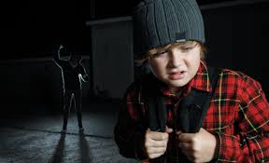
Rising before the sun
Walking on the paved road
Hoping the destination of yesterday
will be a happier place today

Seeing the same faces
Walking the same halls
Hearing the words of judgement
seeping from the confident

Aging from the same routine
waiting for the bell to pack my things
Scampering off to the place I call safe

feeling my brain loosen
as I listen to the silence in my room
feeling the fear melt off my shoulders
And my muscles unknot

