UNDERGROUND NEWS
War Between the Two Most Powerful Groups Continues
A member of the group ROYAL found dead in an alley.
12:45 AM, March 17, 2015 | By: Jerrico Verona

Andy, a 16-year-old boy that’s said to be part of the ROYAL group is found dead in an alley.
He was fatally stabbed below his rib cage, making a wide gap on his flesh. It happened around 11 – 12 PM. The suspects are said to be a group of people involved in the group GUARDIANS.
There are a few suspects that claims that they saw the Royal boy before he died.

Witness A – Gerald
Detective Raizel came and asked him questions.
“I was drunk so I don’t really remember, but I saw a boy lying in the alley last night,” said the drunk witness.
Other than that, Gerald didn’t say other details any further.

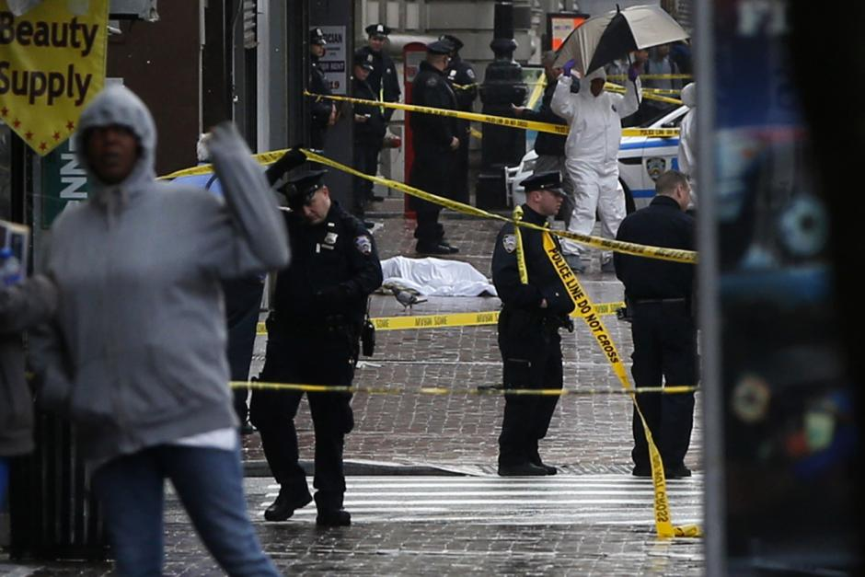
The crime scene where the dead ROYAL was found. Taken by: Shannon Stapleton

Witness B – Freddie and Angela
“We don’t really know what happened,” says the girl, panicking, “We didn’t want to get involved in the fight between the two groups.”
Detective Raizel bombarded them with questions. “You could’ve just called a cop, right?” asked the Detective, “Or at least called an ambulance.”
“Like she said,” said the young man, “We didn’t want to get involved, we were about to help him but we saw the ROYAL on his shirt.”
After that, the detective talked to the dead Royal’s lover, Laura. “I couldn’t believe this!” she complained, “He’s no longer part of that group! I want justice!”
Based on the witnesses, they are hoping to find the Guardians who killed the former Royal.

