How to Shade and Saturate with Pencil Crayons

. Pressure Shading
The simplest, most natural type of shading is to just alter pressure on your pencil. Sharpen it to a fine point and make small overlapping circular marks with as light a pressure as you can. Try to cover the area smoothly at the light end of the section and then gradually increase pressure as you work toward the darker end where it’s filled in nearly solid.
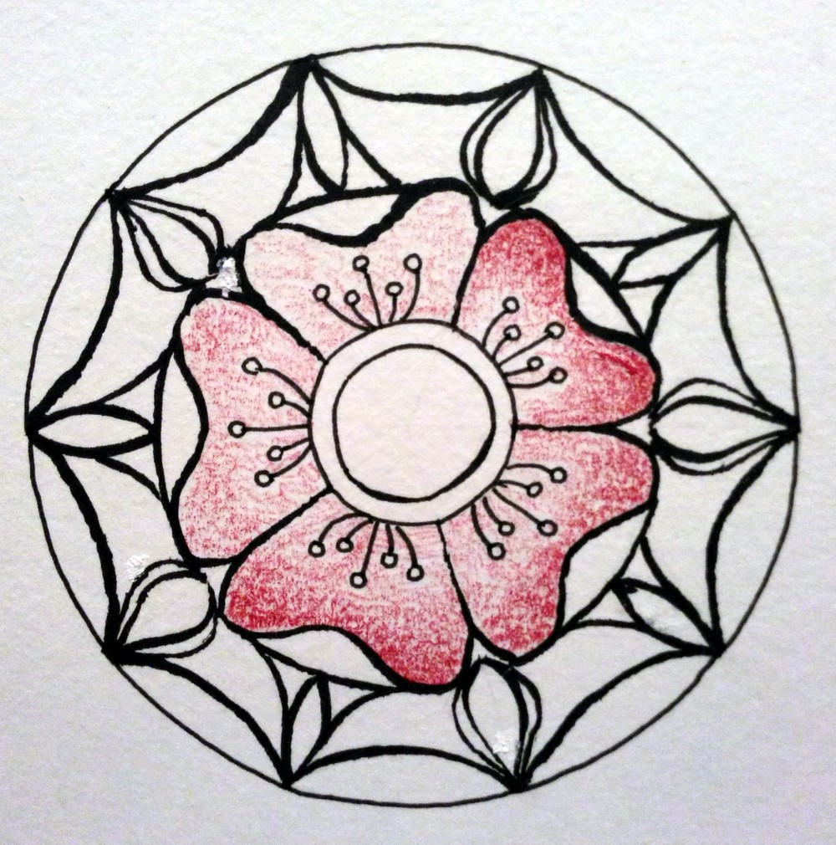Illustration 1: Pressure Shading
Alternately, you can shade the entire area smoothly in the lightest value, then add more layers as it gets darker and darker shrinking the area of the last layers. You can fade these smoothly into each other or leave a clear line between areas shaded once or more than once.
Pressure shading is a good way to take a dark or medium value pencil and get more variations out of it.
Pressure shading is a good way to take a dark or medium value pencil and get more variations out of it. The red in any 12 color set will give at least three or four different pinks before you reach the point where your hand can’t press more lightly and still have control. Practice extends the number of values you can achieve just by pressure changing.
Here’s the petals on the Rose Mandala shaded in entirely with pressure changing:
Ill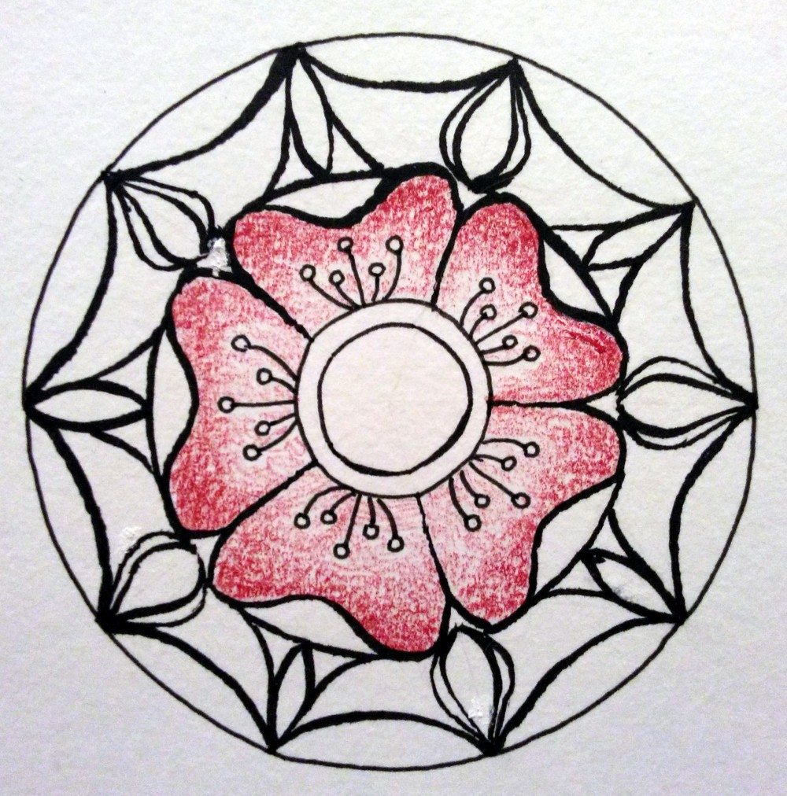ustration 2: Pressure Shading

2. Colorless Blend
Pressure shaded areas show flecks of white from the paper. One of the simplest ways to smooth them is burnishing with a colorless blender. Start at the lightest area and press hard while making slightly larger overlapping short or circular marks. Stay within value areas and work light to dark. This will darken and intensify the color, smooth out all the white specks and give a polished surface to the areas.
Colorless Blender pencils burnish away white specks and blends layers of colors. Use over a color change to get a soft transition.
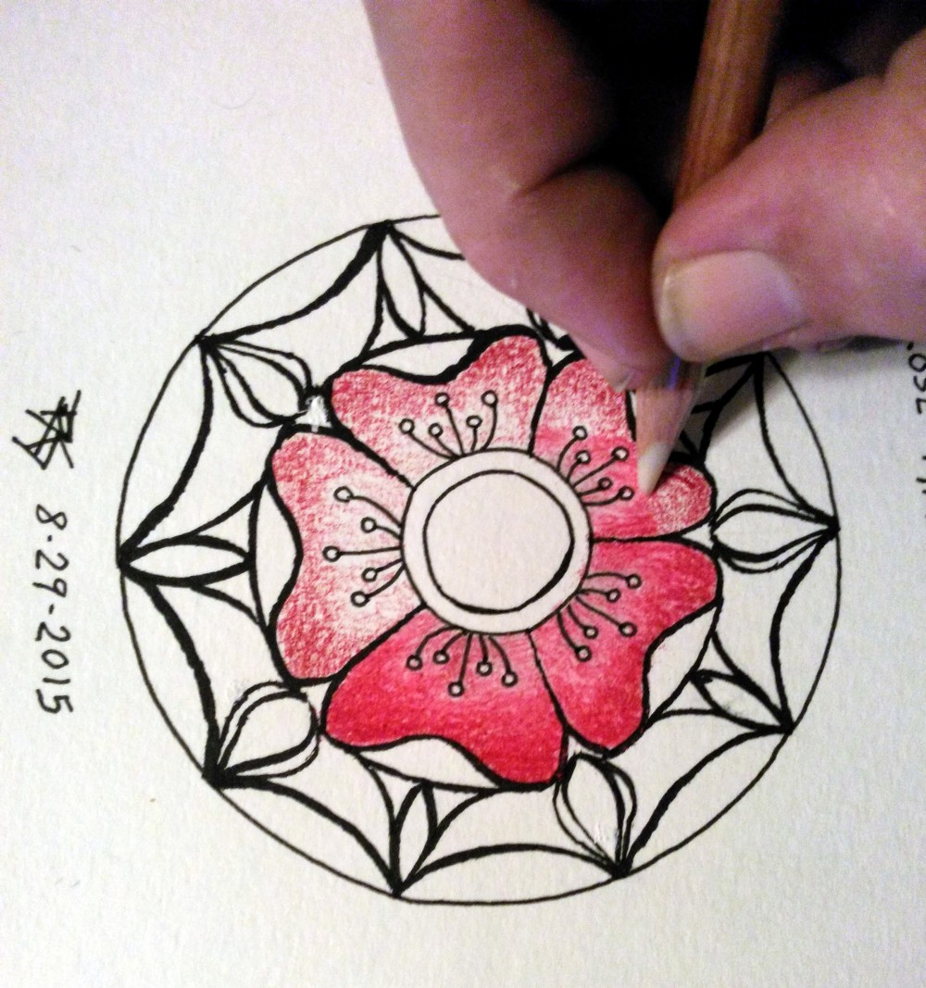Illustration 3: Colorless Blend

3. Add Darker Colors to Intensify Shading
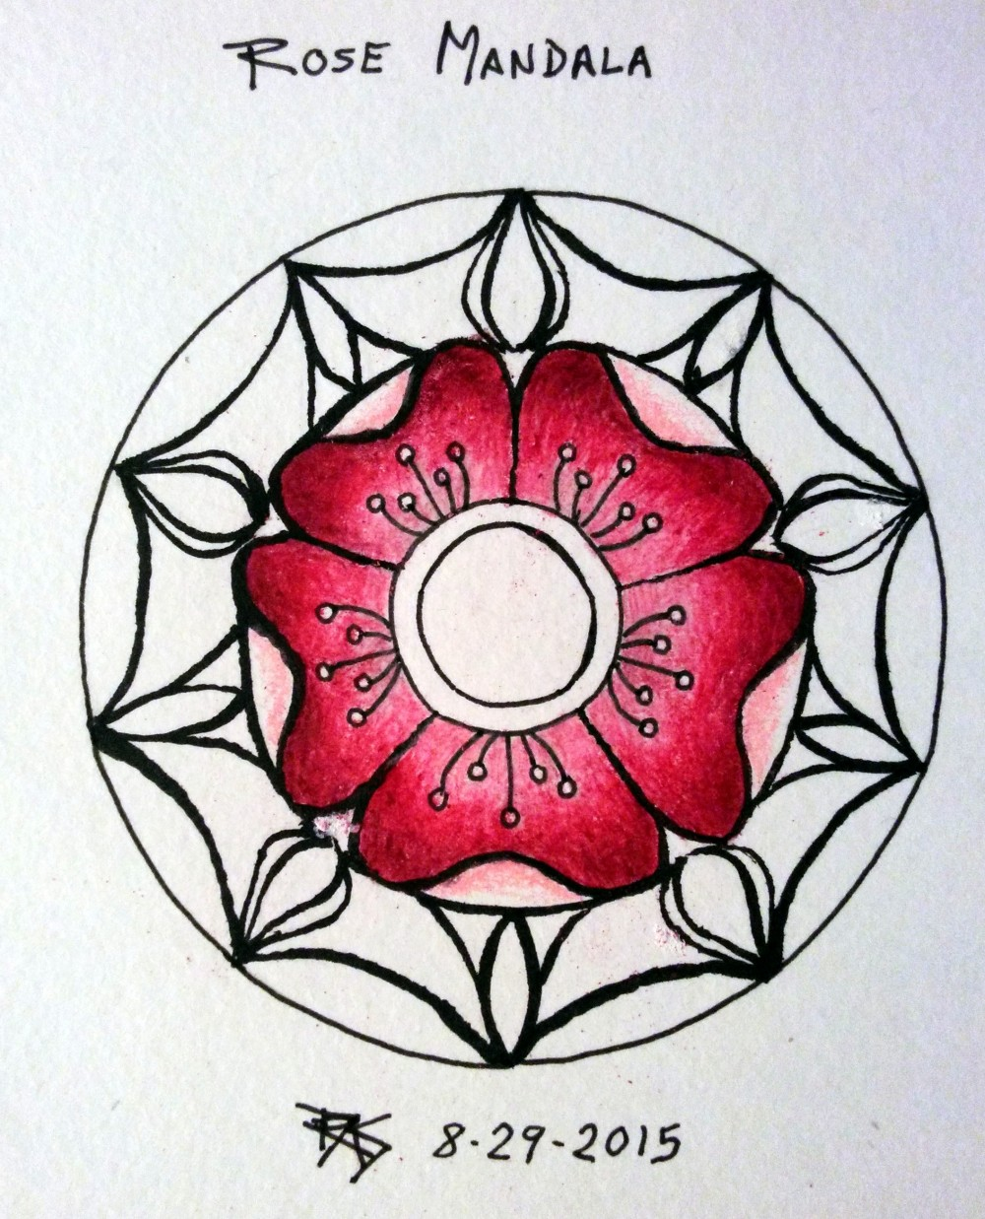Illustration 4: Deeper Color
The contrast diminished in the large petals once I applied the colorless blender, so I intensified the dark edge by adding Tuscan Red right over the burnished area. Colored pencils are translucent and Prismacolors blend easily with the layers under them. It didn’t get quite as dark as Tuscan Red does by itself but reached a nice dramatic dark anyway that lent the flower some depth. A lttle band of stronger Crimson overlapping that into the pinker area smoothed the transition.
Layering darker colors over light or medium adds color and darkens. Layering light over dark burnishes and adds nuances without dramatic changes.
Work back and forth with the medium and dark colors till the transition looks smooth. Either color can help where strokes went awry to create unwanted streaks, spots or patterns blending out the colors under them. Pressure is medium to heavy on these later layers since the paper tooth is filled and you’re smudging with each new stroke, blending new color with what’s under it.

4. Shade Light Colors over Dark to Blend
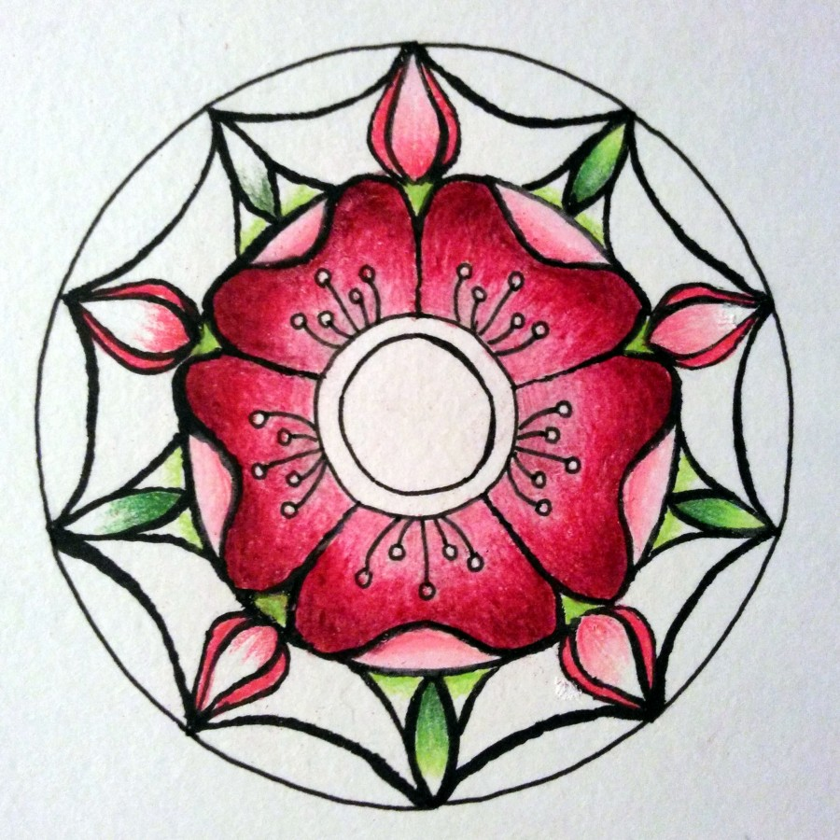Illustration 5: Overlap Colors
Instead of shading entirely by pressure, I did some areas by setting out several values in the same color group. Crimson Red, Carmine Red, Blush Pink and Deco Pink for reds (with Tuscan Red added on the large petals) and Olive Green, Apple Green, Chartreuse and Yellow Chartreuse for greens.
Within a small area, do a small patch at the darkest end and shade away slightly with pressure. Then overlap it with the next darkest color, burnishing the previous color. This technique eliminates the colorless blender stage, as you use either Yellow Chartreuse or Deco Pink to burnish the entire small area. Each color smooths the transitions with the previous colors.
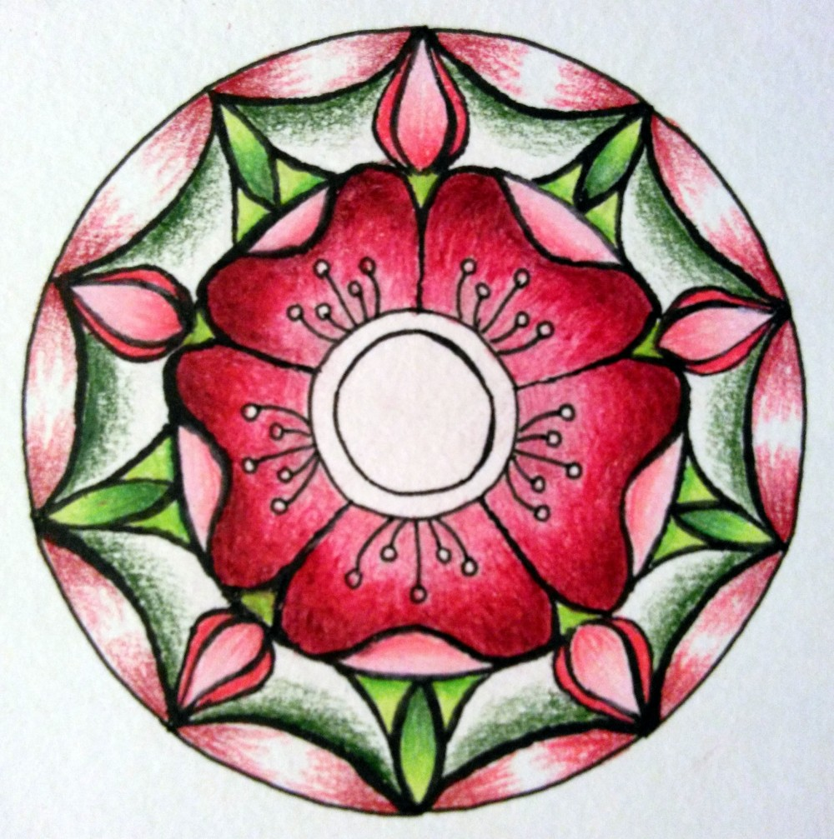Illustration 6: Overlap Colors

5. Use Solvents
If you have watercolor pencils, just choose a watercolor pencil with a similar texture to your other colored pencils. My examples are all in Prismacolor Premier. If you don’t have any watersolubles, many different solvents can work with colored pencils.
Ronson or Zippo lighter fluid works for colored pencils. Bestine rubber cement thinner is very good as a solvent. Another popular solvent is Turpenoid also known as odorless mineral spirits. Test different solvent products on a separate piece of paper to understand how they work with your pencils before applying them to your project.

