Mother’s Seasons
By Jayna Bettesworth

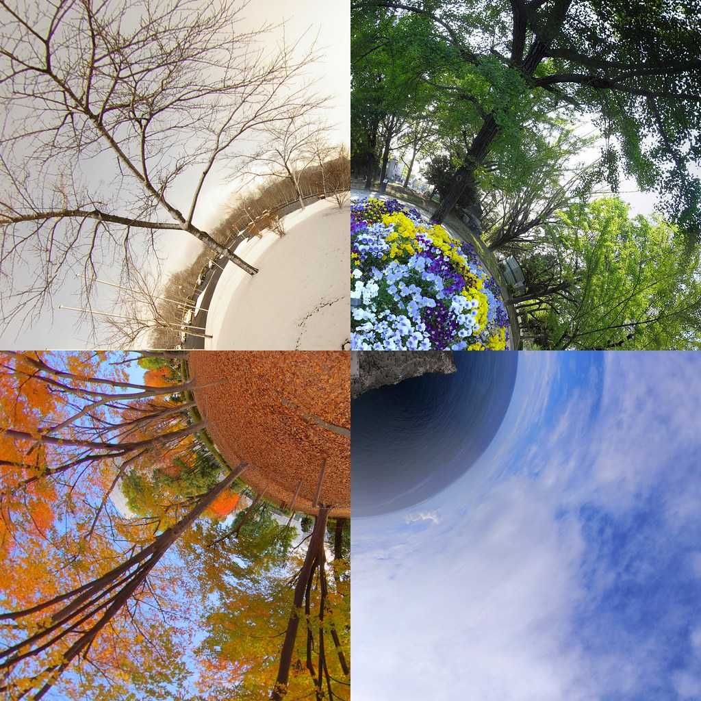

The meadow always blooms in the soft mouths of spring
Leaves rustle in gentle breezes, morning bells will always ring
Flowers leap right from the earth, glistening through rays
Kindly beast smile through the sunshine in their days

In the summer things set on fire in the suns forceful heat
Then humans came with metal boots stomping on earth like wheat
Roses wilt through clouds of smoke looming up ahead
Lost in spite, exploding hate, yearning no forgotten friend

Crisped lonely leaves fall anxiously to the ground
We sing of gunshots music, ringing not for what we found
Rotten berries crumble through the starving hands our mother feeds
Plowing through earth like its our own, ignoring what it needs

Falling flakes of ash blanket the streets in sorrow
Mothers children, mighty beast ready in its burrow
Winters chill of whispering winds persuades us into darkness
We can only run away if we let go of its harness

Spring sweeps around the corner with potential future doom
But, if we can all can get along, the flowers may still bloom
Hand in hand if we all stand for nature can rebirth
We may sing in peaceful harmony for freedom of our earth

