Anmore By: Jayna Bettesworth

Part 1
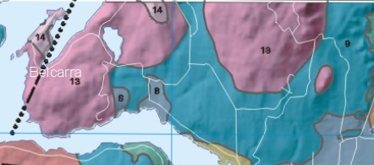
Soil:
In Anmore, the soil mainly consists of Granitic rock and till. Other apparent soil types in the area are foliated sedimentary and volcanic rock, as well as gravel and sand. These soil types occur near the village and beneath the natural forested area’s
Granitic rocks – course grained rock that consist of quartz, feldspar, and biotite giving it a “salt and pepper” type texture. This rock is durable and resistant to erosion, allowing it to form steep mountain slopes.
Till – glacial deposit consisting of clay, silt, sand, and stones ranging in sizes. Surface is very thick and reaches up to 25m deep in some parts. Some types of till can be very compact, where as others can be sandy and loose.
Gravel and sand – deposits of gravel and sand up to 40m in thickness. Good for irrigation and agriculture, common source of flooding.
Foliated sedimentary and volcanic rock – Occurs widely among the cascade mountain range, forming many years ago. Very hard and durable.
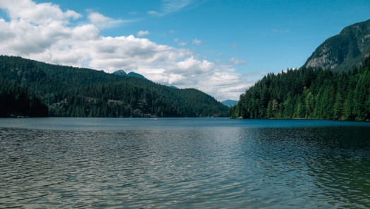
Ecosystems:
Anmore is located north of port moody and encompasses many natural landscapes and native species. A common attraction amongst locals and tourist’s is Buntzen lake. This lake holds marine life good for fishing, and habitats for the animals living near by. We use this park for hiking, swimming, and fishing providing activities for everyone. Belcarra is a regional park near the borders Anmore. This is a managed park for locals and tourist as well, and hosts plenty of outdoor activities. Belcarra is very popular for crab fishing, and hiking, as there are many trails located around the island. Anmore is home to many species living in its area and has salt water, fresh water and land-based ecosystems.
Community
In Anmore, the community holds 2 210 people. Because of its small size, Anmore is considered a semi-rural community. The people that live there have an average net worth of $187 345 income naming it one of the wealthiest cities in metro Vancouver. However, almost all of the people who live there work elsewhere in Vancouver. The village is only 31 years old and is politically independent with under 2500 people. Also because of its small size, it is very quiet with lots of activities for its residents. Anmore is known for Buntzen lake and Belcarra which are large natural attractions near by.
Industries:
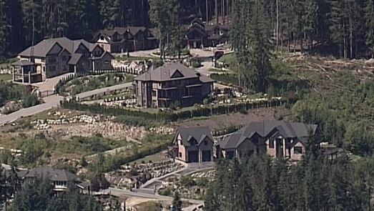
In Anmore, most of the village retains large houses, for residents to live. Because of this, there isn’t many industries or businesses in the village. Just outside the border is an imperial oil terminal called Ioco. This is the main industry that is near by, supplying oil to the surrounding cities, and providing jobs to a few of the residents. Other industries that are apparent in Anmore are the marine industries and the eco tourism industry. Anmore is home to many lakes, and ocean resulting in the marine industries, for people come to Anmore to collect fish, and other marine life. The plentiful forest that surrounds Anmore allows for eco tourism. This industry won’t make a lot of money, but it attracts people into the city, and makes them aware of the natural beauty it retains. Because of Anmore’s small size, there is no major warehouses or business sector, but the wild life that surrounds the village makes up for it.

Part 2
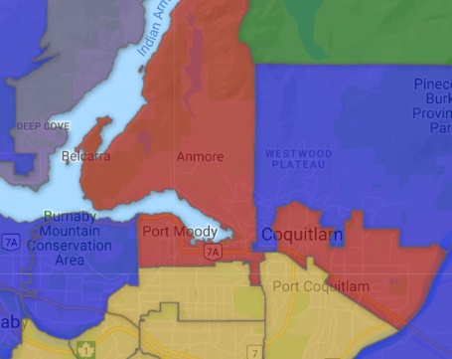
If an seismic earthquake were to occur, the plates that would cause the event would be the Juan De Fuca plate, and the Pacific plate. This is a convergent plate boundary in a subduction zone and is due for another large-scale earthquake. For an earthquake to occur, the plates would get stuck as they slide past each other and build up their pressure. As the force increases, for the plates to slide past each other, the pressure builds up causing stress underneath the earth. When the plates suddenly shift back to place, a ripple in the earth will occur causing a large-scale earthquake that will last up to 5 minutes in length. The destruction that this earthquake will cause, will be tremendous and many casualties will occur, however many programs have taken place near our area to help make buildings earthquake safe. P waves are the first waves to occur in an earthquake, as they are known as the primary waves. They would be very destructive and be a warning for what may be next to come. The S waves are next, that can be much more destructive. Since along this fault zone, there hasn’t been many earthquakes, it is due for one at an extremely high magnitude meaning the earthquake will last upwards of 5 minutes. The soil in this region mainly consists of Granitic rock and Till. Both are very durable, so there may not be too much stress on the soil, lightening the damage. The hard rocks are very durable, so liquefaction is unlikely to happen only where these rocks are in occurrence. Foliated sedimentary and volcanic rock is also apparent in this region, but is hard, and is also unlikely for liquefaction. Till can also be sandy and appear loose, that would result in liquefaction during an earthquake. The soil will lose its strength causing damage to roads and buildings and causing landslides throughout the hills. The sand and Gravel deposits could potentially cause major liquefaction in some area’s, and make the village almost slide because of the hills that it surrounds. With this material, it is common for floods to occur, so any rivers or lakes that will get rerouted, could flood out the city.
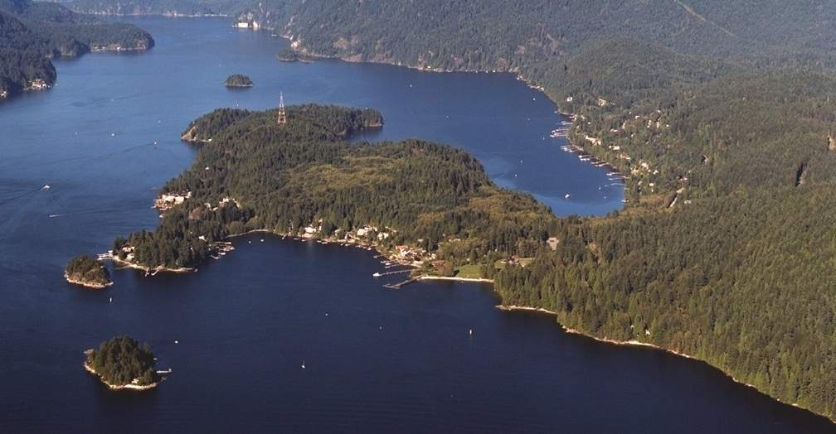
Anmore is well known for it natural ecosystems that surround the area. There are plentiful forests, and big lakes that give Anmore its name. In the event of a major earthquakes takes place, all the great scenery would be ruined. The S and P waves would cause the mountain slopes to deface, causing landslides to tear apart the land. The debris will flow into Buntzen lake, causing flooding in nearby area’s. This will result in habitat loss for animals like bears, coyotes, and dear. The destruction of lakes will cause the fish and other water species to die because of the loss of their home. The city will also lose common outdoor activities that attract thousands, like hiking and swimming around Buntzen lake. Tree’s would fall onto houses and into streets already damaged by the earthquake. Since P waves can travel through liquids, it is highly possible for a tsunami to occur hear causing Belcarra Park to nearly be whipped out.
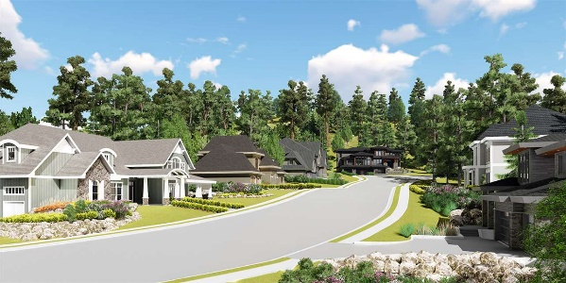
In Anmore there are few people who live there and no high rises in its midst. This may limit the risk of these high buildings to fall and kill many people. Instead, Anmore is home to big and expensive houses. These houses are mainly wood framed, so they would provide some structural support during an earthquake, stabilizing the ground. However, if a magnitude 9 or higher earthquake did occur, the frames would not be enough to keep all the houses standing. The main risk in Anmore would be flooding from the nearby lakes and streams, and the risk of people losing supplies. Since Anmore is isolated because of it extremely small size, It is at risk of becoming overlooked. There is no main businesses or big stores, so most people don’t think about it being much effected, even though it lies in a “very high-risk zone” of an earthquake coming. Anmore relies on other cities to supply electricity, water, food, and majority of its resources. Without this Anmore is at high risk of running out of food and clean drinking water. Roads and bus routes will be in ruin, leaving some residents stranded, as that is their primary source of transportation. There are only a few streets into the city, so when they get ruined in the earthquake, there won’t be access to the village to even send in support systems, and even send patients to hospitals. Anmore will almost be left in the dark, for its strong reliance on other municipalities for its goods, and growth of the city

Part 3
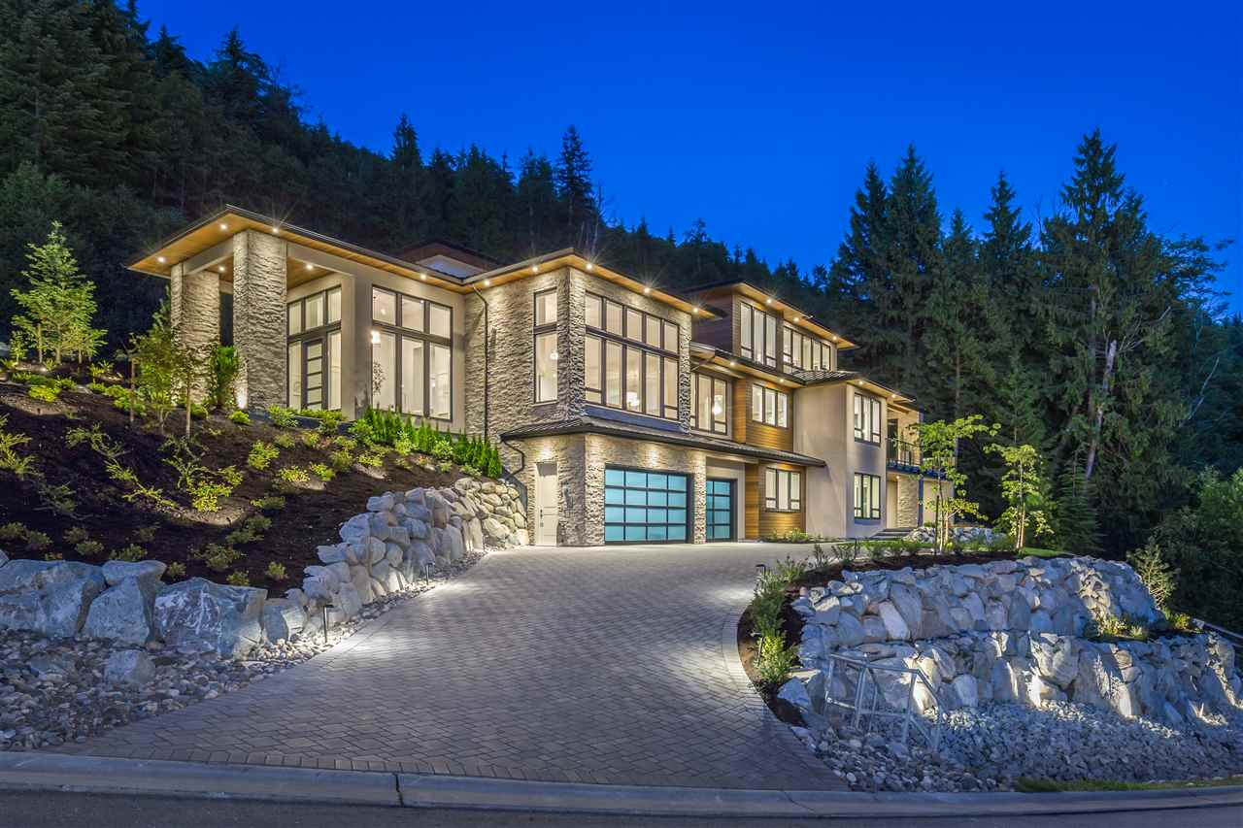
Living in Anmore, the main thing to do is go out in nature like hike around Buntzen lake. I go out every weekend with my family to hike around the lake to get my exercise. We occasionally go to Belcarra to go crabbing because I just got my fishing licence. I go to high school, heritage woods, which is reasonably close to Anmore but lies in Coquitlam. My mom and Dad both work outside of the city. My mom in Surry, and my dad in Vancouver. I take a bus everyday to school from TransLink that runs every hour and arrive on time to do work. We get all our supplies from grocery stores in Coquitlam, as there are none in Anmore. I have a part time job outside of school at Buntzen lake, where I work at the concession stand. The concession is only open for the summer, so I only work there about 2 months of the year. In my free time I like to read at home or spend time in my friends swimming pool who lives near by. Our house is big and soundly structured with a wood frame. It was built 10 years ago so it is well updated and clean. The large earthquake struck around dinnertime at my house. We were waiting for Dad who was stuck at work. During the earthquake, trees fell, and roads started crumbling away. We could feel the house begin to shift and fracture during the shake. The roof is damaged, and the walls are breaking, and some of the other houses around us have crumbled around. Water has rushed into our streets causing a flood zone for those who live on the downhill. The roads are now unable to be driven on and there is no exits to our village. Dad can’t come in, and we can’t get out. Our sewage is beginning to overflow and leak onto our streets. Sickness is vastly spreading because of this leek. Electricity has been cut, and our clean water supply damaged, so we have been left with little to drink and no power to live by. Bacteria is growing in the water, so sickness is spreading fast throughout the people stranded in this town. With the power out, we are unable to connect and contact some of the people around us and be up past dark. We are running out of batteries for our flashlights, and the ability to aid our people. It is getting harder to have fresh water, because we cannot boil the dirty water, for our electrical source is damaged. We are running out of resources fast. The compromise in natural gas have caused the inability for the heating of our house, residing in long cold nights, and the inability to cook and heat water. Over all, our living conditions have declined greatly in this earthquake and everything we once took for granted is now gone.

