Jayna Bettesworth
October 5, 2018
Continental Drift is Not just a Theory
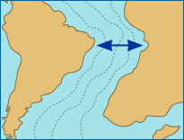
Have you ever noticed the shape of each continent and how they seem to fit together perfectly? This is one of the many reason that Continental drift is not in fact, just a theory!!! Notice the way the coast of South America on the east and Africa’s west coast seem to have a similar coast line. More than a million years ago, they were once connected in one big continent, like the pieces in a puzzle. The world used to be one supercontinent called Pangea but separated overtime. Each continent now is its own piece in the puzzle. Slowly these pieces separated creating two different continents separated by oceans, which once all shared the same land.
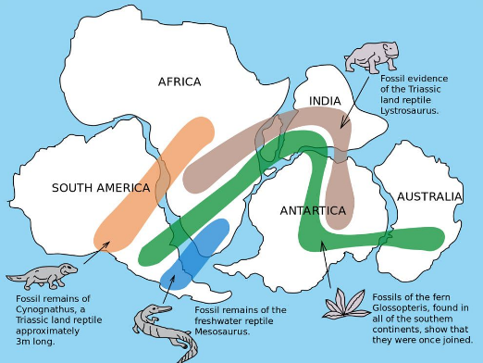
Years ago, scientist found fossil evidence of dinosaurs living through parts of the world. There is evidence of the same specie of dinosaur living in two separate areas on todays map. It would be very uncommon to find the exact same specie at the time in two unique areas separated by an ocean where they would be unable to swim across. The land must have had similar climates at the time that they existed but are drastically different then they are now. This fact concludes that once these lands must have been connected and the same climate for these dinosaurs to have lived there.
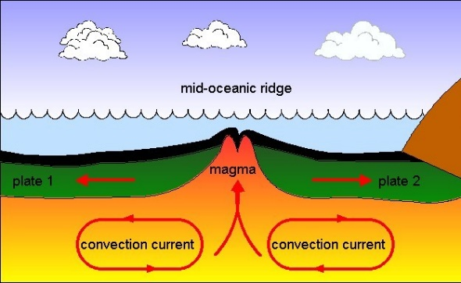
Down in the depth of the ocean, a process occurs called seafloor spreading. Tectonic plates are slowly moving apart, and molten rock is pushed up towards the surface creating a mid ocean mountain range of this molten rock. As this keeps getting bigger and bigger, the continents keep moving away from each other to maintain the same size of the earth. This once again proves that the continents must be moving for seafloor spreading to occur.
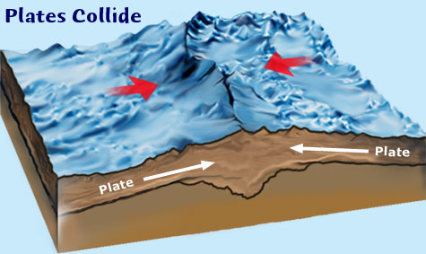
Mountain ranges that grow high into the horizon may not have always been here on this earth. Some type of extreme geological process must have happened to create such large mountains. The only explanation that scientist have concluded are the tectonic plates shifted or collided, creating their large mountains in its process moving around different land masses. So from the tectonic plates in which the continents sit upon move, the gigantic mountain ranges that we know today.
The continents were once connected and every year, they move further and further apart. It only resides in weather we chose to believe the truth or not and have faith in natural science.

