Protein Synthesis
- How is mRNA different than DNA?
There are multiple differences between DNA and RNA the first being that:
- DNA is made up of deoxyribose sugar and mRNA is made up of Ribose sugar.
- DNA is made up of two antiparallel backbones (double strand). RNA is only made up of one (single strand) and this is to allow RNA to bond with the sense strand in order to create proteins.
- DNA twists its two antiparallel strands into a double helix whereas RNA does not.
- DNAs two strands are longer than RNAs single short strand.
- The pyrimidines also differ. DNA has a thymine pyrimidine that complimentary base pairs with Adenine, however, RNA’s pyrimidine is called Uracil and that is what replaces thymine to bond with Adenine.
- DNA codes and creates all an organism’s information however, without RNA this would not be possible.
- Describe the process of Transcription
Transcription takes place inside the nucleus. There are 3 phases transcription takes place:
- Unwinding and Unzipping of DNA
  - During this stage, the RNA polymerase separates the two backbone strands. What it has done is unwind DNAs double helix and has begun to unzip it as shown below.
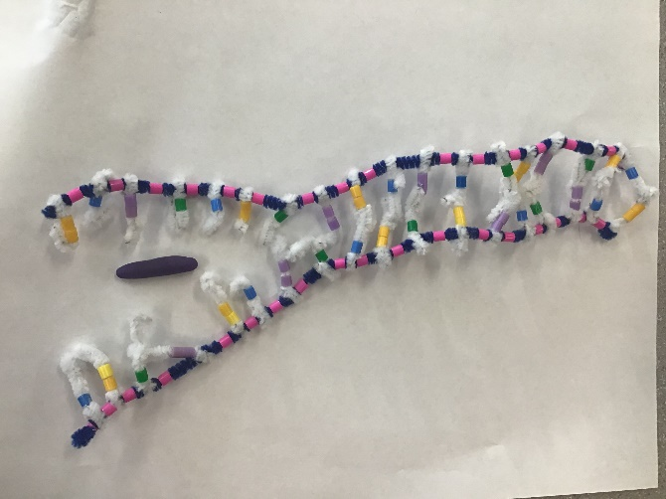
- Complimentary base pairing with DNA
  - RNA nucleotides begin complimentary base pairing with DNAs sense strand. This forms mRNA as nucleotides are covalently bonded together and build the RNA backbone. It is again RNA polymerase that causes the complimentary base pairing.
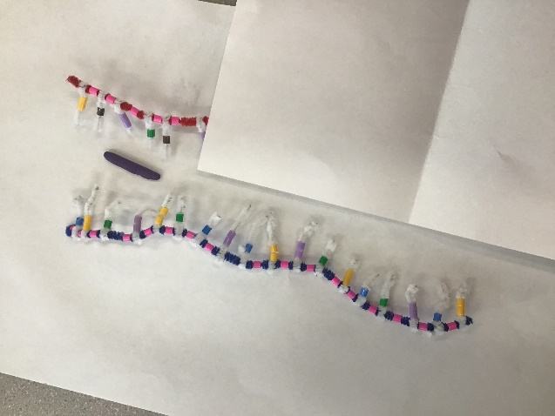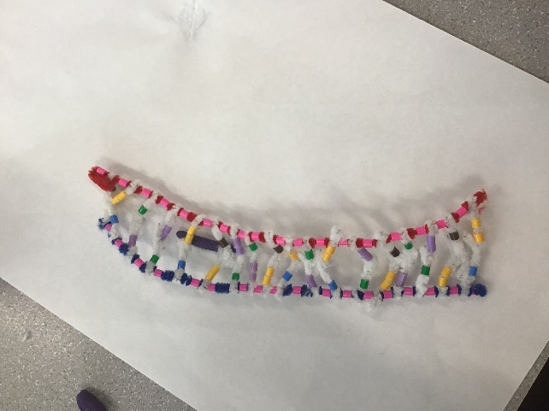

- Separation from DNA
  - Now that the RNA strand has formed and copied DNAs instructions, RNA separates and leaves the nucleus while DNA re-zips and forms its double helix. This mRNA goes to create proteins from the copy of information.
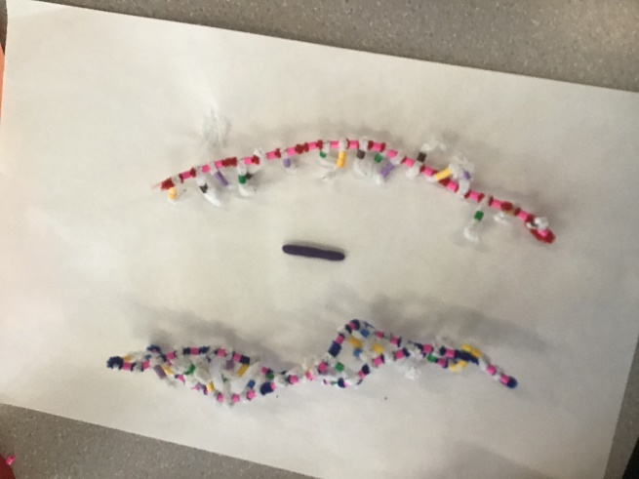
- How did todays activity do a good job of modelling the process of RNA transcription? In what ways was our model inaccurate?
  - Personally I think that this modelling process gave us a good description and basic idea of how the process works and allowed us to visually see the steps and layout, however, because it is hard when using small things like pipe cleaners and beads it is hard to see and demonstrate exactly how the nucleotides form to build RNA. I also noticed that this model did not demonstrate how DNAs two strands are longer than RNA because our strands were the same size and length and that is not accurate. It also did not clearly show the RNA polymerase although I do think overall it was a good lab for learning basic structure and different parts on/of structure. Some steps were just difficult to accurately demonstrate.

- Describe the Process of Translation: initiation, elongation, and termination
  - Initiation is when mRNA is held by the ribosome with an A-site and a P-Site. When the P-site reads the start codon AUG the matching tRNA brings the corresponding amino acid to the start codon. Overall RNA binds to small sub-units of ribosomes and the two units join together.
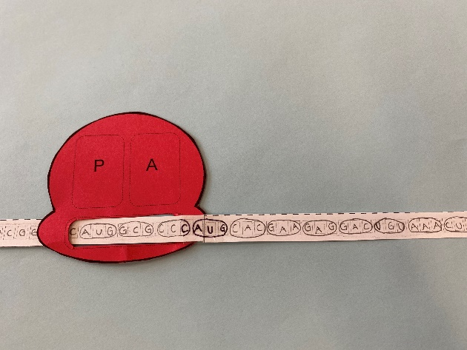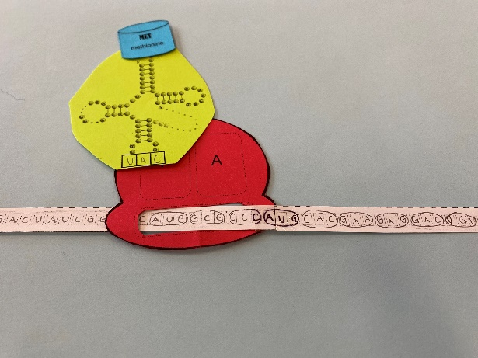
  - Elongation: Ribosome holds the mRNA and “reads” its codons at the A-site. Translation begins when a tRNA complimentary base pairs to the mRNA codon at the P site and the 2nd tRNA complimentary base pairs to the codon at the A site. The amino acid of the tRNA at the P-site is transferred to the tRNA at the A-site. The empty tRNA at the P site dissociates and the tRNA at the A site is moved to the P site. This continues
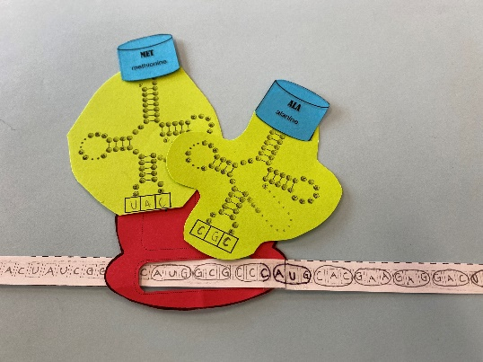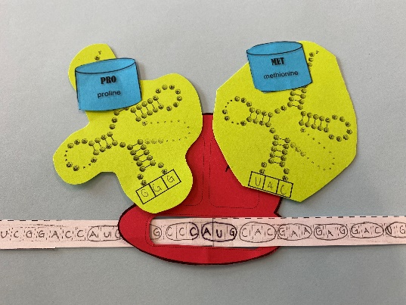
  - Termination: the elongation cycle continues until it reaches a mRNA codon at the p site for which there is no complimentary tRNA. This is called a stop codon and no new amino acid is added to the chain when this occurs. Instead the polypeptide dissociates from the ribosomes.
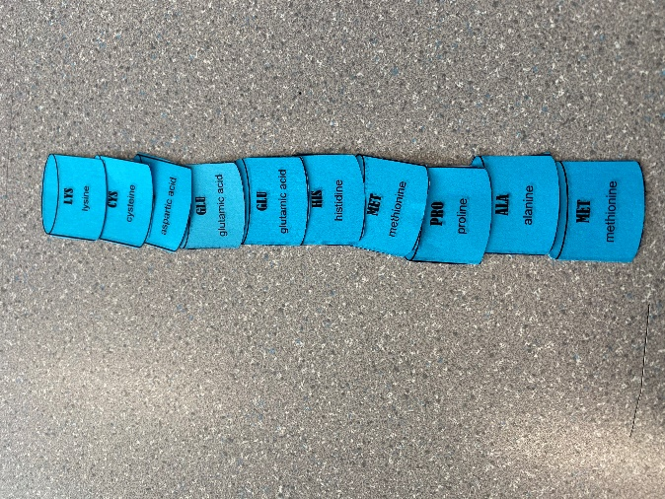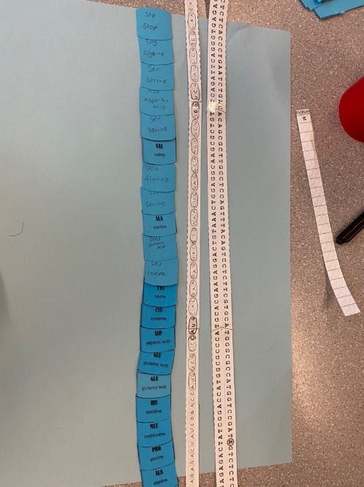
  - Processing: after transcription the RNA molecule is processed in a number of ways: introns are removed and exons are spliced together to form a mature mRNA molecule that consists of a single protein-coding sequence. RNA synthesis involved the normal base pairing but thymine is replaced with the base uracil, specific to RNA.

- How did todays activity do a good job of modelling the process of RNA transcription? In what ways was our model inaccurate?
  - This modelling process accurately showed the RNA, how it was created, and how the ribosome is holding it. It also accurately demonstrated the tRNA building process, however, it did not clearly represent how the amino acids in the “P” and “A” site match and hold the codons. I liked how this activity allowed us to practice the naming and demonstrated the stop and start codons. It also showed how the ribosome can hold 2 tRNA at once with the amino acids. It then demonstrated how the amino acid chain forms which helped me visualize and learn however, it did not clearly represent the ribosome being made of 2 units.
  - Overall this was a good activity to help us see how the process of translation actually works and was good to explain and show the steps of the processes.

