
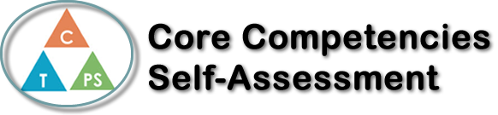
Name: Jayden Bawden | Date: June 18th, 2020

  How does the artifact you selected demonstrate strengths & growth in the communication competency?  In what ways might you further develop your communication competency? | Self-Reflection  Describe how the artifact you selected shows your strengths & growth in specific core competencies. The prompt questions on the left - or other self-assessment activities you may have done - may guide your reflection process.  I can identify small things I can do that could make a difference. I am very proud of myself for being able to successfully understand and complete this skill. Over my four years at Riverside and especially my last one, I have built up more and more capabilities to master this skill. I have created a RAK Wall in which many students and staff members contributed to, getting everyone on board with being kind and showing appreciation for those who are demonstrating this. This was a small initiative that only grew to bigger this. It is linked to my Instagram page which keeps growing its following base, where I am recognizing special people in our community who have done good things. The individuals recognized on my wall, on my Instagram or who have simply viewed either of them, have told me numerous times how much joy it brings them along with a smile. That’s why I love doing them. I can share my feelings and listen to other’s views. This is a skill I have been working hard on the past two years at Riverside. In group projects I find I get set on a specific idea or hold myself to higher standard than others may, this becomes a challenge for me when others have their ideas and I feel they collide with mine. I have noticed a change in myself where before we start anything, we all talk about things we want to incorporate in our project. I have also come to accept that I can’t change others work ethics or standards for themselves so I can just be the best person I can be, do my part and help them if they need it.


How does the artifact you selected demonstrate strengths & growth in the thinking competencies?

In what ways might you further develop your thinking competencies?

X

How does the artifact you selected demonstrate strengths & growth in the personal & social competencies?

In what ways might you further develop your personal & social competencies?
Publish Your Self Assessment
You will now attach and/or embed your self-assessment to the bottom of the blog post with the artifact you have chosen. You may choose to make this post private or public. After placing your artifact on a blog post, follow the instructions below.
- Categories - Self-Assessment
- Tags - Now tag your post using the tag that corresponds to the competency that you have written about. You can choose more than one. Please use lower case letters and be exact.
  - #creativethinkingcc
  - #communicationcc
  - #criticalthinkingcc
  - #socialresponsibilitycc
  - #personalidentitycc
  - #personalawarenesscc
- Use the Add Document button located at the top of your post page and embed your self-assessment at the bottom of your blog post.
- Publish

