
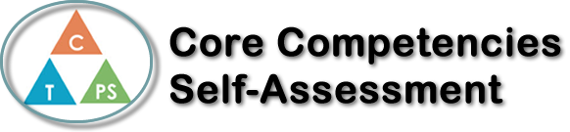
Name: Jayden Armstrong | Date: January 9 2020

  How does the artifact you selected demonstrate strengths & growth in the communication competency?  In what ways might you further develop your communication competency? | I think that this project helped me with my communication skills because even though I wasn’t there the whole time we communicated with what we needed to get done. This was the first project I did after I got my concussion and I think that I could have done a bit better but overall, I think that think project helped a lot with my communication in many way. Whenever I do a group project I have to talk to everyone about what needs to get done and what I need to do, so I think that this project helped me grow my communication skills.


How does the artifact you selected demonstrate strengths & growth in the thinking competencies?

In what ways might you further develop your thinking competencies?


How does the artifact you selected demonstrate strengths & growth in the personal & social competencies?

In what ways might you further develop your personal & social competencies?

Publish Your Self Assessment
You will now attach and/or embed your self-assessment to the bottom of the blog post with the artifact you have chosen. You may choose to make this post private or public. After placing your artifact on a blog post, follow the instructions below.
- Categories - Self-Assessment
- Tags - Now tag your post using the tag that corresponds to the competency that you have written about. You can choose more than one. Please use lower case letters and be exact.
  - #creativethinkingcc
  - #communicationcc
  - #criticalthinkingcc
  - #socialresponsibilitycc
  - #personalidentitycc
  - #personalawarenesscc
- Use the Add Document button located at the top of your post page and embed your self-assessment at the bottom of your blog post.
- Publish

