
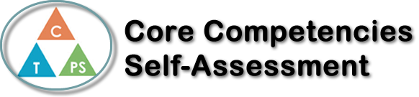
Name: Jason Seo | Date: 6/16/20

  How does the artifact you selected demonstrate strengths & growth in the communication competency?  In what ways might you further develop your communication competency? | Self-Reflection  Reflect upon your time in Calculus 12. Not only have you made it through one of the more difficult courses in your high school career, you have also done so during a challenging world event. Which core competency has been utilized the most for you, to get you through this course? (You can pick more than one if you feel you’ve tackled a couple). Write a couple paragraphs explaining why.  You can refer to the PDF attached the assignment to delve into the specifics of each core competency.  This semester during Calculus 12, I had experienced significant growth in the Personal Responsibility competency. Calculus 12 was virtually the first and only class I had where homework questions were simply for self-development, not for checks or for classroom sharing. This meant that I had the freedom to skip the homework assignments, but that also meant that I was responsible for making sure that I understood the content to the most of my abilities, whether that meant doing the homework or not. I remember in the beginning of the semester; it was very tempting to just not do the homework and have more free time in the evenings. However, I realized that this would not help to have a high mark, so I began doing the homework. Surely there were occasions when doing the homework did not help my understanding (derivatives unit, cough cough), but it generally helped to improve my comprehension.  This competency was also used when online learning began since there was almost no direct teacher presence. This was particularly noticeable during our tests and assessments since it was too easy to cheat and check answers. However, I had to resist this and focus on an honest reflection of my learning. There were many occasions where I had been faced with a rather difficult question and was greatly tempted to check the answer on a website or something, but those moments were definitely when I improved in self-regulation.  The amount of freedom that the course itself was offering, mounted with the increased amount of freedom we were given during online learning really accumulated a lot of responsibility that came along with it. I was often required to put more concentration and effort into learning since it is naturally hard to concentrate on schoolwork at home, but this experience has certainly helped me to develop as a more responsible and independent person.


How does the artifact you selected demonstrate strengths & growth in the thinking competencies?

In what ways might you further develop your thinking competencies?


How does the artifact you selected demonstrate strengths & growth in the personal & social competencies?

In what ways might you further develop your personal & social competencies?

