The cell cycles
M: Mitosis phases: Prophases, metaphases, anaphases, telophases.
G1: first growth phase: Growth and normal metabolic roles.
S: Synthesis phase: DNA replication.
G2: Second growth phase: Growth and preparation for miosis.
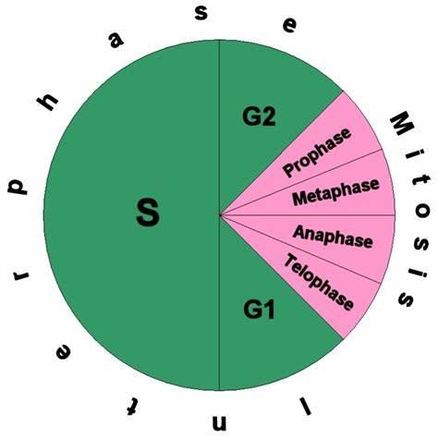

The four steps
- 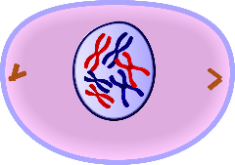Prophase: Beginning after interphase, DNA has already been replicated when the cell enters a prophase.
- 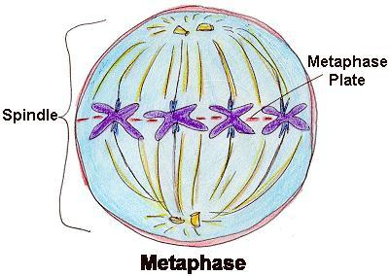Metaphase: is a stage of mitosis in the eukaryotic cell cycle in which chromosomes are at their second-most condensed and coiled stage (they are at their most condensed in anaphase). These chromosomes, carrying genetic information, align in the equator of the cell before being separated into each of the two daughter cells.
- 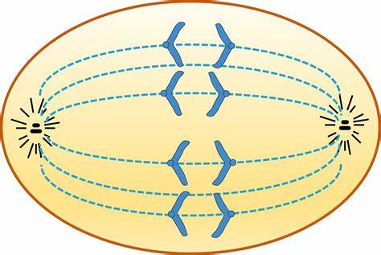Anaphase: In the stage of mitosis and the process of metaphase, when replicated chromosomes are split and the newly and gets copied chromosomes and the daughter and chromatids are moved to opposite stick of the cell.
- 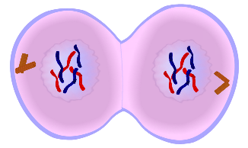Telophase: During telophase, the effects of the prophase and prometaphase the nucleolus and nuclear membrane disintegrating is reversed.

