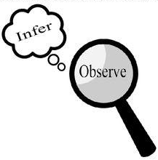
Observations and Inferences
Science 10 Name: Jared Lascano BLK: D

OBJECT | OBSERVATIONS  Words that describe the object | INFERENCES  Ie: Where might the object come from? Possible uses? Etc. | QUESTIONS YOU HAVE ABOUT THE OBJECT
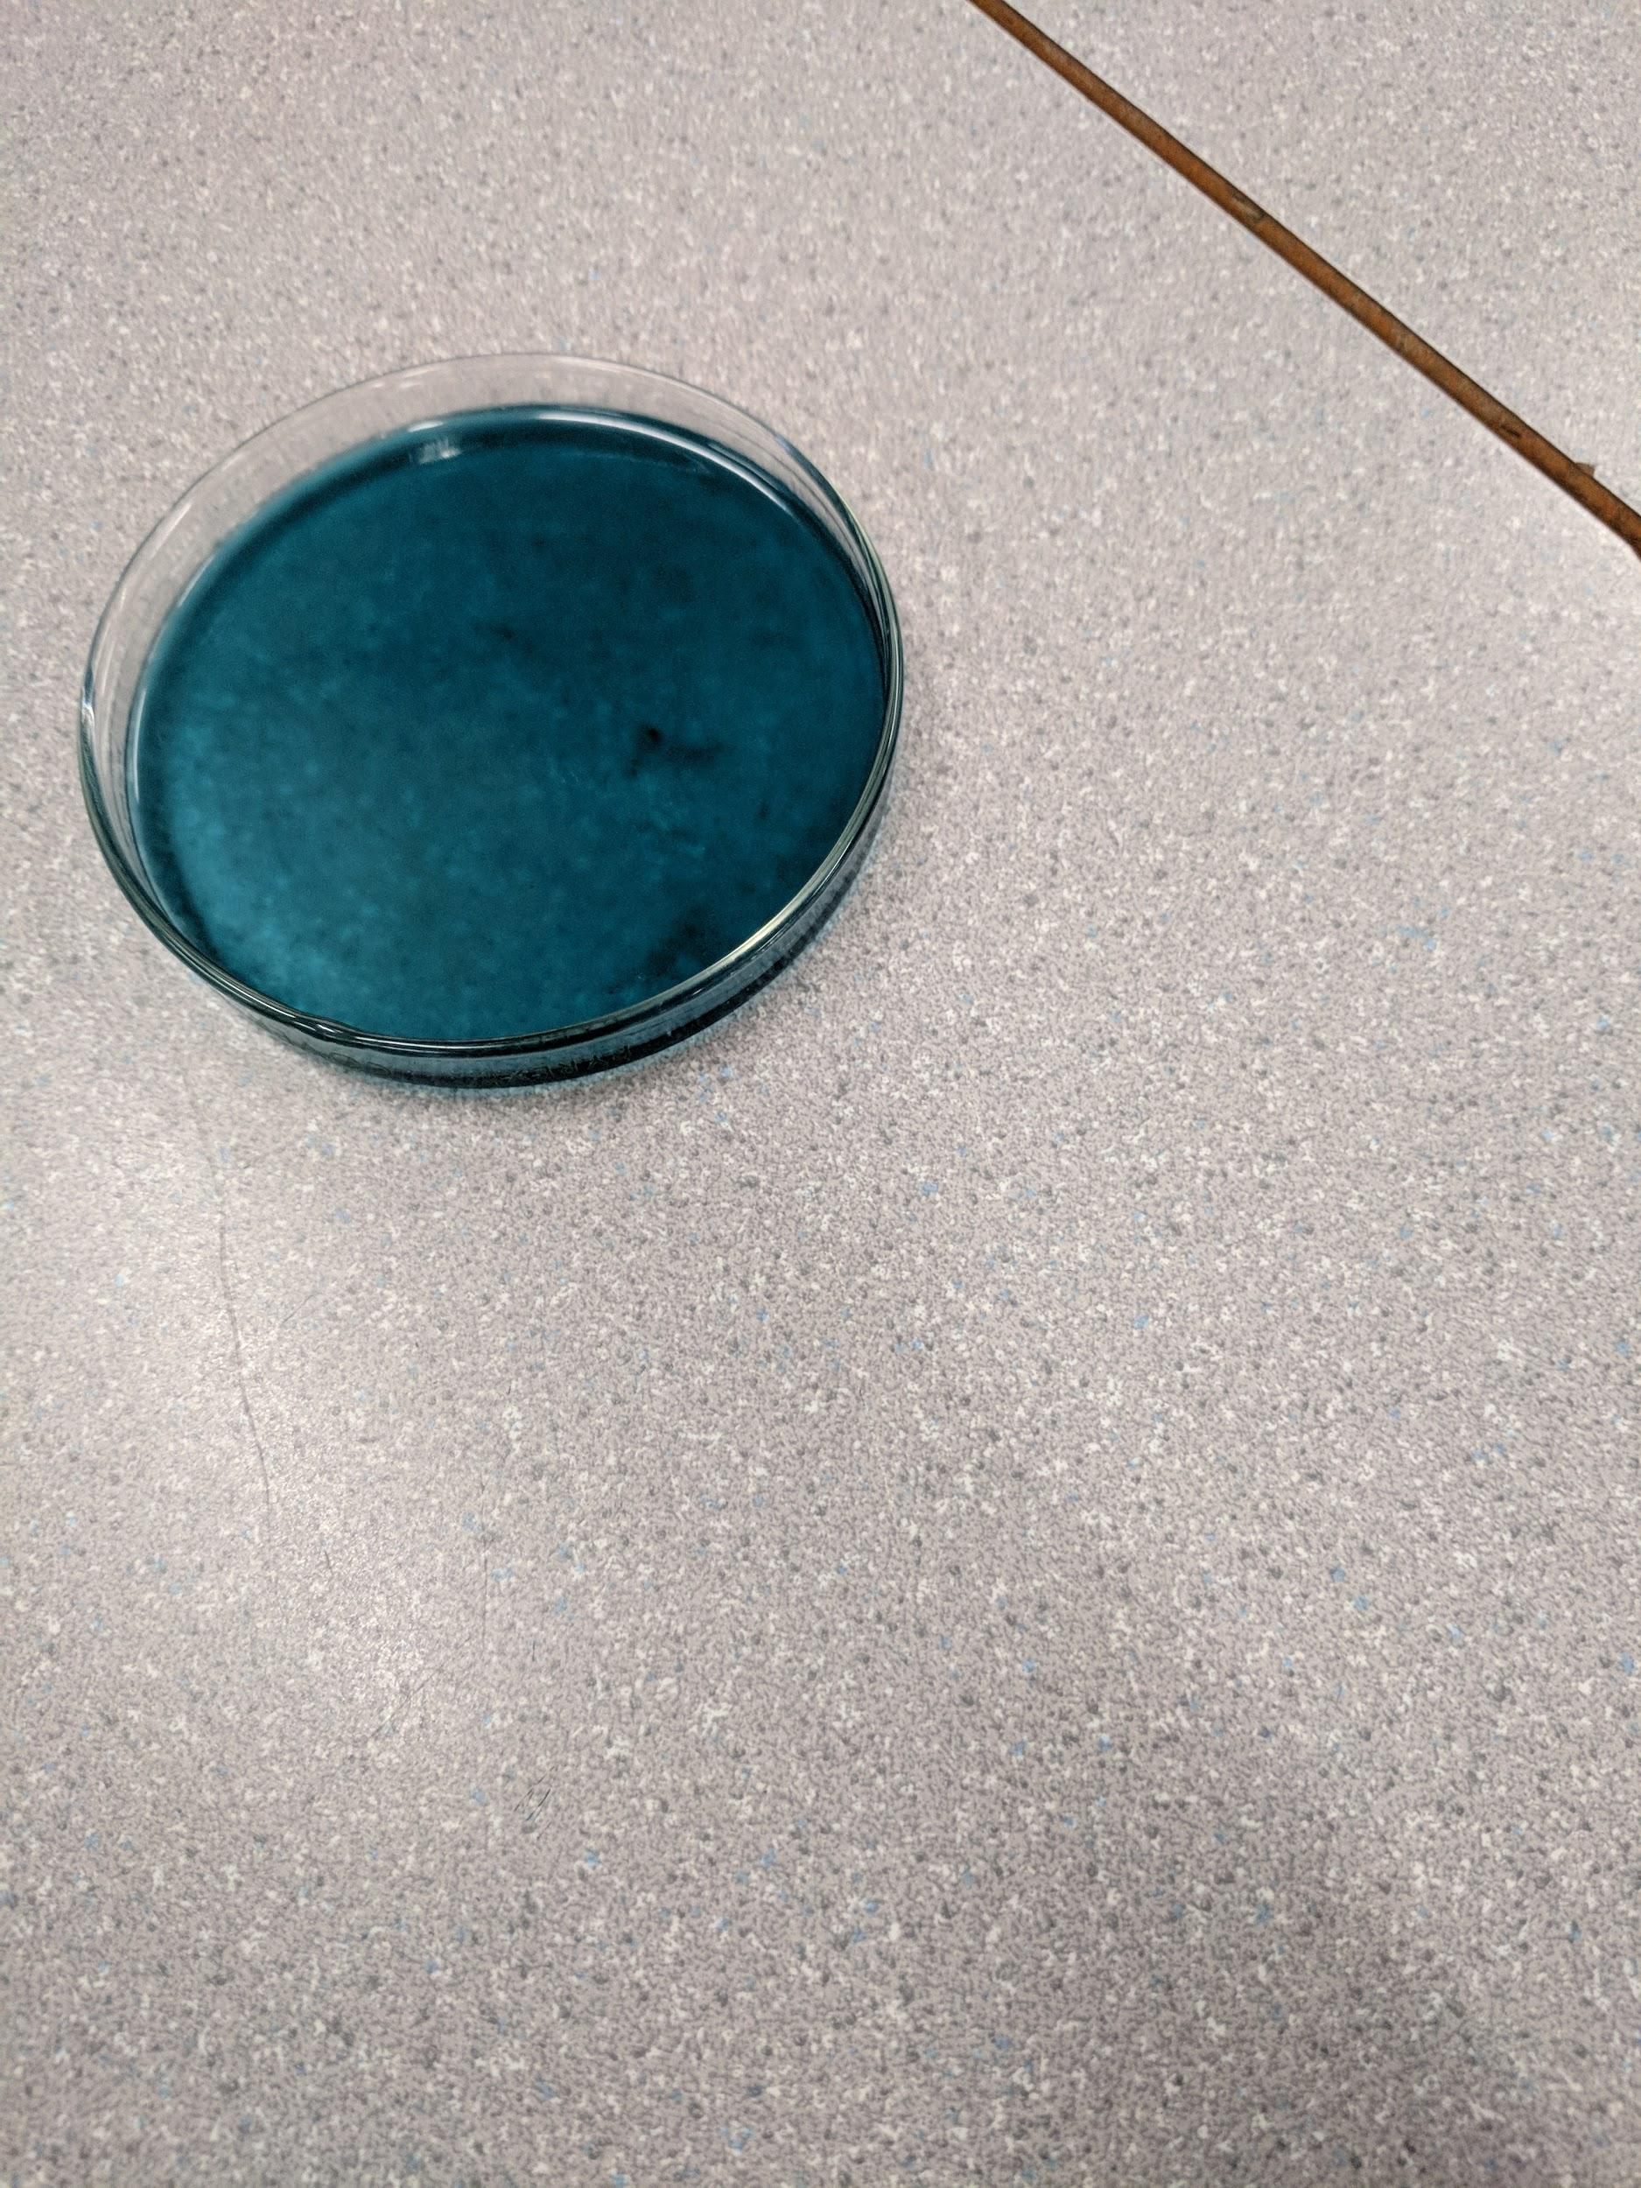 | Smells like fabric softener  Green  In a Petri Dish  Slimy | From a bottle of laundry?  Could be detergent because of smell.  Color is because of dye  The Liquid thickens when you group up all the liquid. | What is it?  What’s its use?  Why is it liquidy?  Why is it this color?
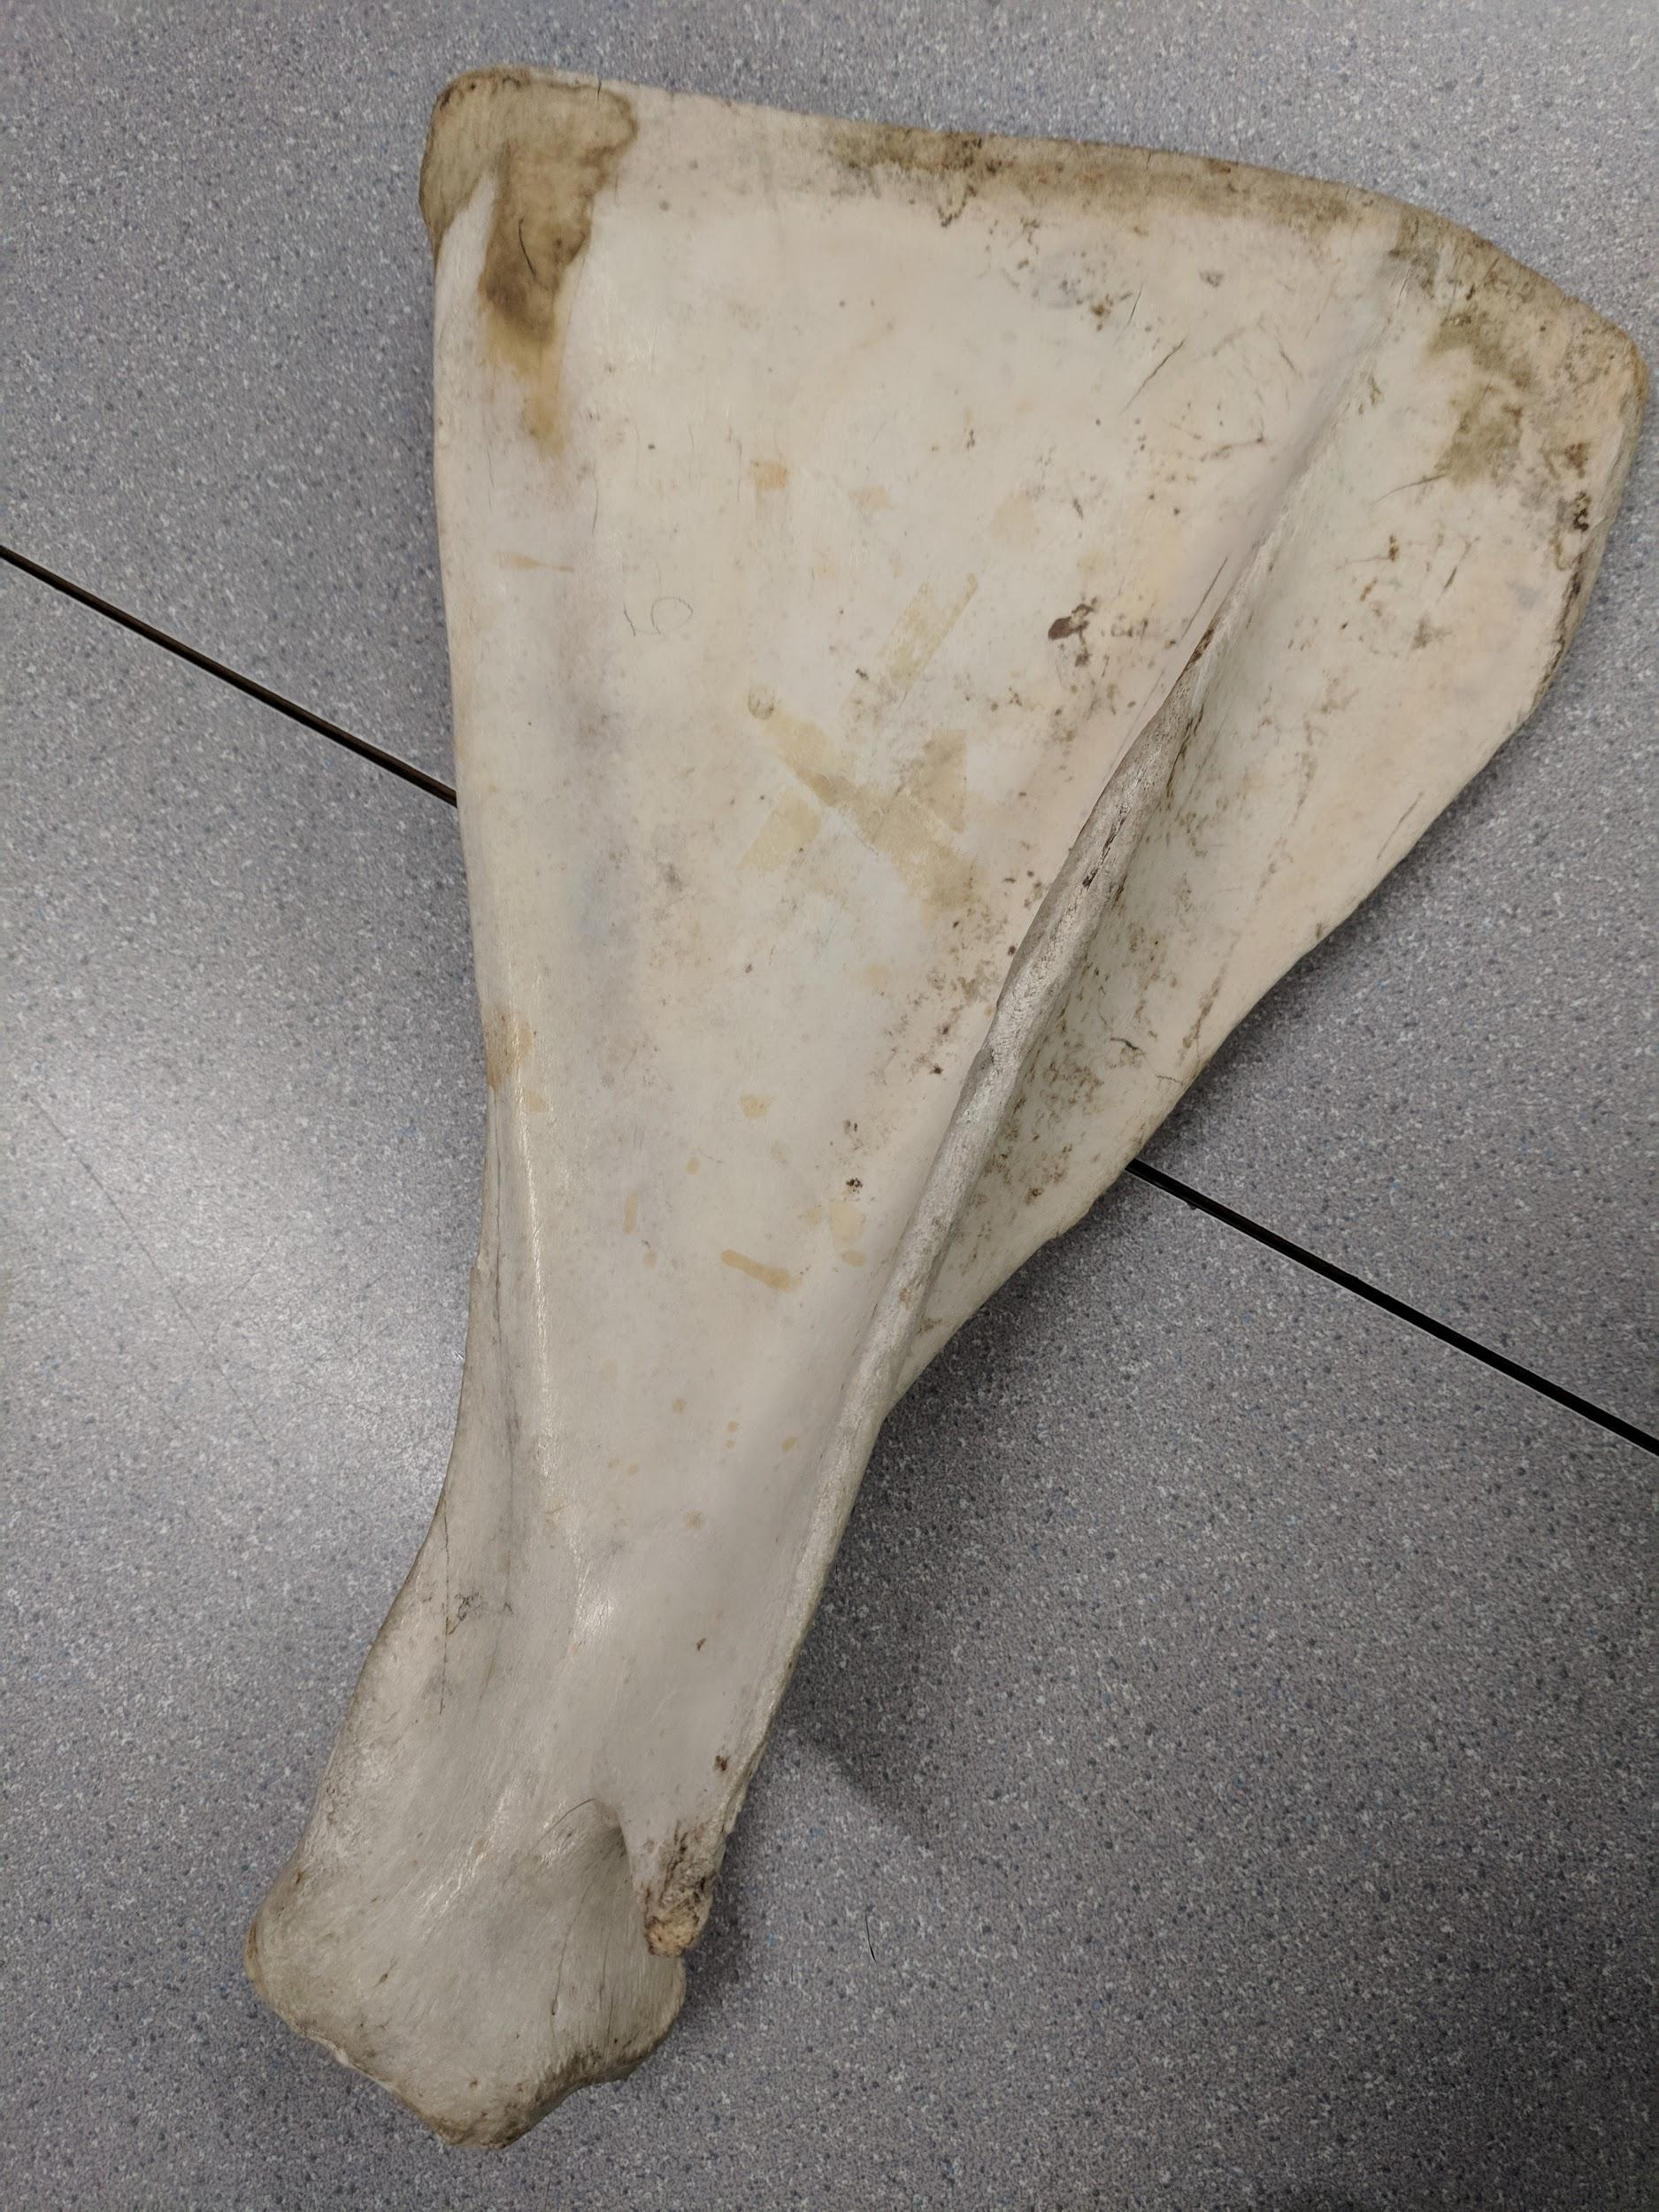 | Sandy Color  Bone  Light  Hard | Could be from a dino  Its a bone from some animal  Could be hollow | How old is it?  What is the bone from?  Why is it shaped like this?  What animal had this bone?
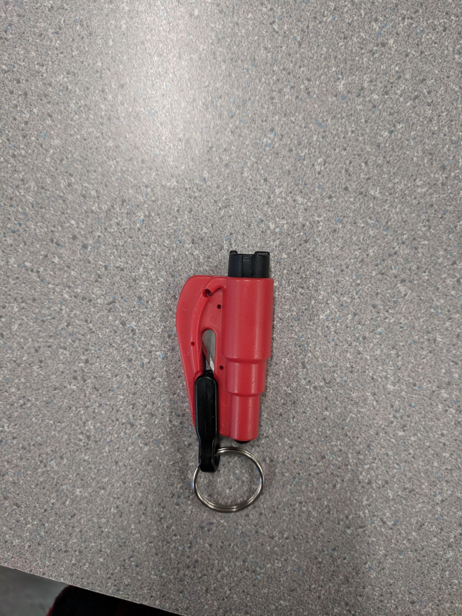 | Red and black  Has a blade  Has a key chain | Came from some store  Multi Tool  Can stab someone  Can be used to break something | Why did they make it?  Who can use it?  What can you cut with it?
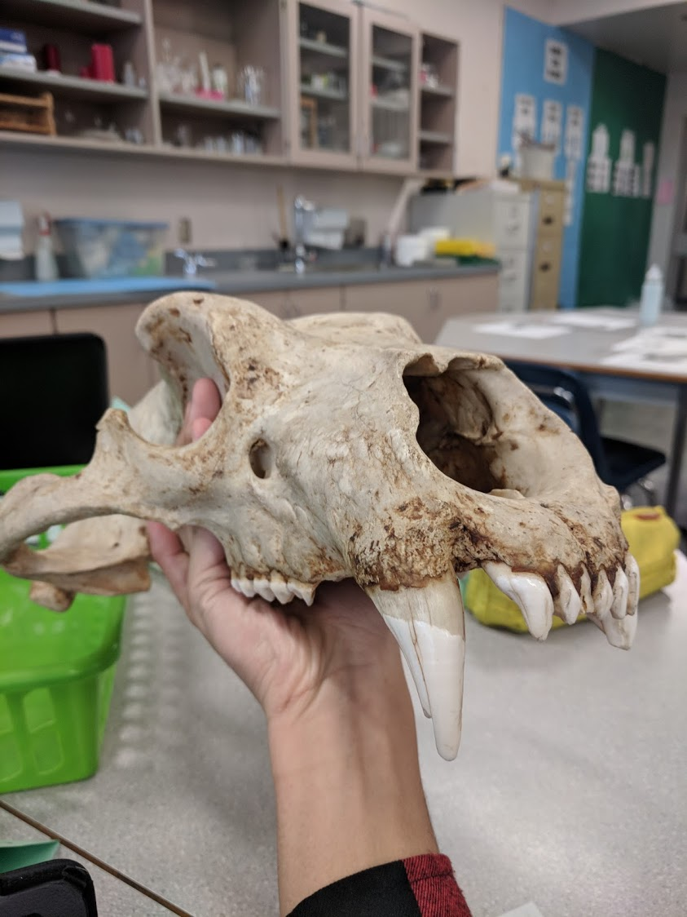 | Sandy Color  Sharp Teeth  lots of holes  Long Skull | Animal Skull  vERY oLD  Very thick  Brain is missing | What animal is this?  Where is it from?  How Old is this Animal?  How did it Die?  Where did it die?

Observations/Inferences Assignment Assessment
Name: _____________________
Ex: Excellent VG: Very Good G: Good S: Satisfactory IN: Improvement is needed
Criteria | IN | S | G | VG | Ex
The following is included
- All 4 Images included
Observations:
- A minimum of 5 detailed observations made
Inferences:
- Thoughtful and logical inferences made
Questions:
- 2 thoughtful and logical questions made
- Spelling/grammar
- Assignment was completed on time
/10

