RNA Transcription
How is mRNA different than DNA?
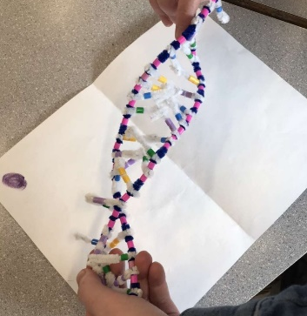
There are quite a few differences between mRNA and DNA. First, DNA is made up of deoxyribose sugar, and mRNA is made up of ribose sugar. Another difference is in DNA, there is a unique pyrimidine base called Thymine. In RNA, the unique base is Uracil (which pairs with Adenine.) For the structure, DNA has a double backbone, whereas RNA has a single backbone. RNA is also shorter than DNA as it has fewer nucleotides.
Describe the process of transcription?
RNA transcription is to make a copy of a gene's DNA sequence.
First: a section of DNA unwinds, exposing one gene.
DNA in double Helix
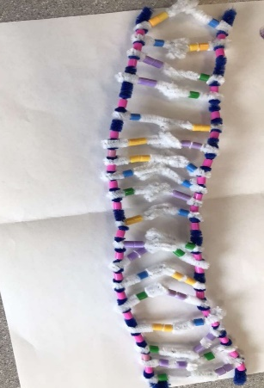
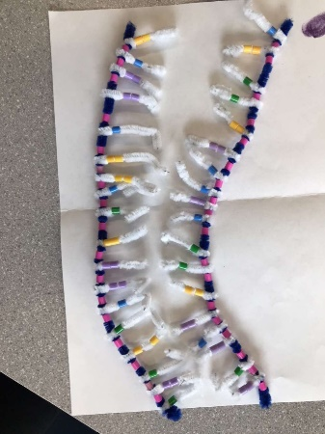

DNA unwound
DNA unzipped
from double helix
form

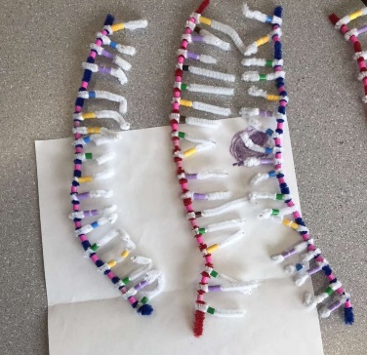

Secondly: the complementary RNA bases create bonds along a strand. Adenine bonds with Uracil (which is only found in RNA.)
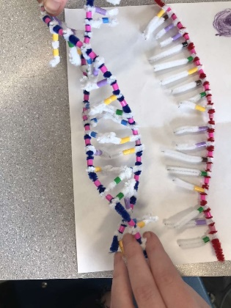
RNA forming from DNA

Third: Neighboring nucleotides form covalent bonds. The RNA backbone is built.
Last: DNA will form, into a double helix shape and RNA is released.
DNA and RNA molecule
How did today's activity do a good job of modelling the process of RNA transcription? In what way is our model inaccurate?
Today's activity demonstrated clearly the process of mRNA transcription. It showed a simple way to understand how the transcription works. It was inaccurate because though because it does not show what happens to RNA after the transcription process. It does not demonstrate parts such as unzipping or how the RNA reattaches to make DNA.

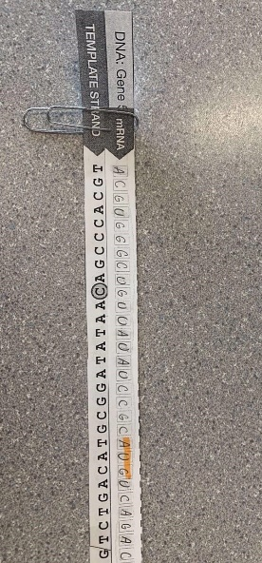
Protein Synthesis Translation
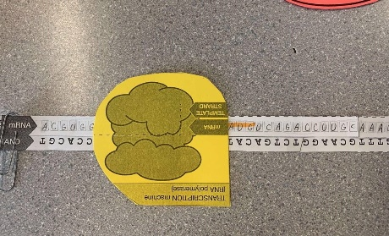
Describe the process of translation: Initiation, Elongation, and termination.

RNA Polymerase
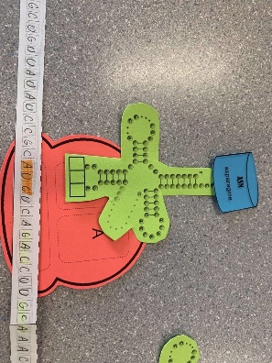
mRNA with transcribed info

Initiation: The ribosome takes hold of the mRNA, getting up to the start codon.
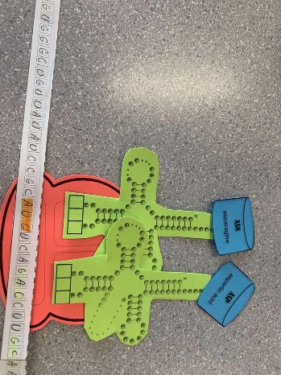
Initiation
Elongation: The ribosome moves along the mRNA molecule and reads the codons that are in the mRNA. tRNA then brings the matching amino acids which ends up creating a polyeptide chain.
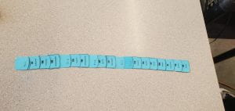
Second tRNA linking

Termination: The ribosome reaches a stop codon, and the protein (polyeptide chain) is released from the tRNA. That terminates protein synthesis (stops reading the mRNA.)
Completed protein
How did today's activity do a good job of modelling the process of translation? In what way is our model inaccurate?
Like previous activities we have done, this activity showed a clear and basic understanding of the translation process. It showed the general big picture on how mRNA and codons work. However, with finer details, this activity was less accurate. It was not as detailed as the lessons and textbooks might be giving us a fuller understanding of translation.

