
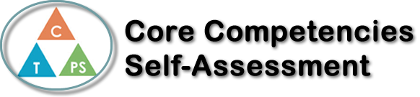
Name: Jane Mackinnon | Date: June 11th, 2020

  How does the artifact you selected demonstrate strengths & growth in the communication competency?  In what ways might you further develop your communication competency? | Self-Reflection  Describe how the artifact you selected shows your strengths & growth in specific core competencies. The prompt questions on the left - or other self-assessment activities you may have done - may guide your reflection process.  The project that I chose to reflect on is my “Cucinare con me” project. I really enjoyed this project because it gave me the opportunity to something that I was interested in and it was something that I was able to choose. I chose to make tortellini from scratch for my project. There were some challenges with this project because tortellini are quite hard to make. My first challenge was rolling the dough out super thin with a rolling pin. It would have been much easier with a real pasta maker. I also didn’t really factor in the amount of time it would take to make, fill, and cook the pasta. If I were to do this assignment again, I would make sure that I account for time that it takes to do the project. I would also make sure that I use more egg wash when I am folding the pasta. Without the egg was it was hard to make them stick together, and I was worried that the filling would fall out of the middle of the pasta. Lastly, I would put more filling into the center of the pasta because when I tried them, they seemed a little too doughy. I think that I grew my creative thinking core competency strength. I improved within this category because I took a recipe that I found online and made it into my own. I improvised a few things in the recipe like the filling, the constituency of the dough. Overall, I was very pleased with the way it turned out. My family thoroughly enjoyed it!


How does the artifact you selected demonstrate strengths & growth in the thinking competencies?

In what ways might you further develop your thinking competencies?


How does the artifact you selected demonstrate strengths & growth in the personal & social competencies?

In what ways might you further develop your personal & social competencies?

Publish Your Self Assessment
You will now attach and/or embed your self-assessment to the bottom of the blog post with the artifact you have chosen. You may choose to make this post private or public. After placing your artifact on a blog post, follow the instructions below.
- Categories - Self-Assessment
- Tags - Now tag your post using the tag that corresponds to the competency that you have written about. You can choose more than one. Please use lower case letters and be exact.
  - #creativethinkingcc
  - #communicationcc
  - #criticalthinkingcc
  - #socialresponsibilitycc
  - #personalidentitycc
  - #personalawarenesscc
- Use the Add Document button located at the top of your post page and embed your self-assessment at the bottom of your blog post.
- Publish

