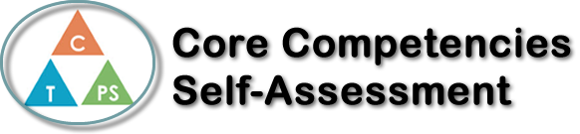
Name: Jaeda Cameron | Date: November 2nd, 2022

   | Collaboration Self-Reflection  - Describe your current collaboration strengths. Use specific examples.  I think that my current collaboration skills are pretty good. When we do our whiteboard questions, I make sure to involve everyone in the solution, and help other people understand as well. At the whiteboards, it’s important to include everyone in the group, so that you and everyone else understands what's going on, rather than just yourself. I would say that my listening skills are also quite good, and listening not only helps you, but it helps the other group members follow what is going on. I think that it’s important to listen to others’ strategies as well, because sometimes they have a better/different way of doing things, which could help others understand further.  I think that my collaboration has improved in coop, because we do a collaboration activity almost every day, and you’re forced to work with others. However, I make the best of the situation by solving problems with the other group members. At the beginning of the year, I wasn’t really open to working with others, since I’d rather figure it out on my own at my desk, but working on problems with classmates all the time, I’ve grown to not hate it as much. At the beginning of the year, I wouldn’t have listened as much to what others were saying or encouraged others as much. I also tended to rush through the questions just so I could go do my work at my desk.  I think that an area for future growth would be to embrace mistakes that could happen while collaborating. It’s not the end of the world and could pretty much always be resolved.




Publish Your Self Assessment
You will now attach and/or embed your self-assessment to the bottom of the blog post with the artifact you have chosen. You may choose to make this post private or public. After placing your artifact on a blog post, follow the instructions below.
- Categories - Self-Assessment
- Tags - Now tag your post using the tag that corresponds to the competency that you have written about. You can choose more than one. Please use lower case letters and be exact.
  - #creativethinkingcc
  - #communicationcc
  - #criticalthinkingcc
  - #socialresponsibilitycc
  - #personalidentitycc
  - #personalawarenesscc
- Use the Add Document button located at the top of your post page and embed your self-assessment at the bottom of your blog post.
- Publish

