
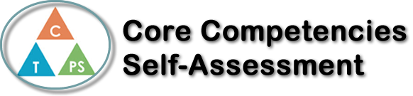
Name: Jaeda Cameron | Date: February 22nd, 2021

  X  How does the artifact you selected demonstrate strengths & growth in the communication competency?  In what ways might you further develop your communication competency? | Self-Reflection  I think that French media plays a role in my learning of French, because it gives you a sense to how they would speak in real life instead of listening to people who are still learning the language. Also, with different types of songs and different types of movies, you can see the different ways people use to say the same things.  When I understand French, like a side conversation in a tv show, I do get a sense of pride, because the people I’m with that don’t speak French will look at me and ask what they said. It also reminds me that the ten years I’ve been learning French have paid off, and can be used in little ways, not just with travel.  I do feel differently when I hear a French song as opposed to a different language that I don’t know, because I get at least the general idea of what they are trying to say, even with the deeper meaning. Also, if it’s a French song that I know, I definitely feel different because I can sing and dance to it.  I think that knowing French impacts my learning because It give you ore opportunities for future learning.

X

How does the artifact you selected demonstrate strengths & growth in the thinking competencies?

In what ways might you further develop your thinking competencies?

X

How does the artifact you selected demonstrate strengths & growth in the personal & social competencies?

In what ways might you further develop your personal & social competencies?

Publish Your Self Assessment
You will now attach and/or embed your self-assessment to the bottom of the blog post with the artifact you have chosen. You may choose to make this post private or public. After placing your artifact on a blog post, follow the instructions below.
- Categories - Self-Assessment
- Tags - Now tag your post using the tag that corresponds to the competency that you have written about. You can choose more than one. Please use lower case letters and be exact.
  - #creativethinkingcc
  - #communicationcc
  - #criticalthinkingcc
  - #socialresponsibilitycc
  - #personalidentitycc
  - #personalawarenesscc
- Use the Add Document button located at the top of your post page and embed your self-assessment at the bottom of your blog post.
- Publish

