Community Connection – Sam Effah

Who I interviewed and their roles and responsibilities:
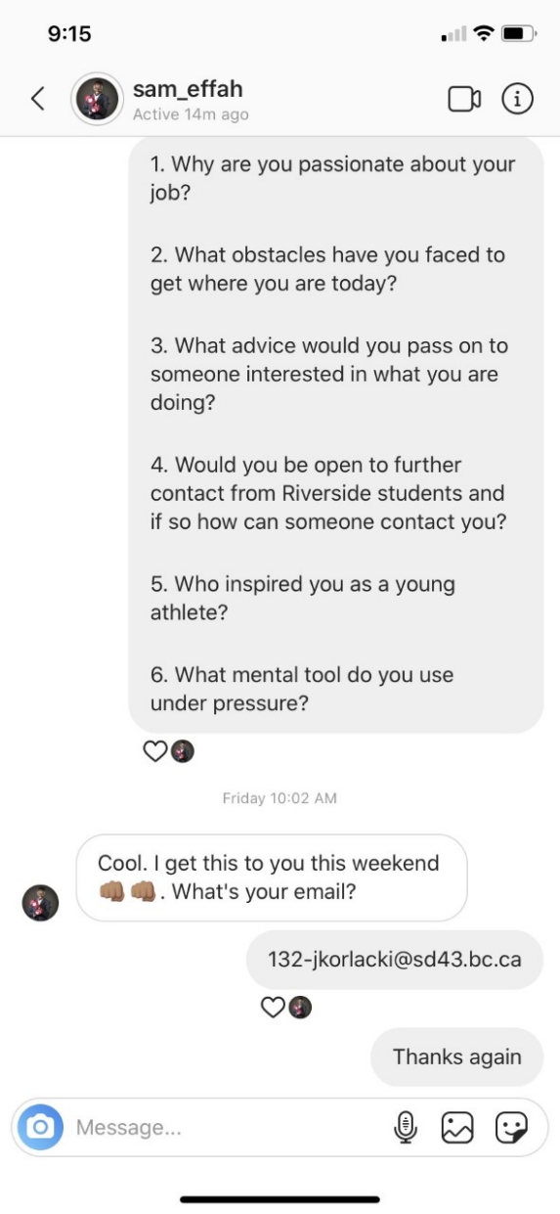
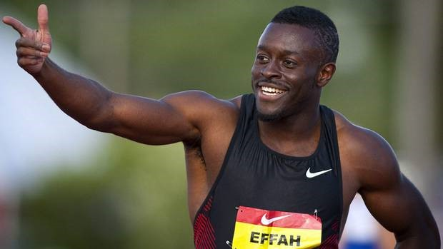
I interviewed one of my favourite athletes and someone who I have learned so much from over the time that I have been watching his career. I chose Sam Effah, he is a Canadian sprinter who has achieved many great results and goals in track and field and inspired many young athletes like myself. One of his biggest achievements in track and field is him being the two time Canadian Champion in the 100m sprint. Sam has represented Canada at three World University Games, at three World Championships, and at the 2018 Commonwealth Games. Sam also had an impressive time in 2010 of just over ten seconds (10.06) in the 100m making him one of the fastest Canadians of all time. He is also an RBC Olympian and speaker as well as a part of the Commonwealth Games Canada Athlete Council. Because of previous injuries Sam has not been able to participate in any Olympic Games, although he is currently training for the 2020 Tokyo Olympics. Apart from being an athlete Sam also has some experience in marketing where at RBC he works in the head office for Brand Marketing. He does an amazing job managing eighteen different Olympic athletes across Canada. Sam also participated in the Amazing Race Canada season seven where he did very well and made it to the final round. Sam is also one of the many speakers for the Classroom Champions program where he inspires many young athletes on various occasions.
Image from Sam Effah

Interview Responses from Sam Effah:
1. Why are you passionate about your job?
I love sprinting because it’s the one sport where you are in charge of your destiny. As an individual athlete, in an individual sport - you are fully responsible for your performance. Each day I'm on the track sprinting, or in the weight room lifting, I know that I am accountable for my performances and I love that. I also like the fact that when I win or do well, I have the opportunity of controlling the narrative of my accomplishments. I do a ton in the community, so I'm motivated to win for them, and tell their stories.

2. What obstacles have you faced to get to where you are today?
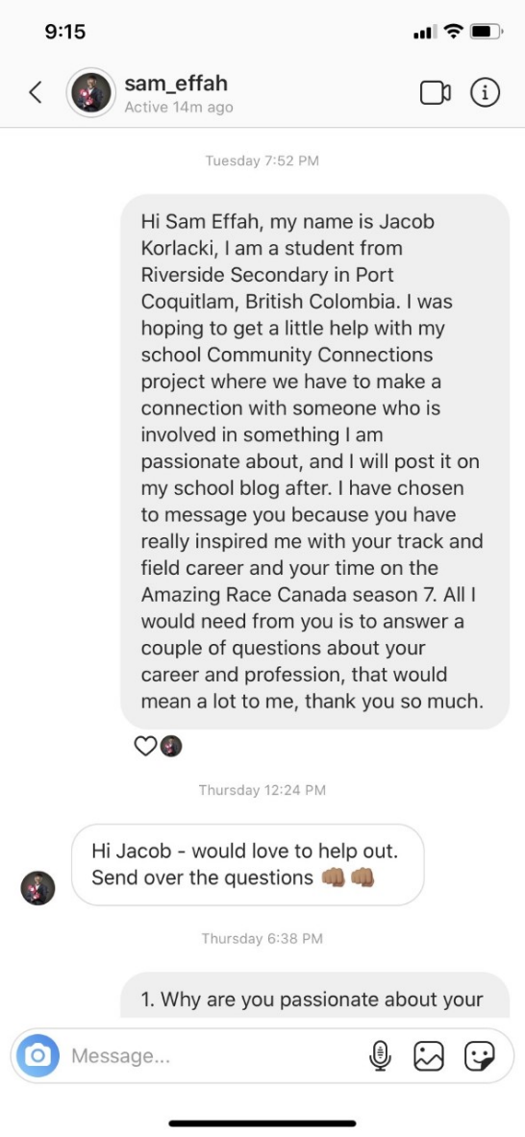
I've been through a lot! Focusing on track obstacles, one major injury that stood out to me was back in 2014. I was diagnosed with 2 major labral tears. It basically felt like I had 2 broken hips, and as a sprinter, this was both devastating and exhausting. I was told that it would be tough to come back and compete on the track, but I never let it get me down. In 2018 I qualified for the Commonwealth Games, in 2019 I competed on the Amazing Race Canada, and now, I am determined to make the 2020 Olympic team.

3. What advice would you pass on to someone interested in what you are doing?
Go for it. Try every event. And remember why you're doing what you're doing. The first step for any goal, is to take the first step!

4. Would you be open to further contact from Riverside students and if so, how can someone contact you?
Of course - tag me/ message me on Instagram or Twitter. I tend to always be active. If you're looking to maybe organize something bigger let your teachers know and maybe we can work something out!
@sam_effah

5. Who inspired you as a young athlete?
As a kid I never really played sports (got into track in grade 12!). But I really enjoyed watching Michael Jordan play basketball. I was always amazed at his athleticism on the court.

6. What mental tool do you use under pressure?
I'm a big believer in positive self talk. Always answer the negative voices or doubts with positive answers. I build confidence by being prepared for every race and situation I'm in. Mental game is so key in sprinting, so its very important to be focused on what you can accomplish as opposed to what if something goes wrong!
Why I chose to interview Sam Effah:
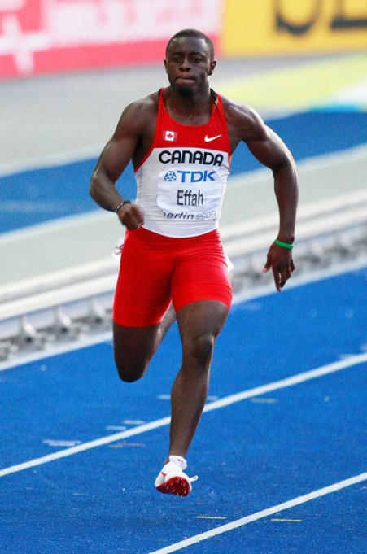
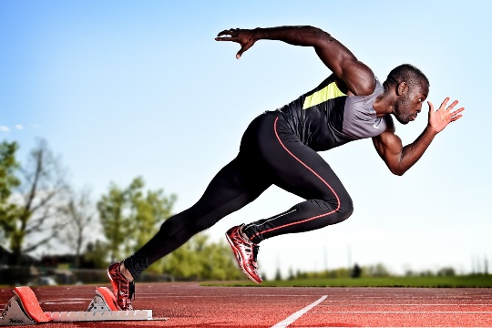
I have been doing track and field for quite some time now at school and I have really enjoyed doing it from the beginning. Ever since I heard about Sam I have been inspired by his story for many reasons. I have heard about his devastating injuries and as serious as they may have been, he never gave up and continued to pursue his dream which really shows a lot about his personality. One important reason to why I chose to interview him is that he has been through a lot and it really inspired me and showed me that if you work hard enough you can get anywhere that you want to be. The main reason I interviewed Sam was because of him being on the Amazing Race Canada season seven, this is where I really learned his story and made a connection with him in a way that was very interesting. I learned so much about his career, his lifestyle and how he got to where he is today. Since the program shows the contestants completing various challenges in the competition everyday, I really learned his personality and what a great athlete he is. I always got excited to watch the new episode of the show every week and see how far Sam could get in the competition, and what he would achieve next. Overall, Sam is just a really inspiring person and I truly enjoyed hearing about his story.
Image from Sam Effah

What I learned from the interview and how it connects to my passions and interests:
There was definitely a lot to learn and take away from this interview, it was a really cool experience to talk to someone who has inspired me for a while now. I think the main thing to take away is that in an athlete’s career there are almost guaranteed setbacks that you just have to learn to get through, that’s just part of the job. If you don’t learn how to persevere and get through tough times then it is going to be very difficult to get far in a sport career. The one thing that I found really surprising and interesting was the fact that Sam only started his track career in grade twelve after trying other sports which he didn’t really find a passion in. This really showed me that it is never actually too late to start at a sport or a new passion, as long as you work hard to reach your goal you can start at any age not only when you are very young. This was also very interesting since I have been doing track and field with school since I was in grade three and I gained much more knowledge about the sport from Sam which was really engaging. As an athlete this was just a really great experience and I learned so much, this will definitely help me in the future with my sports and I am really looking forward to that.

Bibliography:
File:2020 Summer Olympics text logo.svg - Wikimedia Commons
Commons.wikimedia.org
https://commons.wikimedia.org/wiki/File:2020_Summer_Olympics_text_logo.svg

Sam Effah | Canadian Athletes Now Fund
Canadianathletesnow.ca
http://canadianathletesnow.ca/athletes/sam-effah/

Amazing Race Canada: sprinters Sam and Sarah make the final three - Canadian Running Magazine
Canadian Running Magazine
https://runningmagazine.ca/the-scene/amazing-race-canada-sprinters-sam-and-sarah-make-the-final-three/

The Hunger For More Ignites The Soul of RBC Olympian Sam Effah
Team Canada - Official Olympic Team Website
https://olympic.ca/2019/01/16/the-hunger-for-more-ignites-the-soul-of-rbc-olympian-sam-effah/

Sam Effah Personal Website: https://sameffah.com/

