
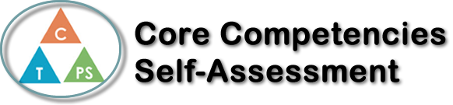
Name: Jack Hinder | Date: Jan 16, 2019

  How does the artifact you selected demonstrate strengths & growth in the communication competency?  In what ways might you further develop your communication competency? | Self-Reflection: (C) I feel I demonstrated that my project up to the best of my ability’s. I feel I went in-depth with it and had a good video and a couple of nice pictures in my project. I feel that my question was strong and purpose full and showed my ability to find great resourceful websites with strong information. I had a lot of growth from this project because in feel its one of my best ones I’ve ever done. I think I could further my communication by asking more questions and going deeper into the question or questions.  (t) I think I had good thinking in my assignment with coming up with a question and asking more questions about my question and digging deep with it I also feel that I had strong thinking with putting all the information I had in my own words and gathering good information with the thinking process of choosing good sources. I was very independent with this assignment with finishing it early and on my own and having extra time to edit the project so there were no mistakes. I know I can father my thinking with the assignment by thinking deeper even though I did dig deep I feel I can put my critical thinking further and dig to the point of there is no more digging.  (PS) I can further my personal and social thinking by being more open with my project by asking for others impute on it and I could have made my question more personal by making my question about something I wonder about, but I chose my question based on what I thought would get a higher mark. Even though I was interested in my project and researching my project and learning about it made me wonder more about it and be more interested in it but If I could do the project again I would do question that id enjoy more and wonder more about and want to go more in depth with it and really wonder about.


How does the artifact you selected demonstrate strengths & growth in the thinking competencies?

In what ways might you further develop your thinking competencies?


How does the artifact you selected demonstrate strengths & growth in the personal & social competencies?

In what ways might you further develop your personal & social competencies?

Publish Your Self Assessment
You will now attach and/or embed your self-assessment to the bottom of the blog post with the artifact you have chosen. You may choose to make this post private or public. After placing your artifact on a blog post, follow the instructions below.
- Categories - Self-Assessment
- Tags - Now tag your post using the tag that corresponds to the competency that you have written about. You can choose more than one. Please use lower case letters and be exact.
  - #creativethinkingcc
  - #communicationcc
  - #criticalthinkingcc
  - #socialresponsibilitycc
  - #personalidentitycc
  - #personalawarenesscc
- Use the Add Document button located at the top of your post page and embed your self-assessment at the bottom of your blog post.
- Publish

