What would happen to the solar system if the sun burned out?

It is said that when the sun dies or “runs out of fuel” all the planets and stars will feel the effects. It is not certain what will happen first whether it’s the temperature changing, the universe expanding or the effect it would have on Earth but what we’re certain about is that it will happen and when it does, we will not be prepared for it.
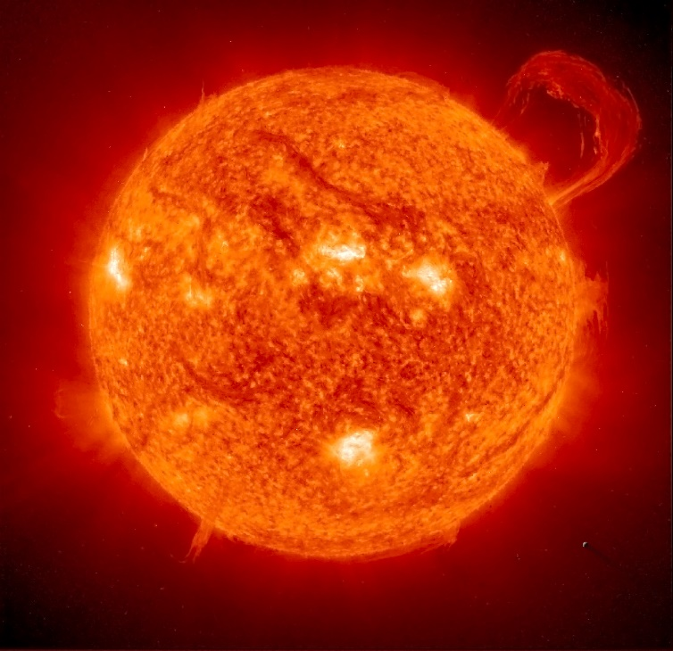
Starting with the Earth, without the sun it would be very chilly. We already know how cold it gets at night, well try having no sun at all. In only just a few days the Earth would be 100 or so degrees below freezing without the sun's radiation. The atmosphere would also freeze sending harsh radiation down to Earth. What would happen to the other planets in our solar system? Well, the same as Earth. Warm planets like Mercury and Venus’ temperature would fall to the ground as they would both be freezing like all the other planets in our solar system and their atmospheres to.
The sun has a very strong gravitational pull. It pulls all the planets, that’s why they don’t leave orbit. If the sun burned out all the planets would be sent into deep space because of the universe’s expansion and each planet would move farther and farther away from each other.
What does the absence of the sun mean for all humanity? Well, like we already know the earth will freeze and even if that and the harsh radiation doesn’t kill all human kind, the sun dying will. When the sun dies it will, NASA says, “destroying Earth and any other rocky planets in its path. In a finale of power, the perishing star will suck in and destroy any nearby asteroids.” So basically, the count down to the extinction of humans started a long time ago.
When is the sun going to die? Well NASA says that in 7.5 billion years the sun will die. Does that mean the end to the Milky way galaxy? Will everything including the stars die? Well it is said that the solar system will outlive our galaxy and by the time the galaxy is dead the sun will yet to be a big red giant.
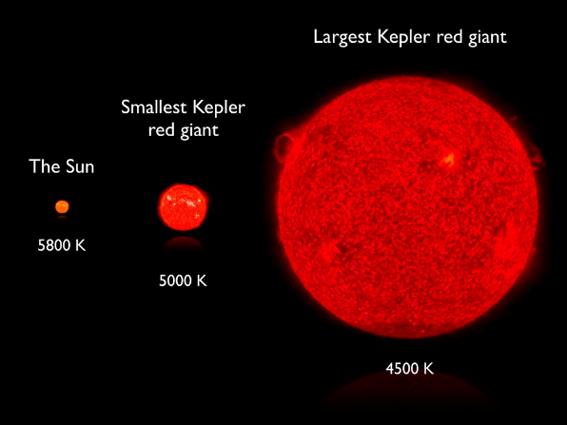
When the sun dies what will happen to all the planets’ moons? Well the moons stay with the planets because of the planets’ gravity so along with the planets when the sun dies it will take out the moons as well.
The sun dying will drastically affect the solar system and life on our planet. We know what will happen when the sun burns out, but how does that take place? What are the phases the sun must go through before it officially dies? Well when the sun expands into a big red giant it will vaporize the solar system along with the planets and moons. But it will not only vaporize them, the big red giant sun will engulf them to leaving almost nothing of the Milky way galaxy left.

Video link: https://www.youtube.com/watch?v=GvBdmIgfntU

(Sources)
(Pictures) https://www.bing.com/images/search?view=detailV2&id=CDDA2E5C3F1D63699B2568C6E2809E615FB91EEE&thid=OIP.PtmLeAM1nE9JUB80YQ-8IAHaHL&mediaurl=http%3A%2F%2Flightsinthedark.files.wordpress.com%2F2009%2F05%2Fearth_and_sun.jpg&exph=2034&expw=2100&q=the+sun&selectedindex=0&ajaxhist=0&vt=0&eim=1,2,6
https://www.bing.com/images/search?view=detailV2&id=B911D2DA6E66B21B3CDE439D2B56F4CE2C0BAD47&thid=OIP.racvVZ36Jut6zickJckyUAHaFj&mediaurl=http%3A%2F%2Fthecommonconstitutionalist.files.wordpress.com%2F2012%2F05%2Fred-giant.jpg&exph=768&expw=1024&q=picture+of+the+sun+as+a+big+red+giant&selectedindex=7&ajaxhist=0&vt=0&eim=1,2,6
(information)
https://www.nasa.gov/
https://www.nationalgeographic.com/science/phenomena/2014/03/24/scientists-predict-our-galaxys-death/
https://www.livescience.com/32879-what-happens-to-earth-when-sun-dies.html
https://mic.com/articles/91431/nasa-and-cambridge-researchers-imagine-what-will-happen-when-our-sun-burns-out#.TCNBfTa7w
https://www.spaceanswers.com/solar-system/what-would-happen-if-the-sun-disappeared/

