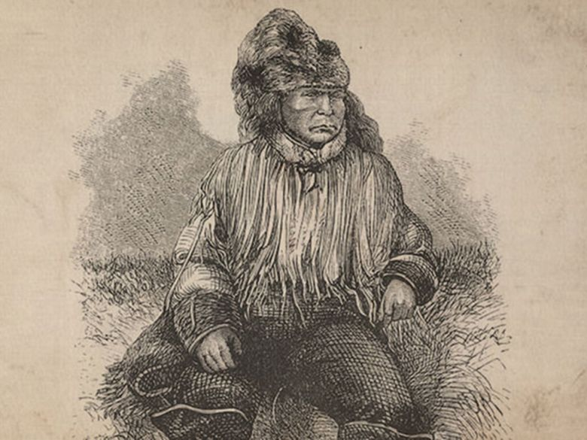
What really happened in the Chilcotin War, the 1864 conflict that just prompted an exoneration from Trudeau?

The Tsilhqot'in had just survived an epidemic on the scale of the Black Death, and had been threatened with a second
Rev. R.C. Lundin-Brownís sketch representing Klatsassin,
the "Head Tsilhqotíin War Chief."
Tristin Hopper
March 27, 2018
10:40 AM EDT
On Monday, prime minister Justin Trudeau offered an official exoneration for six Tsilhqot’in men hanged in 1864 for leading an uprising against colonial authority in British Columbia.
“We recognize that these six chiefs were leaders of a nation, that they acted in accordance with their laws and traditions and that they are well regarded as heroes of their people,” Trudeau said.
The prime minister joins former B.C. premier Christy Clark, who in 2014 offered her own apology for the “wrongful” executions.
Over the decades, the conflict has entered Canadian national myth as a struggle between good and evil: Indigenous warriors defending their land against rapacious colonists. As Clark said in her 2014 apology the executed chiefs were “leaders, and they were engaged in a territorial dispute to defend their lands and their peoples.”
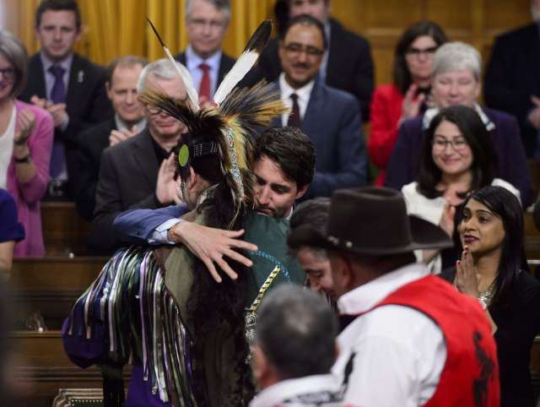
Prime Minister Justin Trudeau hugs a drummer following a performance after delivering a statement of exoneration on behalf of the Government of Canada to the Tsilhqot’in Nation and the descendants of six Tsilhqot’in Chiefs in the House of Commons on Parliament Hill in Ottawa on Monday, March 26, 2018. The Canadian Press/Sean Kilpatrick
But one of B.C.’s darkest events is filled with more nuance than political speeches may let on. The history of the Chilcotin War reveals a drama of conflicting allegiances and a colonial population that may not have been surprised that a Canadian leader would one day be apologizing on their behalf.
“Depend on it, for every acre of land we obtain by improper means we will have to pay for dearly in the end, and every wrong committed upon those poor people will be visited on our heads,” wrote John Robson, editor of the New Westminster Columbian, only days after news arrived of what has since been dubbed the Chilcotin War.
Although 21 men lay dead, Robson was not alone in saying that the bloodshed had been spurred in part by an increasing tendency among B.C. prospectors to ignore the “rights of the Indians and their claims upon us.” Indeed, Robson was reacting to a legal situation that persists to this day, with much of B.C. built atop untreatied land.
In April of 1864, a crew had been building a road through Tsilhqot’in land to get to gold-rich Williams Creek. In a sudden dawn attack, 12 of their number were killed as they lay sleeping in their tents.
The attackers were 24 Tsilhqot’in men. Led by a man named Klatsassin, they were on the brink of starvation and only months removed from a smallpox epidemic that had killed up to half of their 1,500 people. The camp’s few survivors would report that some of the attackers had been singing and merry-making with the road crew only the night before.
Subsequent attacks on a pack train and a lone settler in Tsilhqot’in territory would bring the body count to 21.
The massacres sparked a months-long armed standoff in the B.C. interior. A volunteer army of mainly American newcomers were dispatched from the colonial capital of New Westminster to put down the rebellion in the name of the Crown. Instead, they trekked aimlessly through the interior, camped out in forts and occasionally wounding each other with friendly fire. “It was not one of imperialism’s finest moments,” wrote author John Lutz in the book Makúk: A New History of Aboriginal-White Relations.
The conflict came to an end only when eight of the 24 turned themselves over to colonial authorities, believing that they would be accepted as a peace delegation and brought to negotiate with B.C. Governor Frederick Seymour. Instead, five of the eight were convicted and hanged as murderers, with a sixth executed the next year after he approached B.C. authorities seeking absolution for his role in the massacre.
The Tsilhqot’in never denied that they had killed whites, but maintained that it was an act of war. When the missionary R.C. Lundin would try to point the men towards the commandment “thou shalt not kill,” he was met with the famous reply “we meant war, not murder.” And indeed, in his dispatches Seymour would agree that their actions had constituted an inter-nation conflict. “There was no use any longer shutting my eyes to the fact, this was a war merciless on one side, and in which we were engaged with the greater part of the Chilcotin nations,” he wrote to London.
Attacks on sleeping, unarmed men do not square with modern sensibilities, but this was indeed what war had looked like in B.C. for centuries. Every B.C. First Nation at the time would been on either end of such an attack, often within living memory.
Author John Lutz described a mid-18th century event in which a Tsilhqot’in raiding party had attacked a Carrier village as part of an apparent attempt to seize control of a rich salmon fishery. After killing every villager in sight, they left the mutilated bodies of Carrier children stuck on pikes. A Carrier counter-raid a few years later would do the same to Tsilhqot’in children.
The attack also wasn’t all that different from massacres being perpetrated that very year as part of the American Civil War. Only four months after the start of the Chilcotin War, a Confederate raiding party would execute, maim and scalp 24 unarmed Union soldiers in Missouri. One of those raiders was the future celebrated outlaw Jesse James.
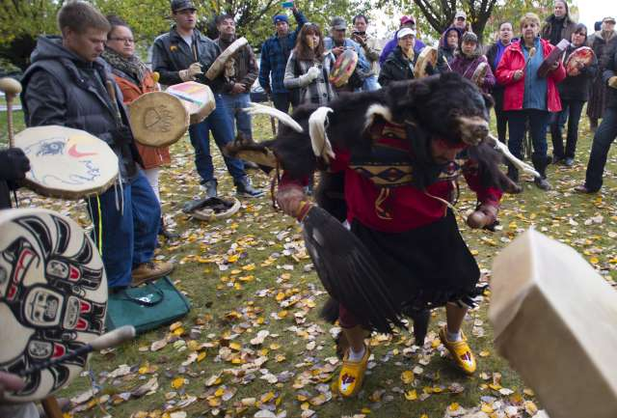
Wearing a traditional black bear dancing outfit Donovan Adolph of Stl’atl’imx Nation dances during a ceremony to commemorate the 150th anniversary of six first nation chiefs being hung to death in Quesnel, B.C.
Sunday, Oct. 26, 2014. The Canadian Press/Jonathan Hayward

It would have surprised nobody at the time that the Tsilhqot’in would be the first to declare war on the British. Famously hostile to outsiders, while they were enthusiastic fur traders they had evicted all Hudson’s Bay Company attempts to set up shop on their lands. This has prompted one frustrated HBC employee to declare that the Tsilhqot’in had an “evil disposition.”
However, the standoffishness played to their advantage. As B.C. became flooded with white settlers in the aftermath of the Fraser Canyon Gold Rush, the relatively isolated Tsilhqot’in were able to dodge the worst consequences of liquor and disease.
Even before the arrival of white settlement, whole villages of coastal peoples had been virtually wiped off the earth by firestorms of smallpox surging in from the east. The Tsilhqot’in had known the stories of coastal settlements populated only by skeletons, but had largely evaded the same fate. That is, until 1862, when smallpox swept in either from Bella Coola or a pair of sick white travellers, sparking an outbreak that killed up to 800 Tsilhqot’in.
The road to Williams Creek was thus being driven through lands that had just been as ravaged by disease as Europe in the depths of the Black Death. In the case of Medieval Europe, mortality rates of this scale had utterly upended society, leading to new religious cults, pogroms and breakdowns in basic social norms. The Tsilhqot’in, already uncomfortable with outsiders, were now coping with the aftermath of an apocalypse that many believed had been wrought by settler magic.
It was in this context that an unidentified member of the road crew almost certainly sealed the fate of his colleagues when he threatened a renewed tide of smallpox upon the Tsilhqot’in. “A white man took all our names down in a book and told us we should all die,” Klatsassin said later under questioning. Other participants in the massacres would similarly report that they believed it was necessary to prevent another existentially threatening tide of smallpox.
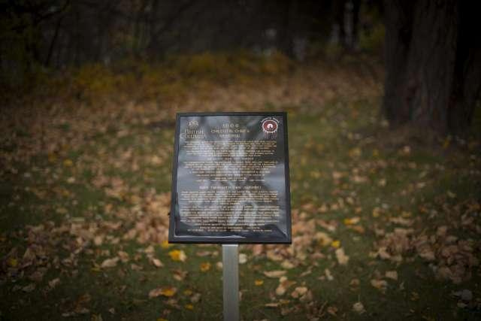
A plaque recognizing five wrongfully hung Tsilhqot’in Chiefs is pictured near the Fraser River in Quesnel, B.C.
Thursday,Oct. 23, 2014. The Canadian Press/Jonathan Hayward

Still, most Tsilhqot’in would have been unaware of the attack on the road crew at the time, and some would even attempt to save the lives of targeted non-Indigenous. This was the case with William Manning, whose Indigenous wife Nancy had reportedly tried in vain to warn him that there were raiders coming to kill him. Another Tsilhqot’in woman, Klymtedza, also tried to warn the targeted pack train, only to be killed herself in the ambush.
Non-Tsilhqot’in Indigenous were also among the first to tend to the survivors of the massacres, and would provide testimony that would lead to the conviction of the six. A Clahoose native identified as “Squinteye” in documents from the era provided one of the most descriptive testimonies of the attacks, and the execution of the six was justified in part with the note that Squinteye’s people had been “nearly annihilated” by Tsilhqot’in.
As the above editorial from John Robson illustrates, settler society was also not of one mind on the incident. Tellingly, the eight Tsilhqot’in encountered no angry mobs or threats of vigilante violence during their transport to Quesnel. They were even paroled without incident as they awaited sentencing.
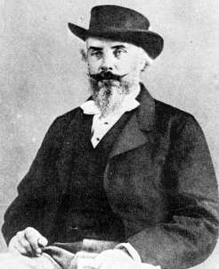
Matthew Baillie Begbie
Judge Matthew Baillie Begbie, the man who sentenced the initial five to die, has shouldered much of the guilt for the Chilcotin War hangings. Nevertheless, Begbie’s notes reveal the thoughts of an intensely conflicted public servant.
The judge was able to speak to the prisoners in their own language. While he referred to them as “savages” in his notes, he expressed deep respect for the group and soon learned of the smallpox threat, not to mention Tsilhqot’in shortchanged for road work and Tsilhqot’in women raped or pressed into prostitution.
“The Indians have I believe been most injudiciously treated if a sound discretion had been exercised towards them I believe this outrage would not have been perpetrated,” he wrote. The judge, as well as newspapers in Victoria and New Westminster, were similarly appalled at how the men had been tricked into arrest under false pretences.
Nevertheless, “the blood of 21 whites calls for retribution,” Begbie wrote in a letter to the colonial governor, adding the postscript that “I do not envy you your task” of deciding whether to grant the men clemency.
To the Tsilhqot’in, the event is as signature to their history as the Red River Rebellion is to Manitoba Metis. The legacy of the execution has also been a major roadblock towards healthy relations with Ottawa. “Reconciliation starts here. Ground zero. Tsilhqot’in. This is where it starts,” Tsilhqot’in Chief Joe Alphonse said Monday.
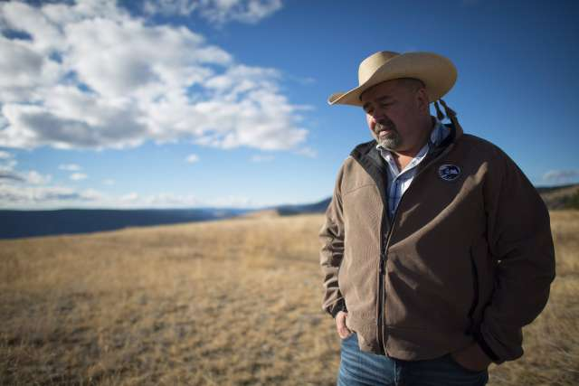
Chief Joe Alphonse, tribal chairman of the Tsilhqot’in Nation. The Canadian Press/Jonathan Hayward

The conflict was also the only significant Indigenous challenge to British colonial authority in what is now British Columbia. It took countless skirmishes with Indigenous peoples to raise the European flags over Atlantic and Central Canada, but west of the Rockies there was really only this one spasm of violence.
As one of the most-studied instances of settler-Indigenous conflict in Canadian history, the Chilcotin War has not been without controversy. On the one extreme, there is a conspiracy theory that the Tsilhqot’in were battling a genocidal British plot to depopulate the colony with germ warfare. On the other are critics who accuse the Tsilhqot’in of whitewashing an event that was little more than an armed holdup. “As many criminals do, (Klatsassin) was smart enough to try to justify his actions with spin,” reads a 2010 column by Kamloops man Mel Rothenburger, a descendant of one of the men killed.
One thing is for sure: The Chilcotin War worked. The road was never built and, to this day, traditional Tsilhqot’in land is almost completely untouched by white settlement. It’s why, in his 1992 book on the Tsilhqot’in, Terry Glavin (also a Postmedia columnist) called their lands the “unconquered country.” In 2014, a Supreme Court decision confirmed as much by granting Tsilhqot’in title to a 1,700 square kilometres patch of land near Williams Lake.
And now, after more than 150 years, the executed Tsilhqot’in have firmly won over the descendant of the Crown authority that had sentenced them to die. On Monday, Trudeau’s exoneration became a rare issue that received full backing from both opposition parties.
Cathy McLeod, the Conservative critic for Indigenous affairs, said Monday that the executed men were merely doing what anyone else would have done in their position.
“Moments such as this cannot change behaviour from another era … we can however recognize a clear lasting and profound impact that past actions have had and scars that have not been healed,” she said.

