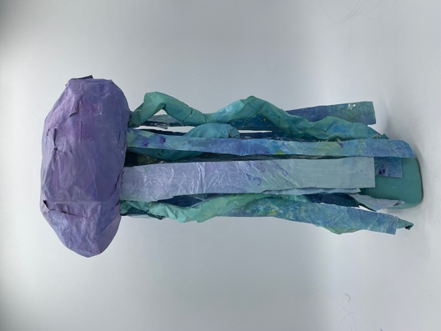

Flow
June 13 2022, Mix Media
Hannah Cheng

Flow is the paper mâché award I gave myself. Its vibrant colour represents all of the wonderful experiences I've had throughout my life, as well as how I always maintain a positive attitude regardless of the challenges I face.
My jellyfish represent my willingness to adapt to changes in life. Jellyfish are adaptable and go with the flow, just like how life changes over time and I will adapt rather than resist changes.
Paper mâché, clay, chopsticks, plastic, wire, tape, tin foil, and acrylic paint are used to create this mixed media piece.

