Name: Hannah | Date: April 20, 2021

How does the artifact you selected demonstrate strengths & growth in the communication competency?  In what ways might you further develop your communication competency? | Self-Reflection  In what areas, if any, do you feel your French has improved this quarter?  The area that I feel like I improved the most this year is definitely my vocabulary, there are much more word I can use without searching up when writing sentences. Also, before I had trouble with the difference of masculine, famine and plural, but now I can conjugate words correctly.  In what areas in French do you want to continue to grow?  I want to work on speaking French more fluently in a conversation and pronouncing words correctly. As I always need to structure what I want to say before speaking.  Choose any aspect of the course that you are the proudest of this semester. Explain why you chose this aspect.  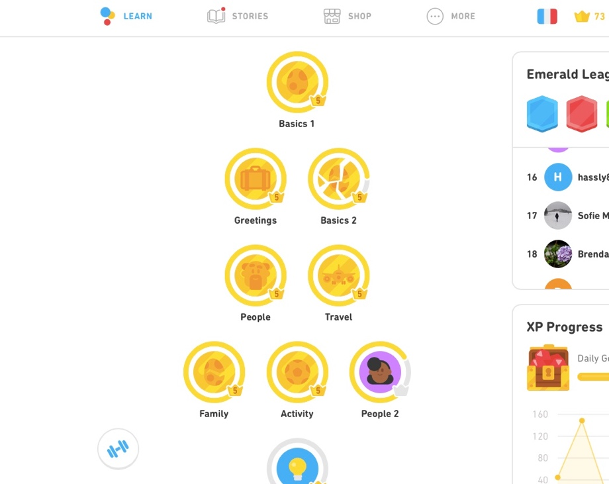  The aspect I am proudest of this semester is Duolingo, I always wanted to maintain a habit which is to go on Duolingo every day to improve my language skills and I finally did it this semester, I hope I would keep this habit even after the course end.

How does the artifact you selected demonstrate strengths & growth in the thinking competencies?

In what ways might you further develop your thinking competencies?
X

How does the artifact you selected demonstrate strengths & growth in the personal & social competencies?

In what ways might you further develop your personal & social competencies?

Publish Your Self Assessment
You will now attach and/or embed your self-assessment to the bottom of the blog post with the artifact you have chosen. You may choose to make this post private or public. After placing your artifact on a blog post, follow the instructions below.
- Categories - Self-Assessment
- Tags - Now tag your post using the tag that corresponds to the competency that you have written about. You can choose more than one. Please use lower case letters and be exact.
  - #creativethinkingcc
  - #communicationcc
  - #criticalthinkingcc
  - #socialresponsibilitycc
  - #personalidentitycc
  - #personalawarenesscc
- Use the Add Document button located at the top of your post page and embed your self-assessment at the bottom of your blog post.
- Publish

