
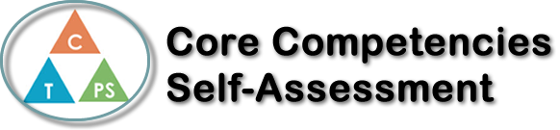
Name: Hannah Cheng | Date: Feb 27^{th,} 2020

  X  How does the artifact you selected demonstrate strengths & growth in the communication competency?  In what ways might you further develop your communication competency? | Self-Reflection  I demonstrated my communication competency in the . In the group conversation, I talked about my ideas and opinion, communicate with my table group. Each of us had a chance to talk about our idea. It is interesting to listen different opinion on different topic. We talked about our thinking on addictive behavior, how to avoid ourselves from it and the solution. In the Culminating project, our group member communicate together to finish my group project and we split our job evenly.  To further develop my communication competency, I could try to discuss more deeply and expand on that topic.


How does the artifact you selected demonstrate strengths & growth in the thinking competencies?

In what ways might you further develop your thinking competencies?


How does the artifact you selected demonstrate strengths & growth in the personal & social competencies?

In what ways might you further develop your personal & social competencies?

Publish Your Self Assessment
You will now attach and/or embed your self-assessment to the bottom of the blog post with the artifact you have chosen. You may choose to make this post private or public. After placing your artifact on a blog post, follow the instructions below.
- Categories - Self-Assessment
- Tags - Now tag your post using the tag that corresponds to the competency that you have written about. You can choose more than one. Please use lower case letters and be exact.
  - #creativethinkingcc
  - #communicationcc
  - #criticalthinkingcc
  - #socialresponsibilitycc
  - #personalidentitycc
  - #personalawarenesscc
- Use the Add Document button located at the top of your post page and embed your self-assessment at the bottom of your blog post.
- Publish

