
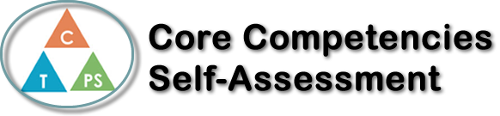
Name: | Date:

  How does the artifact you selected demonstrate strengths & growth in the communication competency?  In what ways might you further develop your communication competency? | Self-Reflection  In this health unit I used the Core Competency communication. I used communication when participating in the group activities and scenarios. By using this core competency, I was able to create a better connection with the topics and the people in my group. I was also able to better understand the topic that we were discussing in the class. Most of the activities involved communication between my classmates and sharing to the rest of the class. If I didn't use the core competency communication, I don't think I would have got as good of an understanding and wouldn't have got as much out of it as I did. I feel as if I have learned more about addictions and ways of preventing those addictions. I not only learned about other people’s addictions, but I also found some addictions that I have and ways that I can minimize and prevent them from getting out of hand. I think communication was a very important part of this unit because the whole point of the lessons were to make personal connections and learn from other people’s personal connections. When making personal connections it is hard not to communicate with people, so I think almost everyone in the class had to use communication at one point in the lesson. Not only did I communicate, but I communicated responsibly and appropriately and at the right times. Because I used this core competency, I helped others and myself to grow in the lessons and discussions.


How does the artifact you selected demonstrate strengths & growth in the thinking competencies?

In what ways might you further develop your thinking competencies?


How does the artifact you selected demonstrate strengths & growth in the personal & social competencies?

In what ways might you further develop your personal & social competencies?

Publish Your Self Assessment
You will now attach and/or embed your self-assessment to the bottom of the blog post with the artifact you have chosen. You may choose to make this post private or public. After placing your artifact on a blog post, follow the instructions below.
- Categories - Self-Assessment
- Tags - Now tag your post using the tag that corresponds to the competency that you have written about. You can choose more than one. Please use lower case letters and be exact.
  - #creativethinkingcc
  - #communicationcc
  - #criticalthinkingcc
  - #socialresponsibilitycc
  - #personalidentitycc
  - #personalawarenesscc
- Use the Add Document button located at the top of your post page and embed your self-assessment at the bottom of your blog post.
- Publish

