
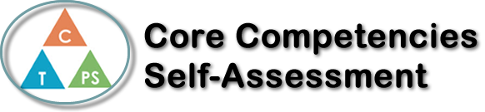
Name: Gideon Seo | Date: January 5th, 2020

  x  How does the artifact you selected demonstrate strengths & growth in the communication competency?  In what ways might you further develop your communication competency? | Self-Reflection  Describe how the artifact you selected shows your strengths & growth in specific core competencies. The prompt questions on the left - or other self-assessment activities you may have done - may guide your reflection process.  This project was called Adanac and it was a game and Adanac is, for your information, Canada inversed. Adanac was where there were 5 groups (colonies) and they all had their own criteria sheet where if they did a certain movement, they would win or lose points and the colony that has the most points at the end wins the whole game. And technically, all the groups were trying to make Adanac by uniting all the colonies together since they were all separated.  I loved this activity that we did since it was a type of debate and by that, we got to improve our French too because we had to talk at conferences about our own ideas.  I chose critical thinking and communication. At the conferences, only the representatives could speak and I was not a representative so I did not get to talk but once in a while, the representatives could go back to their group and discuss/share ideas about the situation at their “home” territory and they were forbidden to talk or even share notes during the conferences. And I gave a couple of ideas to our representatives so they could fight back and I needed to think critically since if the representatives ran out of ideas, I could provide them with well thought reasons to convince the other territories to have the same thought as us so we would also get the point.

x

How does the artifact you selected demonstrate strengths & growth in the thinking competencies?

In what ways might you further develop your thinking competencies?


How does the artifact you selected demonstrate strengths & growth in the personal & social competencies?

In what ways might you further develop your personal & social competencies?

Publish Your Self Assessment
You will now attach and/or embed your self-assessment to the bottom of the blog post with the artifact you have chosen. You may choose to make this post private or public. After placing your artifact on a blog post, follow the instructions below.
- Categories - Self-Assessment
- Tags - Now tag your post using the tag that corresponds to the competency that you have written about. You can choose more than one. Please use lower case letters and be exact.
  - #creativethinkingcc
  - #communicationcc
  - #criticalthinkingcc
  - #socialresponsibilitycc
  - #personalidentitycc
  - #personalawarenesscc
- Use the Add Document button located at the top of your post page and embed your self-assessment at the bottom of your blog post.
- Publish

