
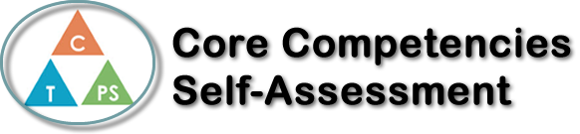
Name: George Plesu | Date: March 4th, 2021

  x  How does the artifact you selected demonstrate strengths & growth in the communication competency?  In what ways might you further develop your communication competency? | Self-Reflection  Describe how the artifact you selected shows your strengths & growth in specific core competencies. The prompt questions on the left - or other self-assessment activities you may have done - may guide your reflection process.  I have chosen the Communication Core Competency to represent this Health Unit reflection because I believe that communicating to others and sharing knowledge is the best way to understand how important maintaining a healthy lifestyle is. Being able to inquire, interpret, and present information is the best way to inform and teach others about importance of making the right decisions to maintain a healthy lifestyle. Another very important factor to this unit was to connect and engage with others. Learning about a healthy physical and emotional lifestyle can be difficult at times but having others to connect and engage with can help you understand the importance of health and decision making. Another reason why communication is such an important aspect of this Health unit is because the best about way to learn about physical and emotional health is from people, not the internet. Having teachers who are very active is very helpful because they can share their knowledge and help students maintain a healthy lifestyle. Overall, I have learned a lot in this unit, and I will be using a lot of the information I learned in my daily life, such as eating healthier.


How does the artifact you selected demonstrate strengths & growth in the thinking competencies?

In what ways might you further develop your thinking competencies?


How does the artifact you selected demonstrate strengths & growth in the personal & social competencies?

In what ways might you further develop your personal & social competencies?

Publish Your Self Assessment
You will now attach and/or embed your self-assessment to the bottom of the blog post with the artifact you have chosen. You may choose to make this post private or public. After placing your artifact on a blog post, follow the instructions below.
- Categories - Self-Assessment
- Tags - Now tag your post using the tag that corresponds to the competency that you have written about. You can choose more than one. Please use lower case letters and be exact.
  - #creativethinkingcc
  - #communicationcc
  - #criticalthinkingcc
  - #socialresponsibilitycc
  - #personalidentitycc
  - #personalawarenesscc
- Use the Add Document button located at the top of your post page and embed your self-assessment at the bottom of your blog post.
- Publish

