
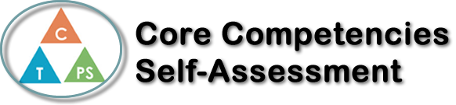
Name: Gaverielle Infante | Date: June 1st, 2023

   | Collaboration Self-Reflection  - Describe your current collaboration strengths. Use specific examples.  - How has your collaboration improved in this course? What are you proud of? Provide specific examples.  - Identify and elaborate on an area for future growth in collaboration.  My collaboration strengths for example, during whiteboard activities I always leave room for others to participate and offer the pen for them to try out the questions, I make sure to ask questions and show all my work so that others will understand and check in. My collaboration has improved in this course because of the whiteboard activities. I am more open and comfortable with asking questions and seeking clarification when I am confused. I am proud of how I was able to overcome not asking for help when I needed it. For future growth in collaboration, I want to work on not relying on others to reach the answer and help out with some questions rather than standing on the side with no participation.




Publish Your Self Assessment
You will now attach and/or embed your self-assessment to the bottom of the blog post with the artifact you have chosen. You may choose to make this post private or public. After placing your artifact on a blog post, follow the instructions below.
- Categories - Self-Assessment
- Tags - Now tag your post using the tag that corresponds to the competency that you have written about. You can choose more than one. Please use lower case letters and be exact.
  - #creativethinkingcc
  - #communicationcc
  - #criticalthinkingcc
  - #socialresponsibilitycc
  - #personalidentitycc
  - #personalawarenesscc
- Use the Add Document button located at the top of your post page and embed your self-assessment at the bottom of your blog post.
- Publish

