
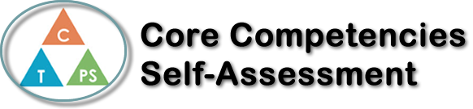
Name: Eva K | Date: June 17, 2020

  How does the artifact you selected demonstrate strengths & growth in the communication competency?  In what ways might you further develop your communication competency? | Calculus 12 Self- Reflection  I believe I grown more within the “Personal Personality and Cultural Identity” and “Critical Thinking” competency. Since the course started, I have developed methods to study, help me focus, or figure out other methods to solve problems with. For example: my highlight of this semester was the ¾ term exam, where my class was given a list of calculus questions before hand, and we had at least 2 months to study, it had no answer key (except checking with a graphing calculator), and I couldn’t ask for help from my teacher. Some questions were simple and easy, and some were slightly harder. When I progress, I tried different methods whenever I get stuck, I tried by researching my question, working on a whiteboard, or take breaks and come back later; and these methods help change my work pace and prevented me from too frustrated. This demonstrates how I analyzed my actions and adjusted them in order to receive the result I wanted - inclining to “critical thinking”.  For the PPCI competency, the concepts and problems I learned how to solve in Calculus will stay with me to use for post-secondary and potentially in my career. But while the worlds’ event took hold, I had to work on my self- regulation while at staying home, such as: staying as active as possible, getting enough sleeping, and adjusting my schedule for how much I spend my time working and taking breaks.


How does the artifact you selected demonstrate strengths & growth in the thinking competencies?

In what ways might you further develop your thinking competencies?


How does the artifact you selected demonstrate strengths & growth in the personal & social competencies?

In what ways might you further develop your personal & social competencies?

