
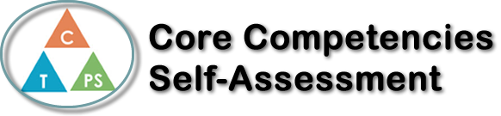
Name: | Date:

  How does the artifact you selected demonstrate strengths & growth in the communication competency?  In what ways might you further develop your communication competency? | Badmin-Pong  The assignment we (my group and I) were tasked was to create a new game, but it had to follow the standards placed for this pandemic – remain at least 1 meter apart and no contact of each other or others equipment; overall, it was a tight window to work with. We continued to weigh our options and choose the best methods for no-contact play, like: using equipment and have gamerules where players don’t need to be close together. We put heads together and aimed to finish all the planning in one day then spend 2 weeks filming.  We first started out basing our game with badminton and ball-pong (trick-shots with cups as the goal), and mix the 2 games together. Everyone kept giving ideas and solutions, even get inspiration from smaller games had a contribute. This project was really well done as we completed the planning in 2 (30 minutes) meetings.


How does the artifact you selected demonstrate strengths & growth in the thinking competencies?

In what ways might you further develop your thinking competencies?


How does the artifact you selected demonstrate strengths & growth in the personal & social competencies?

In what ways might you further develop your personal & social competencies?

Publish Your Self Assessment
You will now attach and/or embed your self-assessment to the bottom of the blog post with the artifact you have chosen. You may choose to make this post private or public. After placing your artifact on a blog post, follow the instructions below.
- Categories - Self-Assessment
- Tags - Now tag your post using the tag that corresponds to the competency that you have written about. You can choose more than one. Please use lower case letters and be exact.
  - #creativethinkingcc
  - #communicationcc
  - #criticalthinkingcc
  - #socialresponsibilitycc
  - #personalidentitycc
  - #personalawarenesscc
- Use the Add Document button located at the top of your post page and embed your self-assessment at the bottom of your blog post.
- Publish

