
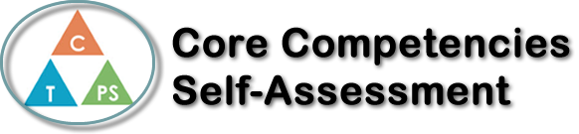
Name: Ethan Sherle | Date: Oct 30,2019

  How does the artifact you selected demonstrate strengths & growth in the communication competency?  In what ways might you further develop your communication competency? | Self-Reflection  Describe how the artifact you selected shows your strengths & growth in specific core competencies. The prompt questions on the left - or other self-assessment activities you may have done - may guide your reflection process.  I think one objective I did well in my synthesis essay is using my understanding of literature devices for my essay. For my three paragraphs I focused on examples of contrast in Identities and Miss Brill. Identities contrasted the rich wealthy neighborhood and the poorer, gloomy neighborhood that the man drives though, and Miss Brill contrast the light park and the dark, compact apartment where Miss Brill lives. I believe I could’ve done a better job of having personal text to world connections in this essay and give nonfiction examples for each of the stories. I think I did a good job with incorporating evidence and quotes from the stories to support my arguments. For Identities and Miss Brill, both of their motivation got them hurt. I talked about how Miss Brill is brought back into reality after thinking she is a part of something when she is in the park and is emotionally hurt, whereas The Man in Identities is killed because he doesn’t think the police officer will shot he because he did nothing wrong but he is killed because he looks like a criminal. I think one competency I developed and used in this essay is the critical thinking competency. I had to think critically for this project so I could relate my theme, thesis, paragraphs etc. To the overall question about the human condition. I think I could have done better tying my thesis and my paragraph to match one another but other than that I think I did a good job on exploring the human condition in this essay.

X

How does the artifact you selected demonstrate strengths & growth in the thinking competencies?

In what ways might you further develop your thinking competencies?


How does the artifact you selected demonstrate strengths & growth in the personal & social competencies?

In what ways might you further develop your personal & social competencies?

Publish Your Self Assessment
You will now attach and/or embed your self-assessment to the bottom of the blog post with the artifact you have chosen. You may choose to make this post private or public. After placing your artifact on a blog post, follow the instructions below.
- Categories - Self-Assessment
- Tags - Now tag your post using the tag that corresponds to the competency that you have written about. You can choose more than one. Please use lower case letters and be exact.
  - #creativethinkingcc
  - #communicationcc
  - #criticalthinkingcc
  - #socialresponsibilitycc
  - #personalidentitycc
  - #personalawarenesscc
- Use the Add Document button located at the top of your post page and embed your self-assessment at the bottom of your blog post.
- Publish

