Introduction
Come "west" - to the land of opportunity and a better life!
Confederation Jul 1, 1867, the Federal Dominion of Canada was formed. At that time, the Dominion of Canada included Ontario, Quebec, New Brunswick and Nova Scotia. Manitoba joined the Dominion on July 15, 1870, and British Columbia joined July 20, 1871. New settlers were needed to populate the western territories, later known as the provinces of Saskatchewan and Alberta, (1905).

Eastern European Immigrants-
Many people fled repressive regimes in Eastern and Southern Europe to become new Canadians. In Austria, in 1848, the emancipation of peasants lead to individual wages and personal choice. The growing number of people, living on small plots of land, made it difficult for families to survive. In Austrian cities, if work could not be found, people began to look to North America. In the 1880's political unrest as well as personal and economic factors caused many ethnic groups like the Ukrainians, Poles, Czechs, Slovaks, and Jews to leave Europe. Canada offered immigrants land, which one day they could own; homesteads were a great enticement. Newcomers were welcomed by the government of Canada and thus began the migration of the Bodnaruk and Fischer families.
Family from England also came for a chance of a better life and new opportunities.
Wilfrid Tovey also came to Canada looking for the opportunity to own his own farm. Conditions in England were much better than in Eastern Europe but still it was difficult to own land.
Margaret Faulkner – also came looking for more opportunities. Most young girls in England worked as domestic servants until they married. Canada needed women also and Margaret saw a chance to try a new career.
The Godfrey family came after WW1. Fred had worked on farms as a young man but after getting married, had a job with the steel mills. A major strike closed down the mills for sometime. Fred decided to go back to farming and as there was still farmland available in Canada so they too came to the land of better opportunities.

Margaret Faulkner and Charles Wilfred Tovey

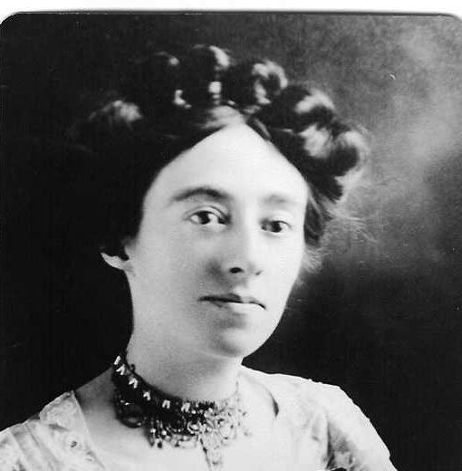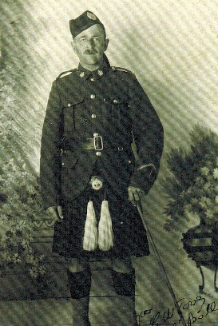
Charles Wilfred (aka Bill) was born in Birmingham, Warwickshire, England, 06 Jul 1886. After completing school, Charles decided to immigrant to Canada. Records state he arrived in 1905. Although unconfirmed it appears he arrived at Halifax on 01 April 1905 on board the vessel the Victorian. He spent some time in MB and then in 1909 filed for a homestead in the Coutts area of Southern AB.

Margaret Faulkner was born in Padworth, Berkshire, England, 01 Nov 1885. Canada was advertising for women to fill many new jobs. Margaret was accepted at MacDonald College in Montreal as kitchen staff. She arrived on board the vessel, Canada, on 07 Mar 1908. Records tell us she returned to England in Dec 1910 but returned to Canada in Jan 1911. Her brother, a farmer, and his family were living in the Coutts area of AB and she went for a visit and to help with the little ones. It was while staying with her brother that she met Charles.
Charles and Margaret were married in Lethbridge 17 Mar 1914. The family lived on the homestead until Charles enlisted with the Canadian Army in Aug 1916. Margaret then lived in Lethbridge for a short time, and then in Red Deer with a friend before moving to Calgary. Charles returned in Jan 1919 and the family, now including daughter Kathleen, moved to a farm in Central AB (Cornwall Valley). The family relocated to Calgary in about 1943.
Margaret passed away suddenly 13 June 1944 in Calgary. Charles passed away also in Calgary 05 Sep 1981. They were laid to rest at Queen’s Park Cemetery in Calgary.

Frederick Godfrey and Ann Maria Tate
(aka Fred and Annie)
Frederick Godfrey was born 29 May 1879 in Beltoft, Bleton, Lincolnshire, England. Fred worked on farms as a youth.
Anne Marie was born 14 Jul 1882 in Flixborough, Lincolnshire, England. As a young lady Annie worked as a dometic servant, also on farms. In the 1901 Census of England Fred Godfrey is woking on the George West farm in the village of Gunness. Also working on the farm is Annie Tate. This is possibly how Fred and Annie met.
Fred and Annie married 27 Jul 1909 in Scunthorpe, Lincolnshire. The familie’s first home was in Crosby, Lincolnshire where John was born. The 1911 Census of England tells us Fred was now working at the steel mills in Scunthorpe. They later moved to nearby Gunness where son Albert was born. Following a strike at the steel mills Fred and Annie decide to move to Canada where they could have their own farm in April 1926 the Godfrey family boarded the S. S. Alaunia bound for Canada and better life for their sons. Land was again being offered for new immigrants. On 23 April they left Liverpool and arrived at Quebec, Quebec, Canada on 03 May 1926. They then travelled across the country by train arriving at their new home in Lousana, AB.
Annie passed away 12 aug 1944 and Fred passed away 03 Nov 1965. They were laid to rest at the Trenville Community Cemetery, not far from where they framed.

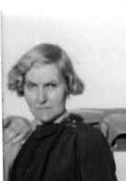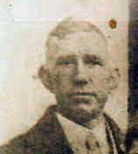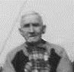

Although lanuage was not an issue for the family coming from England they did leave behind family and friends, and most of their belongings. Annie did bring some of her favourite cooking utensil and her sewing machine on which her granddaughter Margaret learned to sew many years later.
In England most folks lived in small villages so they always had neighbours close by. In AB living on a farm often meant the nearest neighbour was several misle away so I’m sure, especially for the women folks, there was a feeling of lonlenyess and isolation. The Godfrey family were lucky as their nearesst neighbour were only a short distance away.

Traditions:
Roast beef and Yorkshire pudding!!!
Christmas baking – Christmas cakes, Plum Pudding and Mince tarts.
Always an orange in the Chirstmas stockings.

John Henry Godfrey and Kathleen Lillian Tovey
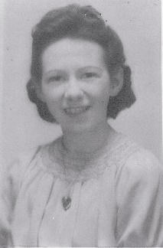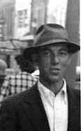
John was born 18 Jan 1912 in Crosby, Lincolnshire, England and received his schooling there. He immigrated with his family to central AB (Lousana) in 1926. John worked on the farm with his father and brother.
Kathleen was born in Red Deer, AB 31 Jan 1917. She and her mother lived in Red Deer and then Calgary until, when she was nearly two years old, her father returned from WW1. The family then took up farming in the Cornwall Valley area of central AB. Kathleen received her elementary schooling in Cornwall Valley and her high school in Elnora , AB. Upon finishing high school, Kathleen worked in Vancouver, BC and Calgary, AB.
Kathleen’s brother Jim was working on a farm, which was very close to the Godfrey farm. Jim got to know John and brought John home. Kathleen was home and a romance began.
Kathleen and John were married 23 July 1942 in Calgary, AB. They returned to the family farm and raised their family of one son and two daughters there. Their daughter Margaret married Pat Bodnaruk.
When their father retired, the brothers took over the farm until 1972 when John and Kathleen moved to the village of Delburne and John’s brother, Albert, moved to Red Deer for employment. .
Kathleen passed away 15 Mar 1994, John passed away 25 Jul 2000. They were laid to rest in the Delburne Cemetery.

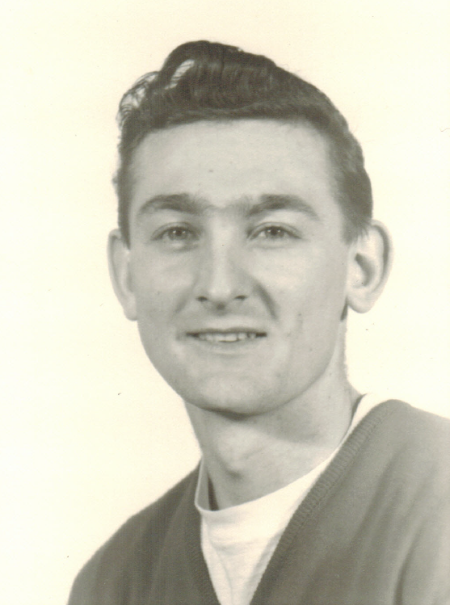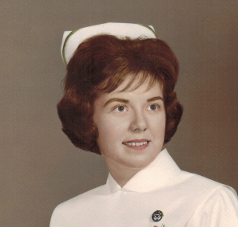

Patrick and Margaret:
Patrick -born in Lethbridge and raised on the farm south of there. After school worked as a sales representative.
Margaret – born and raised in Lousana, AB. After completing grade 12 moved to Lethbridge to train as a Medical Technologist.
We met in Lethbridge but both moved to Calgary for work. In June 1968, we married in Calgary and had two children a daughter, Lori and a son. In 1978, Pat was transferred with his work to Vancouver and we settled in Coquitlam.

Traditions kept
Roast beef and Yorkshire pudding, Christmas cake and mince tarts, an orange in the Christmas stockings.

Lori Bodnark and David Sherle
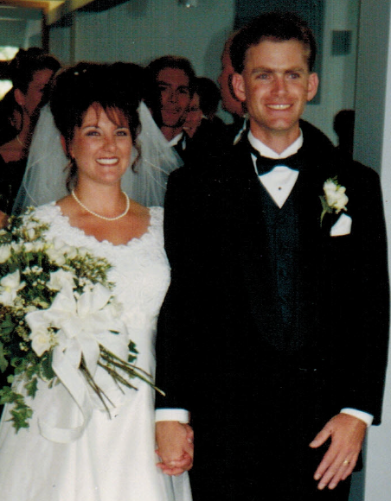

William Bodnaruk and Anna Fischer
William (aka as Wasil/ Bill) was born in Bukovina, Austria on Oct 14 1885.
Anna was born 29 Apr 1884 in Ogradina, Austria (now Romania).
As with the Janosik family, the repressive regimes of Eastern Europe left the peasants with poor wages. Western Canada was opening up and offered “Land” which one day could be owned. Thus, William Bodnaruk and the Fischer family headed to Canada.
Records indicate that William at the age of 19, boarded a ship called the S. S Pallanza at Hamburg, Germany and set sail for Canada. He arrived at Halifax, Nova Scotia and then by rail travelled to Winnipeg MB. After a short stay in Winnipeg, he continued by rail to Lethbridge. He found work in the mines.
Anna Fischer, along with two sisters and a brother-in-law left Antwerp, Belgium onboard the S. S. Montreal and on 06 May 1905 arrived at Montreal, Quebec. From there the group travelled by rail to Lethbridge. Anna’s brother-in- law found work in the mines where William worked and it is probably through the men folk that Anna met William. Anna and William were married 06 Nov 1905 in Lethbridge. William later applied for a homestead and the family moved to the farm. William and Anna had five children. Son John married Katherine Yanosik. After retiring from farming William and Anna returned to Lethbridge. Anna passed away Jan 1968 and Bill in 1973. They were laid to rest at St. Patrick’s Cemetery, Lethbridge.
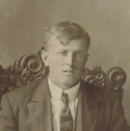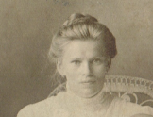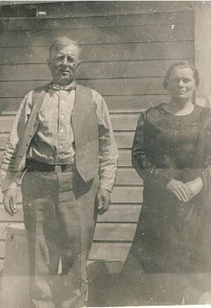
Note: Later Bill’s father George and his ½ brother Nick immigrated to the Lethbridge area, as did two more of Anna’s sisters.

Ferencz- Yanosik (Janosik) Family
Maria (Mary) Ferencz was born 22 Sept. 1878 Also, Slovakia
Joannes Janosik (later anglicised to John Yanosik), was born about 28 Oct 1874 in Felso, Slovakia.
(Felso and Also were villages very close together)
They married on 17 Oct 1898 in Slovakia.
From 1001 AD to 1918, the Hungarian (Magyar) landowners dominated Slovakia and the Slovakian people were considered peasants. Thus, John and Mary, wanting a better life for themselves and family decided to immigrate to Canada. John arrived on 23 May 1899 abroad the ship the Friedrich De Grosse at New York. He then travelled by train to Lethbridge, North West Territories (later Alberta). There he found work in the coalmines and a home. Mary joined him later that year. She and a friend arrived in New York aboard the ship the Kaiser Wilhelm Der Grosse on 05 Sept. 1899 and like her husband travelled by train to Lethbridge. Both John and Mary embarked at Bremen, Germany. Only a few days after arriving in Lethbridge Mary gave birth to a son. The couple had 11 children. Their daughter Katherine would later marry John Bodnaruk. When the Canadian Gov’t opened up homesteads in Saskatchewan the Yanosik family farmed in southwestern Saskatchewan for a few years. In the 1930’s there was a terrible drought in that area, crops were very poor and many folks were forced to leave in order to survive. The Yanosik family moved back to Lethbridge.
John passed away in June 1936, Mary passed away May 1978, just a few months before her 100th. birthday. Both were laid to rest at St. Patrick’s Cemetery, Lethbridge.

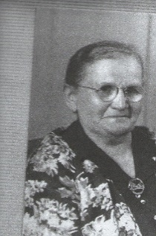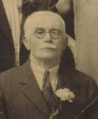
These new Canadians left behind family, friends, and most of their belonging.
Hardships for Eastern European families – different language, work in the mines was difficult and dangerous.
However many other folks from Eastern Europe also immigrated to Lethbridge so they had a group of friends?

Traditions:
William Bodnaruk was of Ukrainian descent so the family celebrated Christmas on Dec 25 and on the Orthodox Christmas on Jan 6. Lucky kids!
Traditions:
Christmas Eve – 12 course meatless meal
Weddings were a 4-5 day celebration.

Foods: Cabbage Rolls, perogies, poppy seed cakes and buns, plum buns, sauerkraut, home made noodles for the homemade chicken noodle soup.

Still have cabbage rolls and perogies.

John Bodnaruk (1909 – 1985) and Katherine Yanosik (1914- 1944)
John and Katherine were both born and raised in the Lethbridge. They were married 23 Feb 1936 in Lethbridge and then returned to John’s farm, south of Lethbridge. They had two sons and one daughter. Sadly, Katherine was killed in a train /automobile accident in 1944. John passed away in 1985. Their son Richard Patrick married Margaret Godfrey.

