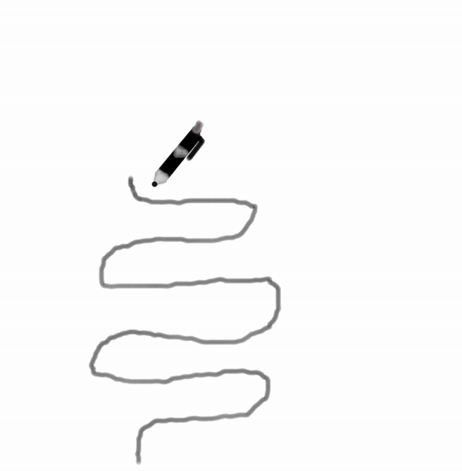
Simile: “glanced a moment over his shoulder at the curved beauty of his ski trail on the hill above, curved and smooth and thin, like the tracing of a pen upon the snow.”
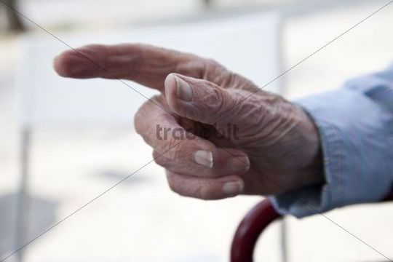
Metaphor: “while he rested there panting, the cold was an old man's fingers feeling craftily through his clothes.”
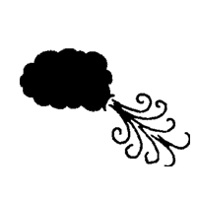
Personification: “the loud wind howling in crescendo by his ears,”
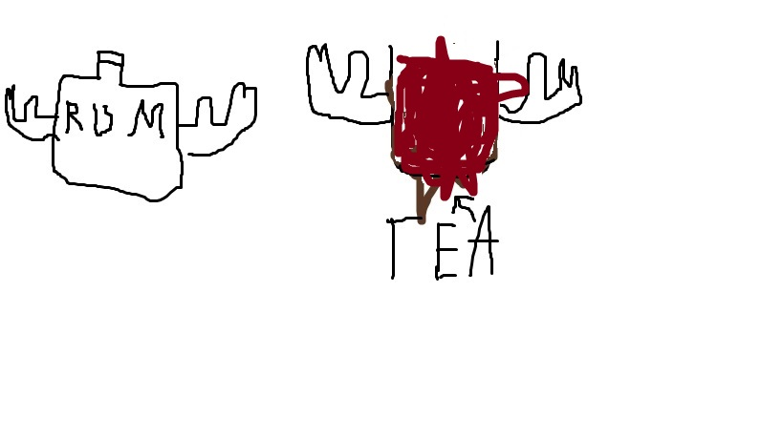
Hyperbole: “tea red and strong as rum.”

