ADL 10 Chemistry app review

For this digital assignment we were told to find an app that we could use for our chemistry unit in science. After we found an app we could write a review about it using solution fluency. The app I found is called chemistry lab and the system I used was android.
Define: We were told find an app to use in our science unit on chemistry, then write a review using solution fluency
Discover:
- How are they going to teach me chemistry
- Does it cost me money
- Will a learn anything new from this app
Dream: If I could get this app to read the text out to me it would really help. If I doing my choir or walking to school and have in ear buds in I could listen to important points on ions while doing other things.
Design: My plan is to go through most of the apps on the google plat store, find one that I like and write a review about it.
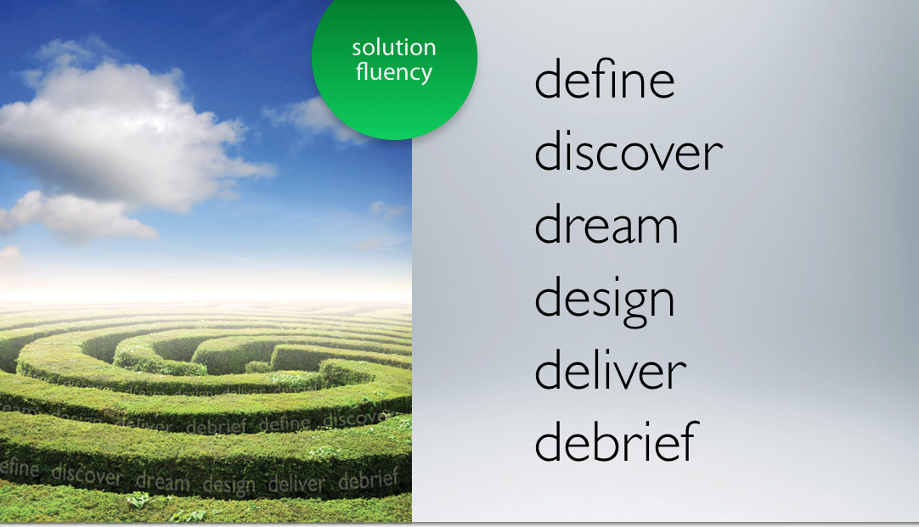
Deliver: The app I chose to write about is called chemistry lab. It has many different feature including periodic tables true or false questions about chemistry and three different sections with different unit in chemistry. The app doesn’t cost any money and pretty highly rated on the google play store. If you go into any of the unit on the app, there will be books and if you click on one of the books it will give you a multi chose test on basic chemistry. In the end I think this app would be really helpful for anyone studying chemistry.
Debrief: One way I could improve my plan is to get a app that is compatible with text to speech.
http://www.bing.com/videos/search?q=solution+fluency+video&qpvt=solution+fluency+video&view=detail&mid=2CAD52D1651477133A942CAD52D1651477133A94&FORM=VRDGAR

