English First Peoples 10
Ms. Graham
Local Legends Project
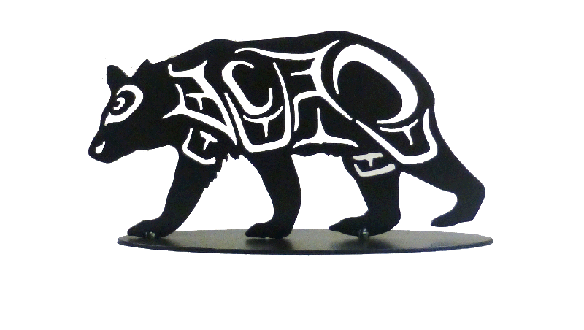
Exploring creation stories and other stories helps us understand ourselves and make connections to others and to the world.
Your religion was written upon tables of stone by the iron finger of your God so that you could not forget. The Red Man could never comprehend nor remember it. Our religion is the traditions of our ancestors-the dreams of our old men, given them in solemn hours of night by the Great Spirit; and the visions of our sachems; and it is written in the hearts of our people.
Chief Stealth (Seattle)
AWOKB: Learning honours our Ancestors, Elders, Knowledge Keepers and Descendants.
Important teachings emerge through stories
- Place is multidimensional. More than the geographical space, it also holds cultural, emotional, and spiritual spaces which cannot be divided into parts.

"Oral tradition is the means by which cultural transmission occurs over generations, other than through written records. Among First Peoples, oral tradition may consist of told stories, songs, and/or other types of wisdom or information, often incorporating dances or various forms of visual representation such as carvings or masks. In addition to expressing spiritual and emotional truths (e.g., via symbol and metaphor), oral tradition provides a record of literal fact (e.g., regarding events and/or situations)." Source: English 10 and 11 First Peoples Curriculum – 2010 – Ministry of Education
Step 1: Choose your story. This can be based on place, Nation, interest in animal characters.
You may choose your story from:
1. “Legends of Vancouver” by Pauline Jackson
2. “Ah Mo: Indian Legends from the Northwest” compiled by Judge Arthur Griffin
3. “Native Legends of the Indian Arm Area” compiled by Ralph Drew
4. Any of the Anne Cameron books I have.
5. Mink stories gifted to me by Ms. Galligos
6. “Kou-Skelowh” We are The People, A Trilogy of the Okanagan Legends
7. Xeel’s The Creator
8. Find your own legend ensuring its authenticity with me first

Step 2: Read your story. Fill out the story planning sheet below with the key elements of the plot, characters, lesson, setting, etc.
Title of Legend: Where is this legend from?
Characters: How will you distinguish each character as you tell the story
Rising Action/Events: How will you memorize the key events.
1.
2.
3.
4.
5.

Setting/Time: what local landmarks can you identify and play apart of the story?

Problem/Conflict:

Teaching/Lesson: How will you reinforce the theme/lesson of the story?
Visual Aids: images you could add to support your telling

Magic or transformation:

Trickster Figure:

Step 3: Storytelling
- Memorize the opening and closing of the story, important key phrases, refrains, dialogue, conversations, morals, etc.
- Incorporate different voices to represent changes in the action or different characters..
- Record you telling the story-do you need to add changes in tone, volume level?
Step 4: Tell Your Story
- You will present your story in front of the class: you should have a visual presentation to support to support (map, images of geographical landmarks, pictures)
- Can be PPT, Sway, Lego Stop Motion, recorded video, be creative!
- You can record your story and play it out loud.
- Presentations will be in class.
Step 5: Blog Post
- You write a blog post, summarizing your legend and also discussing why oral storytelling is still important in all cultures.
- You will add your digital presentation to the post with a short introduction to the project
- Tag: efp10local legends
- Category: English First Peoples 10

Resources:
https://www.ictinc.ca/blog/11-things-you-should-know-about-aboriginal-oral-traditions
http://indigenousfoundations.arts.ubc.ca/oral_traditions/
http://www.learnalberta.ca/content/ssbi/pdf/aboriginalperspectivestheoraltradition_bi.pdf

Local Legends Project
English First Peoples 10
Ms. Tate

Category | 4 | 3 | 3 | 1
Comprehension of Story | Demonstrates outstanding comprehension of legend, and recognizes the influence of land/place in First Peoples oral texts. | Demonstrates a good comprehension of legend, and shows some understanding of the influence of land/place in First Peoples oral texts.  . | Demonstrates some comprehension of legend, but may miss the influence of land/place in First Peoples oral texts | Demonstrates a basic or lacking understanding of legend, but misses the connection to land/place.
Storytelling | Speaks clearly and concisely shares their story with clear intonation, enunciation, volume, pacing, expression and diction.  Visuals accompanying story reflect a strong understanding of the influence of land/place in First Peoples oral text. | Speaks clearly and concisely shares their story with clear intonation, enunciation, volume, pacing, expression and diction.  Visuals accompanying story reflect a growing understanding of the influence of land/place in First Peoples oral text. | Speaks shares their story, but may lack intonation, enunciation, volume, pacing, expression and diction.  Visuals accompanying story reflect a minimal understanding of the influence of land/place in First Peoples oral text. | Does not speak clearly and many words are not understood.  No visuals  Not rehearsed.
Blog Post | Uploaded correctly to blog with all components properly and effectively completed (title, tag, category, well-written description, art piece visual, and sources)  No errors in English fundamentals (capitalization, spelling, etc) | Uploaded correctly to blog with all components included (title, tag, category, well-written description, art piece visual, and sources)  Few if any errors in English Fundamentals | Uploaded correctly to blog with some components being limited (title, tag, category, well-written description, art piece visual, and sources)  May have 3+ more errors w | Missing components (title, tag, category, well-written description, art piece visual, and sources)  Errors in English distract from meaning.

