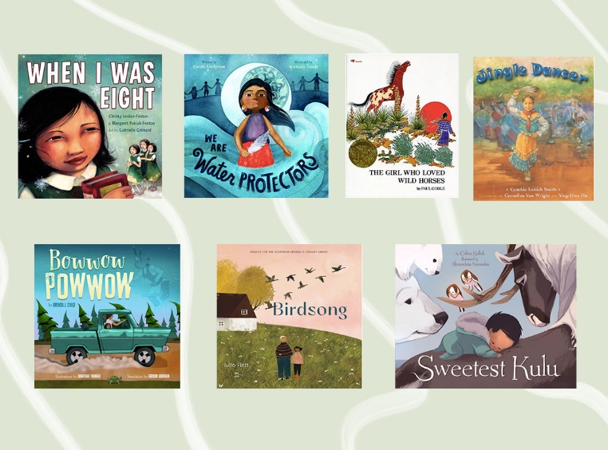
Children’s Book Gallery Walk
A. Statement of Beliefs and Values about Children
While First Nations people, Métis and Inuit have distinct cultures and languages, they also share common beliefs, values and histories. It is with this in mind that the Statement of Beliefs and Values about Children was written.
We believe...
- That children are a gift from the Creator.
- That our children have a right to live proudly as Aboriginal people in the lands of their ancestors.
- That children have a right to learn their respective Aboriginal language(s) and histories, and adults have a responsibility to pass on the instructions that the
- Creator gave in the beginning of time as are reflected in our languages, cultural beliefs and cultural practices.
- That each child is part of what makes a community whole.
- That it is essential for children to develop meaningful relationships with Elders, the carriers of knowledge and history.
- That children, under the guidance of Elders, will learn to love learning throughout their life.
- That adults are community role models who are to teach children how to live a good life.
- That children deserve opportunities to gain knowledge and experience of how to live a good life.
- That children acquire knowledge by watching, listening and doing, and adults are responsible for encouraging and guiding them in all those activities.
- That children, through being loved, valued and encouraged, will gain the courage, the strength and the wisdom to use the power of a good mind and spirit in all that they do.
- That children have a right to enjoy the opportunities that education offers.
- That children have a right to live in healthy, self-determining communities that are free of violence.

In groups of four, choose the following roles:
- Reader (reads the book out loud),
- discussion manager (facilitates the discussion and poses questions),
- recorder (writes down the answers on the worksheet)
- reporter (reports out to the other groups at the end)
EACH STUDENT IS REQUIRED TO PARTICIPATE IN DISCUSSION DESPITE THE ROLE
- Read and discuss each of the books in the stations. You have 15 minutes to do this
  - To discuss:
    - What is the topic of the story?
    - What is the theme or the story?
    - What themes correspond to the beliefs/values that you see to the right?
    - How do the visuals enhance the storyline?
- In your final station, have the recorder fill in the Discussion Questions graphic organizer with ALL students’ ideas.
- The reporter is to present the story and the answers to the rest of the class, asking for input to improve their worksheet.
- Exit slip: what did you learn about exploring children’s literature?

