Name: ______________________

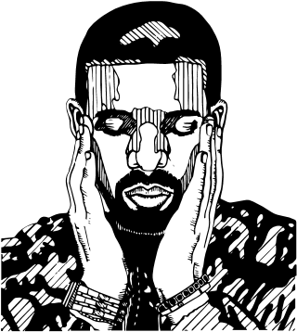
Similes & Metaphors
1) Diagnostic: What do you already know?
Categorize each of the sentences below as either a simile (s) or metaphor (m). Leave the ‘correction column’ blank for now. Have a go, even if you are unsure.
LYRICS | Diagnostic  Simile or  metaphor? | Correction  After copying rule
1. “Love is an open door” (Frozen).
2. “I came in like a wrecking ball” (Miley Cyrus).
3. “We push and pull like a magnet do” (Ed Sheeran).
4. “Just gonna stand there and watch me burn. But that's alright, because I like the way it hurts” (Rihanna).
5. “Shake it like a polaroid picture” (Outkast).
6. “I’m the glue” (Travis Scott).

2a) Key Terms: Definitions
Fill in the gaps to complete the definitions. Next, provide two examples of each technique.
WORDS: | different | like | NOT | words |  | comparison | as | things
SIMILE |  |  |  |  | METAPHOR
A _____________ of two different _______ that uses the words “____” or “__”. |  |  |  |  | A comparison of two _________ things that DOES ____ use the _______ “like or “as”.
“He eats like a pig” |  |  |  |  | “She is a snake”
Your Examples: |  |  |  |  | Your Examples:
1.  2. |  |  |  |  | 1.  2.
Finished? Use the definitions above to correct your diagnostic task.
3a) Identify: Similes & Metaphors
Simile | Metaphor
Shade Yellow | Shade Blue
Circle the words being compared and then highlight the text to indicate whether they are similes or metaphors.
Example: “You could make out his eyes, glinting like black beetles under all that hair“
(Harry Potter and the Philosophers Stone by JK Rowling)
Text Extract | Simile or Metaphor?
1. “You ain’t nothing but a hound dog, cryin’ all the time” (Hound Dog by Elvis Presley).
2. “I float like a butterfly, sting like a bee” (Muhammad Ali, 1974).
3. "The sun was a toddler insistently refusing to go to bed: It was past eight thirty and still light” (Fault in Our Stars by John Green).
4. “The other was fair as can be, with great masses of golden hair and eyes like pale sapphires.” (Dracula by Bram Stoker).
5. “All the world’s a stage, and all the men and women merely players.” (As You Like It by William Shakespeare).
6. “The parents looked upon Matilda in particular as nothing more than a scab. A scab is something you have to put up with until the time comes when you can pick it off and flick it away.” (Matilda by Roald Dahl)
7. “Time has not stood still. It has washed over me, washed me away, as if I’m nothing more than a woman of sand, left by a careless child too near the water.” (The Handmaid’s Tale by Margaret Atwood).
Finished? Which is your favourite example from the list above and why?

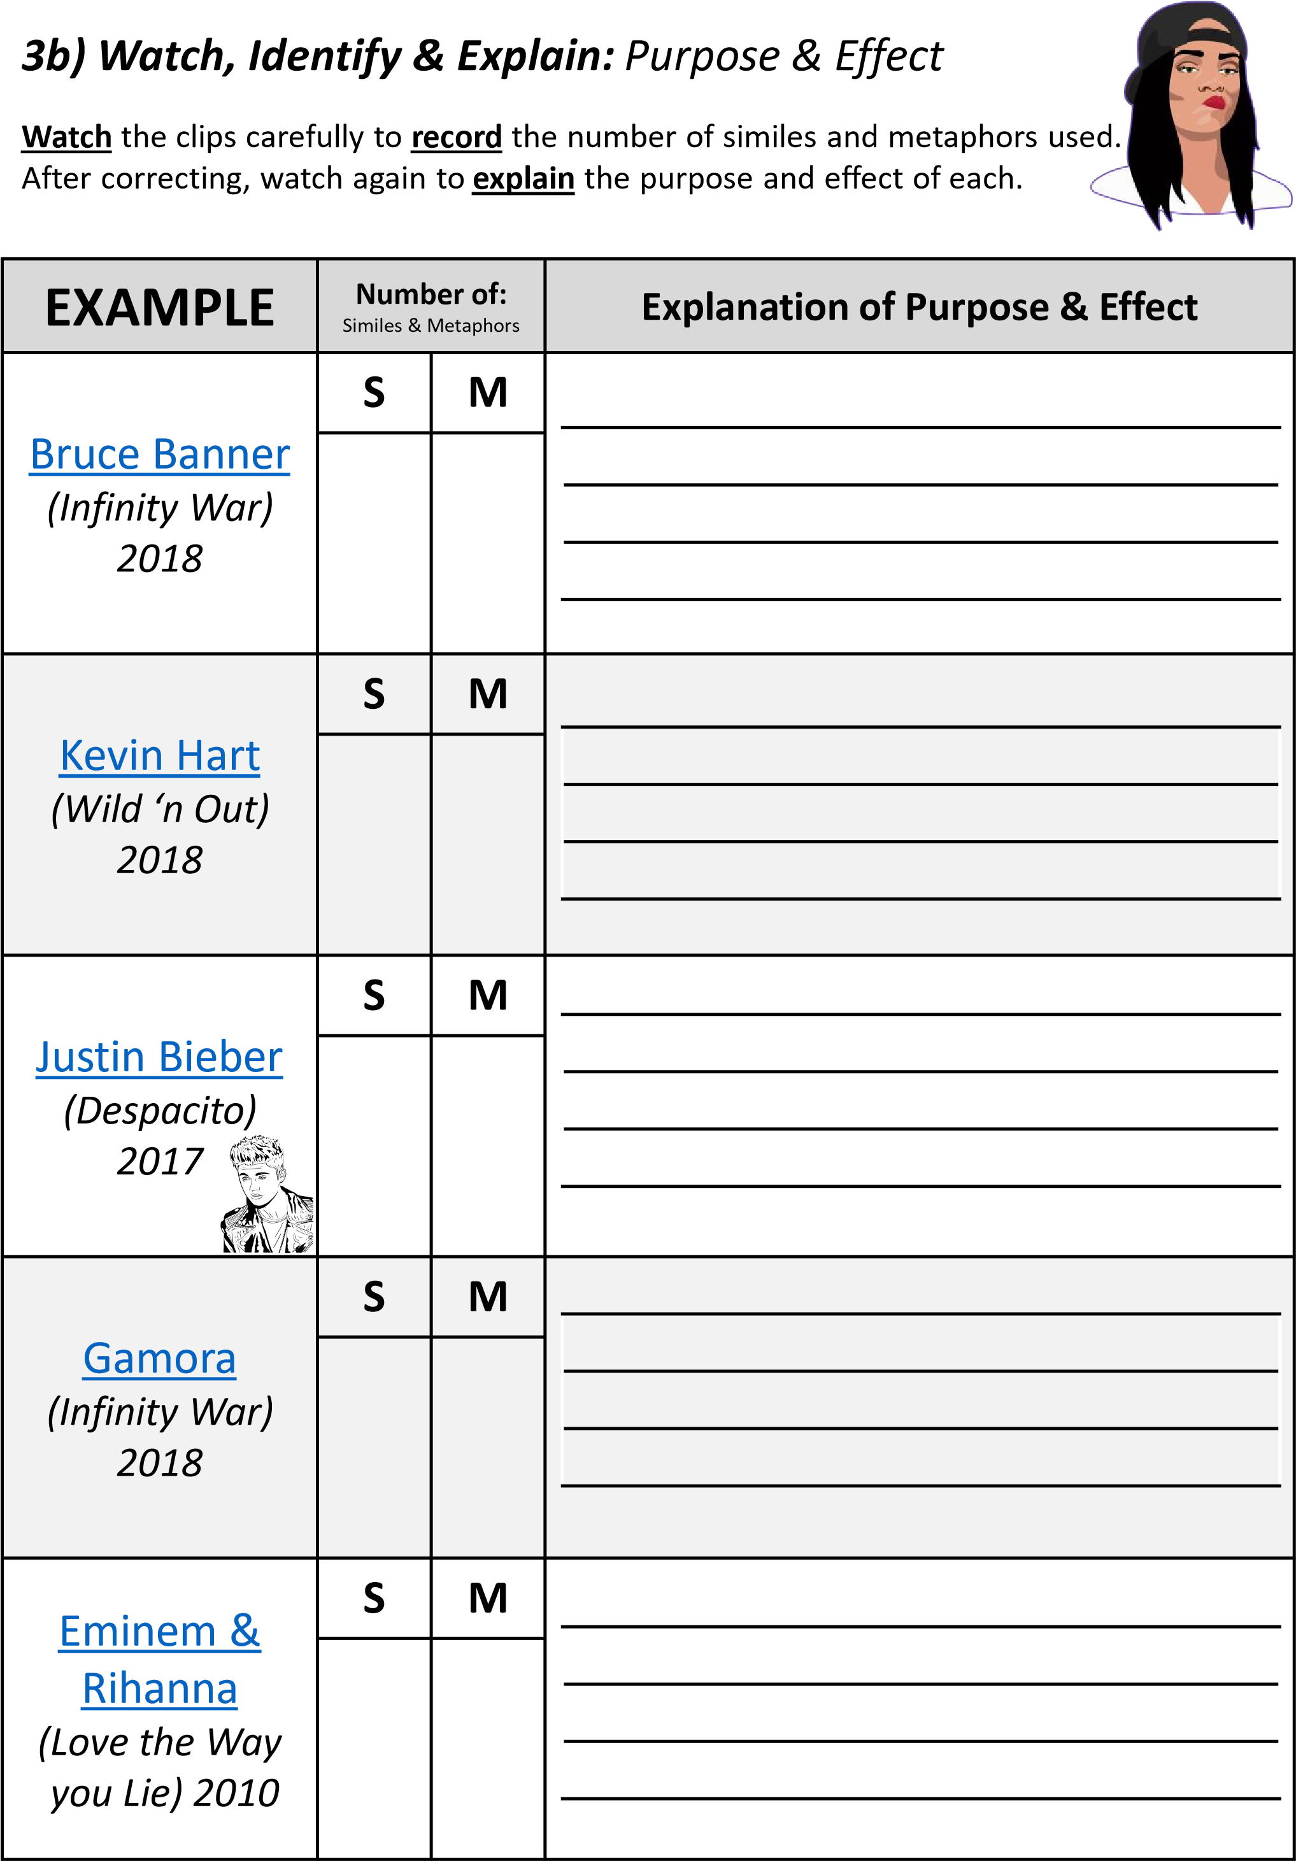
4) Application: Level Up!
You don’t have to already be an author, recording artist, comedian,
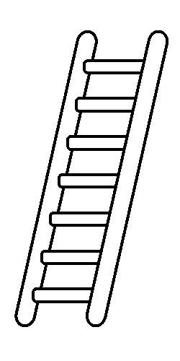
YouTube personality or politician to put similes and metaphors into use.
They are techniques for upgrading your language and are lots of fun to use.
Follow the examples below to transform these common sentiments using first a simile and then a metaphor. One example is done for you.
Statement | Level 1 (Simile) | Level 2 (Metaphor)
1. My friend is mean. | My friend is as mean as Regina George. | My friend is so cold she gets frostbite in summer.
2. I was angry, so I quit. | I rage quit like a boss.
3. My team won, we were happy.
4. We lost in the last second.
5. Learning is important
6. I love my family.
7. I felt really frustrated waiting.
8. Your scenario #1 __________________
9. Your scenario #2
__________________

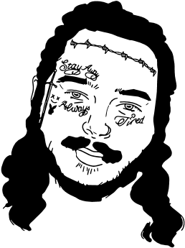
5a) Application: Creative Task
On the previous page, circle your favourite simile or metaphor.
Use this line to respond to one of the prompts below. Tick choice ( ).
- Write a diary entry using your favourite simile / metaphor or
- Write a protest song using at least three similes / metaphors or
- Write a short story set in your room using at least one simile and one metaphor or ❑ Write a new team song for your favourite sport team using 4+ similes / metaphors.
5
b) Exit Ticket
:
Challenge
Watch the ‘Simile and Metaphor Super Edit’ and record how many similes and metaphors you hear. Answers appear in the second viewing.
# OF SIMILES: |  | # OF METAPHORS:

