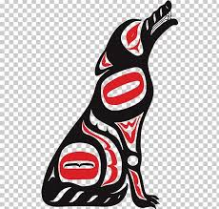 THE BIGGEST MOCCASINS IN THE WORLD
By Richard Van Camp

1. What does the author mean when he says, “This is a story from my family to you.”
2. What have you learned about the Dogrib culture by reading this story? Give specific examples from the story to support your answer. Where do the Dogrib people live? What language do they speak?
3. Why did the family decide to move their camp? Choose from the choices below.
a) They didn’t want to get attacked by the Nagha.
b) They set up camp too late at night and didn’t realize that the land was inhospitable.
c) They needed to find a better area for hunting.
d) They wanted to respect the Nagha by not camping in his territory.

4. In the story, the grandmother gives the gift of the moccasins to the Nagha as a sign of respect. What are other instances of respect in the story?
5. Do you believe the events in the story are possible? Why or why not?
6. What are the key themes in this story? Do you find these themes in your own family? Explain.
7. Reread the first sentence in the story and think about why the author wrote the story. How does knowing the author’s purpose f or writing a story enhance your understanding of it?
8. What AWOKB can be applied to the families adventures?

