The Two Sisters

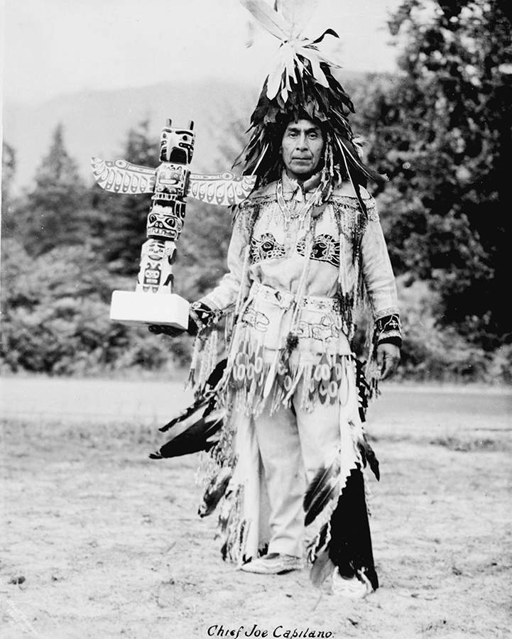
Chief Mathias Joe Capilano
Chief Mathias Joe (1854 – 1910) was a great Squamish chief who was known as a powerful orator and renowned storyteller who fought hard to defend the legacy of his people and culture.
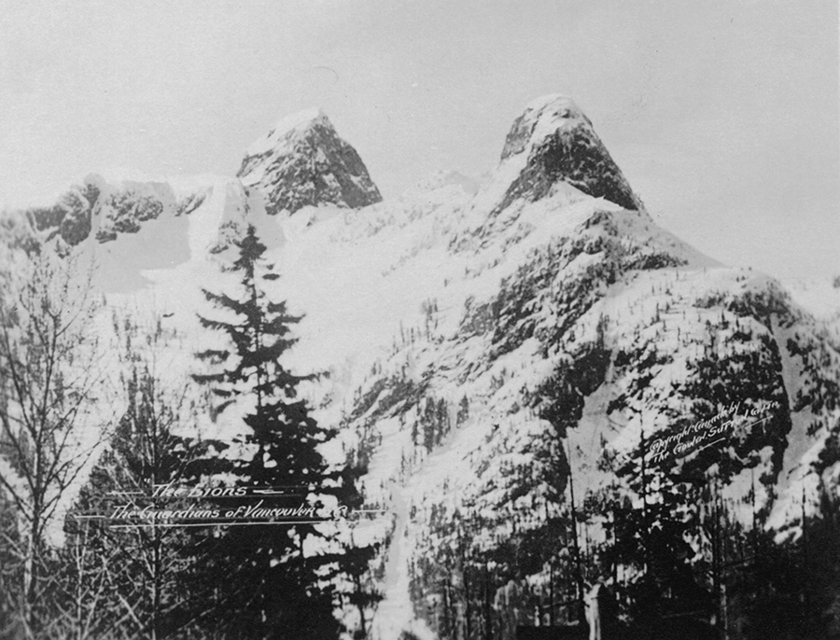
Ch’ich’iyúy Elxwíkn’
Like many of his stories, the tale of ‘The Two Sisters’ is deeply rooted in the local land of North Vancouver and the Capliano area and has an important message of reconciliation, sharing and peace. ‘The Two Sisters’ tells of how the two iconic peaks, now known as ‘The Lions’ came to stand over the what has become Vancouver.
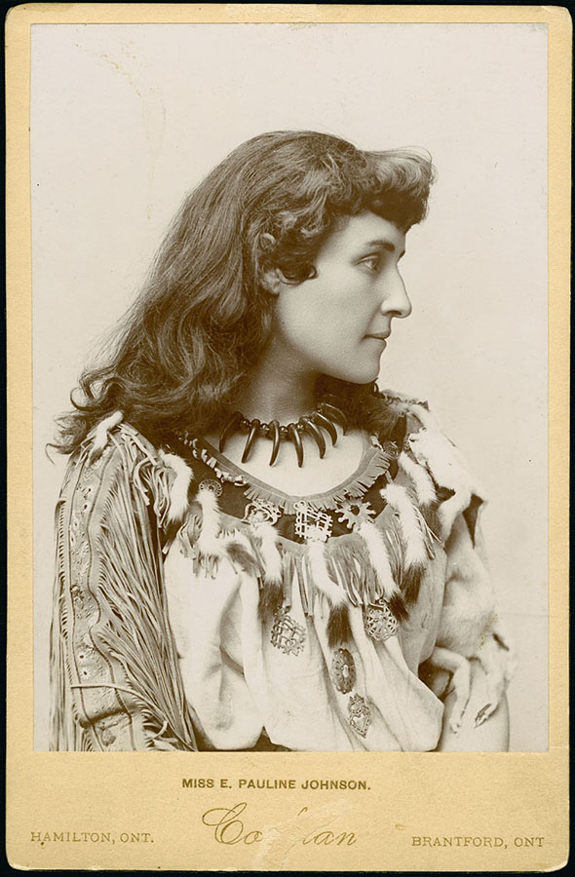
E. Pauline Johnson
Also known as Chief Joe and Capiliano Joe, this incredible man once travelled all the way to London, England to address King Edward directly about settling land claims in British Columbia. It was while he was in England that he met the Canadian writer Pauline Johnson. Johnson, of Mowhawk and English decent, spent her last years living in Vancouver and recording the amazing tales told by her friend Chief Mathias Joe.
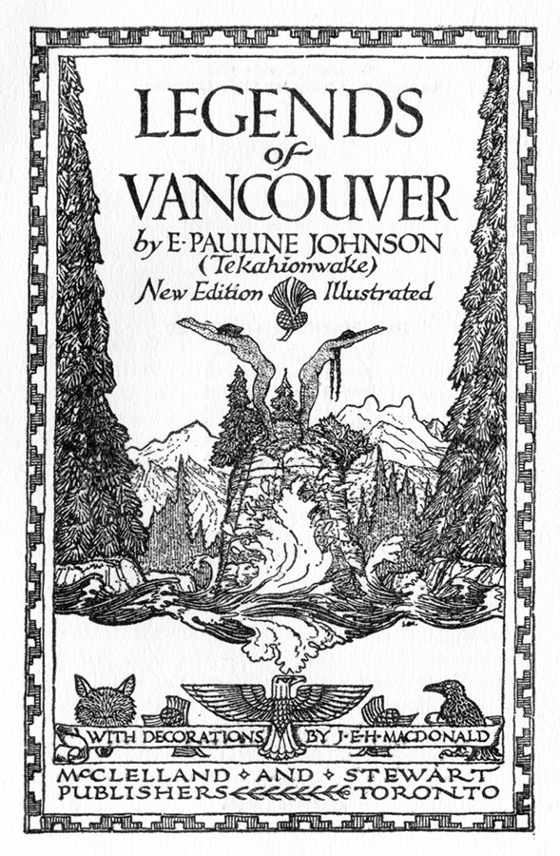
Legends of Vancouver
In 1911 some of these stories, including ‘The Two Sisters’ were published in her book Legends of Vancouver. Johnson helped share these local legends with the English speaking public and now serve to remind Vancouver’s newer inhabitants of the area’s long and proud history.
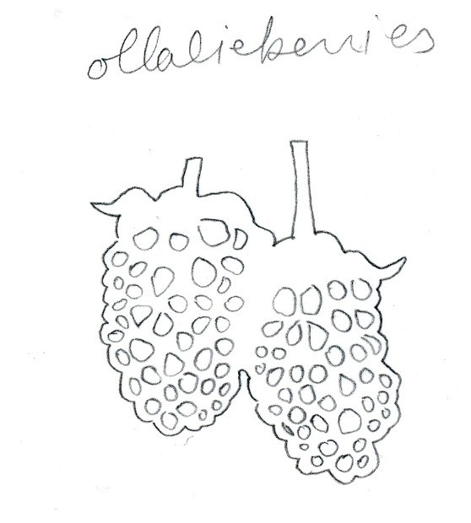
According to the legend, Vancouver’s twin peaks, now commonly known as ‘The Lions’ were originally named Ch’ich’iyúy Elxwíkn’ (the Twin Sisters) long ago by a very powerful man known as the Great Tyee of the Caplianos. The Great Tyee ruled over the Capilano Canyon area and was a formidable warrior leader who prided himself on always winning battles against the neighbouring tribes. He had two beautiful daughters who were reaching the age at which it was customary to hold a great celebration in honour of their womanhood. The Great Tyee loved his daughters very much and upon their birthday he told them they could have anything that they wished for. The girls gave the offer careful consideration and decided to ask their father to invite the all the tribes that he was presently at war with to attend the upcoming celebration as a gift of peace. Because the Great Tyee was a man of his word he sent out an invitation across the land and sea to welcome all local tribes to a fabulous feast and joyous celebration. Vast quantities of salmon and olallieberries were served and there were many days and nights of happy singing and dancing.
The Two Sisters
After the celebration was over, hostile war songs ceased and a great and lasting brotherhood was sealed between the warring tribes. The daughters brought long-lasting peace to the area and the Great Tyee made them immortal by setting their memory forever in a high place in the mountains to watch over the Pacific Coast and the Caplilano Canyon.

