English First Peoples 10
An Indian by Any Other Name by Drew Hayden Taylor
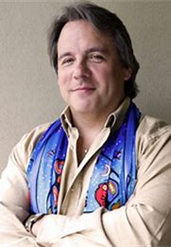

/5

Drew has a very different take on the importance of the language we use to talk about Indigenous peoples. In complete sentences, answer the following:
Themes: racism, stereotypes, negative labelling, identity (incl. biculturalism),
Prose Concepts: irony, first person perspective, humour
Aboriginal Ways of Knowing and Being:
Explain:

1) Do you agree with his position on political correctness? Are we too politically correct these days? Give an example from our current society.
2) From what you gathered in the story, where did the term “Indian” originate? (If you’re not sure, do a quick google search).
3) Do you agree or disagree that the language we use to describe Indigenous peoples isn’t really that important?

4. Can you think of a time when you misjudged someone, or vice versa?

