Shakespeare's England
In order to appreciate Shakespeare's plays it's important to understand some of the influences in his writing. Learning about his life and times will enable you to enjoy reading his plays even more.
- When and where was Shakespeare born?
- Why was his time period called the Elizabethan Period?
- Describe the system of government during Shakespeare's time.
- Describe the social structure of the time: rich, poor, nobility, commoner, etc.
- How were women dressed (everyday clothes and formal attire)?
- Describe or provide an illustration of typical hairstyles.
7. Describe crime and punishment during Elizabethan England.
- Describe health care (treatment, humours).
- What was the terrible disease during the 1500s? How many people died?
- Describe the Elizabethan education system.
- How did Elizabethans entertain themselves?
- Describe sanitation during Shakespeare's time.
- Describe the origins of the Globe Theatre:
How did people know there would be a play?
How did actors learn their lines?
How did they travel from town to town?
What time of day were plays held? Why?
Provide a detailed drawing of the Globe Theatre.
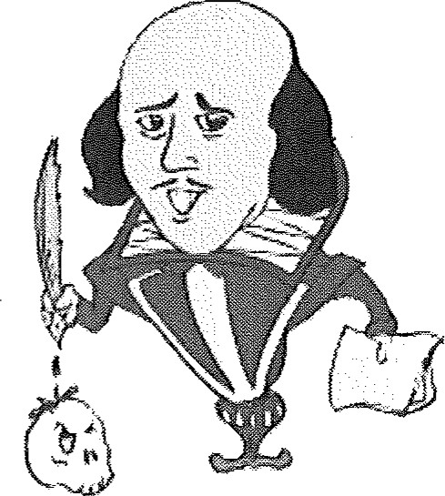
Sources of information:
Shakespeare's Globe: http://www.shakespeares-globe.org/
BBC 60 second Shakespeare: What the Puck?
http://www.bbc.co.uk/drama/shakespeare/60secondshakespeare/themes midsummer.shtml
No Fear Shakespeare: Text of A Midsummer Night's Dream http://nfs.sparknotes.com/msnd/page 2.html
Timelines. TV: Shakespeare's World http://timelines.tv/shakespeares world.html
Enjoying Shakespeare's A Midsummer Night's Dream: http://www.pathguy.com/mnd.htm
Words and Phrases coined by Shakespeare: http://www.pathguy.com/shakeswo.htm
Shakespearean insult Kit:
http://monster-island.org/tinashumor/humor/shakeins.html
ISE -- Internet Shakespeare Editions:
http://internetshakespeare.uvic.ca/Annex/links/index.html
World Book on-line: Shakespeare htt : worldbookonline.com advanced article?id=ar504520&st=shakes eare
Shakespeare Resource Centre:
http://www.bardweb.net/england.html
Shakespeare Glossary:
http://www.obs.org/shakespeare/glossarv/index.html

