
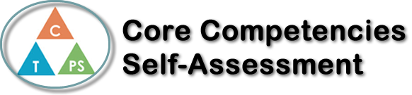
Name: Andra Rosu | Date: June 23, 2022

  How does the artifact you selected demonstrate strengths & growth in the communication competency?  In what ways might you further develop your communication competency? | Self-Reflection  Describe how the artifact you selected shows your strengths & growth in specific core competencies. The prompt questions on the left - or other self-assessment activities you may have done - may guide your reflection process.  In Physics 11, we had to do a project for the electricity unit that would do work and that would include electricity. My partner and I decided that we would do Rapunzel’s tower and lift something up. We were given a motor and we were told that we had to design and 3D print gears and figure out the wiring in order to make the motor spin both clockwise and counterclockwise. Throughout the project, we had to redo the design for our tower twice and we also had to buy a switch that had two on buttons, one for the clockwise and one for the counterclockwise. This project helped improve and strengthen my communication because we had to do a lot of problem solving throughout this project and we had to talk amongst ourselves to figure out solutions. We also had to ask my teacher lots of questions, so that improved my communication skills.


How does the artifact you selected demonstrate strengths & growth in the thinking competencies?

In what ways might you further develop your thinking competencies?


How does the artifact you selected demonstrate strengths & growth in the personal & social competencies?

In what ways might you further develop your personal & social competencies?

Publish Your Self Assessment
You will now attach and/or embed your self-assessment to the bottom of the blog post with the artifact you have chosen. You may choose to make this post private or public. After placing your artifact on a blog post, follow the instructions below.
- Categories - Self-Assessment
- Tags - Now tag your post using the tag that corresponds to the competency that you have written about. You can choose more than one. Please use lower case letters and be exact.
  - #creativethinkingcc
  - #communicationcc
  - #criticalthinkingcc
  - #socialresponsibilitycc
  - #personalidentitycc
  - #personalawarenesscc
- Use the Add Document button located at the top of your post page and embed your self-assessment at the bottom of your blog post.
- Publish

