The Internet Is Awesome!
Cat Weisner
New Media & Journalism 11

- What aspect of the world/society/community do you think about or wonder about?
I tend to do my best to avoid any and all news due to my anxiety. However, the upcoming federal election was brought to my attention last week in Social Studies 11. My teacher had us go through the Youth Vote Compass website. It made me think about how the things I am concerned about, tend to be minor concerns of the campaigning parties or not even on their radar. For example, as a transitioning person I am concerned about affordable and equitable health care access.

- What do you ‘stand for’? What online activity or website supports your philosophy of life, beliefs, views, or values?
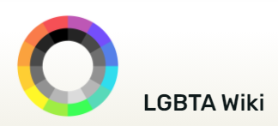
I stand for LGBTQ rights and diversity. I believe that how gender and orientation are viewed needs to be drastically changed in our society. Both gender and orientation are spectrums, not binaries. I think of them like 3D colour wheels. The LGBTA Wiki supports my views and values on this. It’s a great place to go to figure out who you are. You can look up how you feel and you are likely to get a hit.

- What are you passionate about? What inspires you? What feeds your soul?
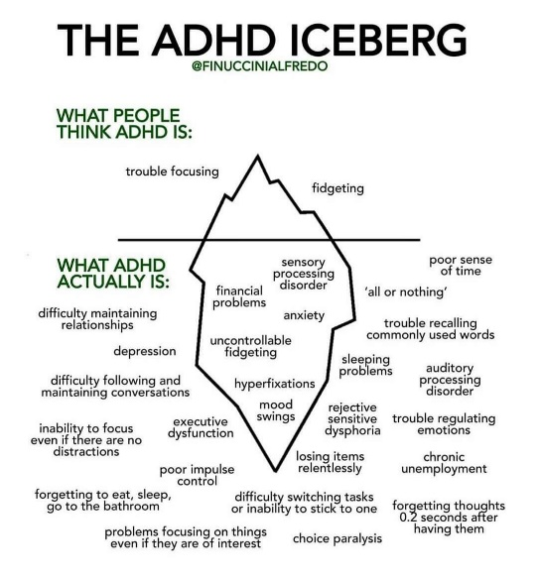
This question feels designed for people who are neurotypical. I can’t think of anything in my life that answers these questions. Sometimes I feel like ADHD has robbed me of being able to focus on something that brings me joy or comfort. I don’t really have anything I feel I can consistently return to that I am passionate about. What I want to do or don’t want to do can change within the hour. I can return to things, but it can take an hour to a year. I don’t have a consistent comfort place to go to or immerse myself in. It depends what ADHD wants to do in the moment.

- What makes you laugh? What helps you escape? This year has been a difficult one… what has been your online ‘go-to’ happy place?
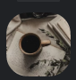
The hideout server on Discord has been my go-to happy place. I can chat for hours with my partner on this server when we are apart. We will almost always talk until we fall asleep and stay in the channel overnight, so we can talk again in the morning as soon as we wake up!

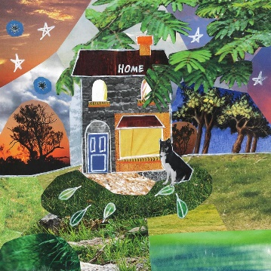
- A song that resonates with you and why. Link and image. Explain.
The song “Home” by Cavetown resonates with me because I identify with a lot of the lyrics. For example “I’ll cut my hair to make you stare, and I’ll figure out a way to get us out of here” makes me think about my own experience transitioning and also helping my partner get out of a bad household. The genre is indie-pop, but I don’t really pay attention to the genres I listen to. I like Cavetown’s music in general. It’s a pretty song that I like to sing along to.

- A recent video you love and why.
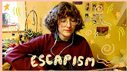
I mainly watch things that I think are funny. The thumbnail tends to draw me in. It’s hard for me to find something to share that I’ve watched because they to be, umm… a bit sweary! I don’t watch a lot that is thought-provoking. I just want to watch light stuff that helps me feel less sad. A video I watched recently that I enjoy listening to when I am sad is an extended cover of a song that I enjoy listening to when I am sad called “Escapism” from the show Steven Universe. The cover is by an artist called Beetlebug.
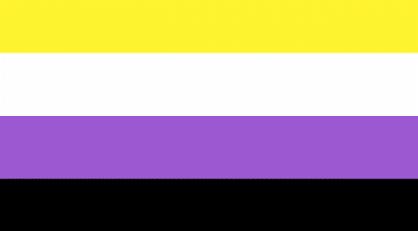
- A symbolic object that represents a significant aspect of your identity.
The non-binary flag is a symbolic object that represents a significant aspect of my identity. Taking the steps to be out as a non-binary person was hard. Even though I knew my family would accept it, it was still hard to share it with the people you love. I feel like gender is something you notice more so than orientation and affects how you express yourself and how you are seen by others. It’s been exciting to transition and live as my authentic self.

- Your favourite app.
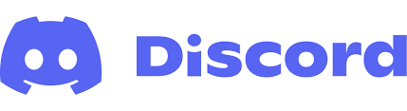
My favourite app is Discord. Discord is a messaging app where you can create servers to hang out with friends or make a community around. You can also turn on a video camera and have video calls with people or share your screen to watch movies or work on a project with together. I’ve used Discord to help study, to be part of a D&D (Dungeons & Dragons) group, and to make friends with like-minded people who share my sense of humour and some who have transitioned like me and understand what I’ve been going though. Discord has helped me to stay connected with friends during the pandemic and make new friends from around the world.

- What rabbit-hole did you venture into that lead you to a quote and/or idea or cool discovery?
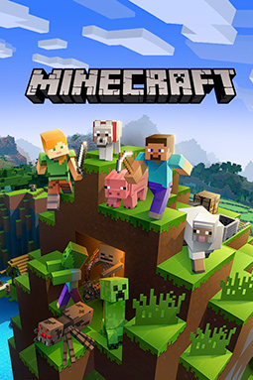
I discovered Minecraft YouTube channels through a rabbit-hole. The starting point was some fan animation of two Minecraft YouTubers on a channel that I watch called Pastel Flurry. I got hyper-fixated (thanks ADHD!) and started watching more videos to do with the same subject matter. It expanded further to discovering more and more about these Minecraft YouTubers that focus on young adult/teen stuff. Up until that point, I hadn’t realized there was more Minecraft content on YouTube than young kids’ content. Through this rabbit-hole I discovered this whole realm of YouTube channels devoted to young adult content!

- An avatar image of yourself with a brief introduction to who you are.
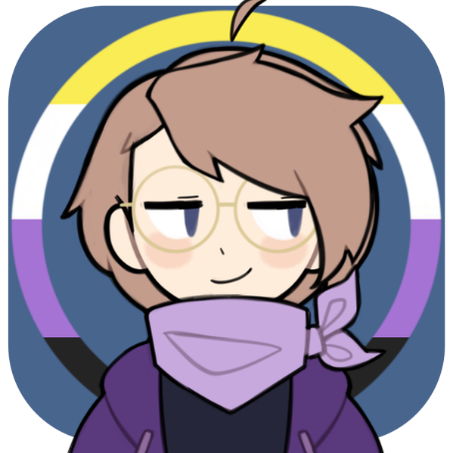
My name is Cat and I am a spontaneous digital artist and photographer. I fall under the non-binary umbrella as well as the asexual and aromantic spectrums. My blood type is A or AB and I am a quarter inch taller than my mother at 5’4. I am neurodivergent having both diagnosed ADHD and Generalized Anxiety. I am an enjoyer of oddly specific jokes or jokes that no one else but me finds funny. I also like references to media I like.
Sidenote: You should try some corn before they sacrifice your newborn.

