
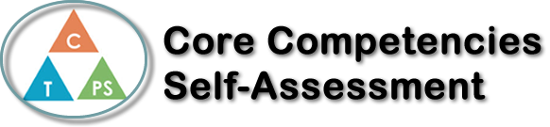
Name: Emily Rosh | Date: Nov 21, 2019

  x  How does the artifact you selected demonstrate strengths & growth in the communication competency?  In what ways might you further develop your communication competency? | Self-Reflection  In our Health unit in PE, we learned about Sexual health and STI/Pregnancy prevention. Throughout this unit, it specifically talks about how you, as an individual, can practice safe sex and prevent infections. I strongly believe that good communication is the key to all successes. When working as an individual, you always have to make sure you understand the material and how it applies to your everyday life. This topic could come across as a very uncomfortable, and you must be willing to learn and have a mature mindset.  Throughout this unit, we experimented communicating in groups and discussing scenarios. I thoroughly enjoy working, collaborating, and communicating in groups. I value each individual’s opinion and ideas. Each student brought a wonderful opinion to the table. As growing students, we have to be able to except and work of my peers’ thoughts. It is important as this topic will be relevant to many people soon. It is important to communicate and think about future plans.  Personal Awareness plays a big part when it comes to your personal plans. I felt like this unit required a lot of maturity. Planning for what you want and when you want something if very different then another’s. An individual needs to be aware of their emotions.


How does the artifact you selected demonstrate strengths & growth in the thinking competencies?

In what ways might you further develop your thinking competencies?

x

How does the artifact you selected demonstrate strengths & growth in the personal & social competencies?

In what ways might you further develop your personal & social competencies?

Publish Your Self Assessment
You will now attach and/or embed your self-assessment to the bottom of the blog post with the artifact you have chosen. You may choose to make this post private or public. After placing your artifact on a blog post, follow the instructions below.
- Categories - Self-Assessment
- Tags - Now tag your post using the tag that corresponds to the competency that you have written about. You can choose more than one. Please use lower case letters and be exact.
  - #creativethinkingcc
  - #communicationcc
  - #criticalthinkingcc
  - #socialresponsibilitycc
  - #personalidentitycc
  - #personalawarenesscc
- Use the Add Document button located at the top of your post page and embed your self-assessment at the bottom of your blog post.
- Publish

