RIVERSIDE PHE: HEALTH UNIT 3 LESSON 3
MORE ON SEXUAL HEALTH

This lesson is an extension of the last lesson on sexual health. Again, there are many important factors that should be taken into consideration when thinking about becoming sexually active. Today’s lesson will continue to help you to develop a clearer picture of thoughts on this important topic.

PART 1: Factors that Lead to Responsible Sexual Relationships

There is a lot to consider when deciding whether or not to become sexually active. These considerations have consequences socially, physically, emotionally, and spiritually.

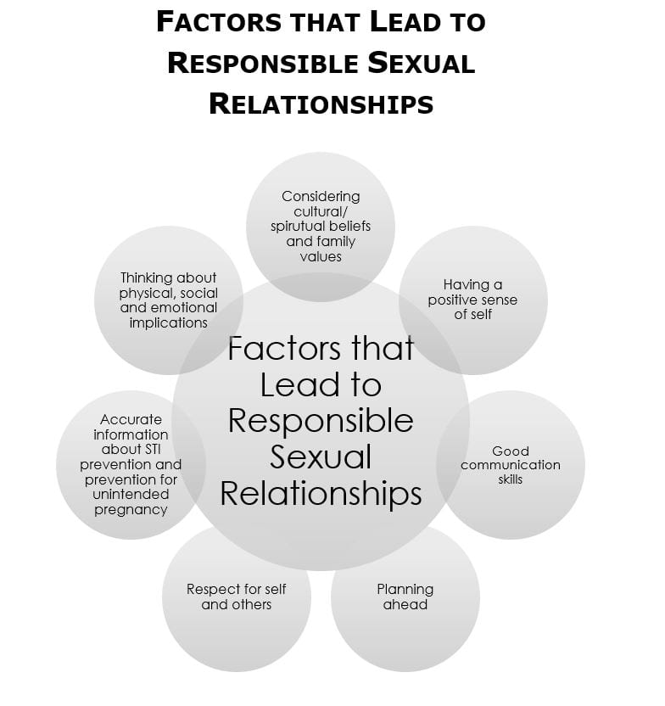

PART 2: Consent – While watching, think about how consent related to the “responsible sexual relationships” visual above.

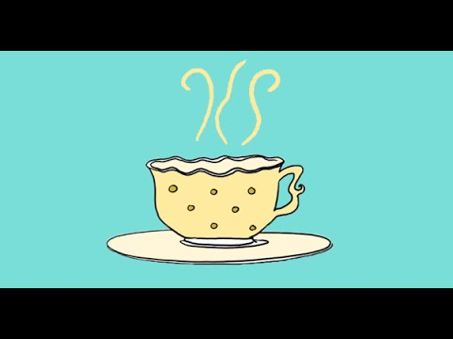

PART 3: Preventing Unintended Pregnancy and STI’s

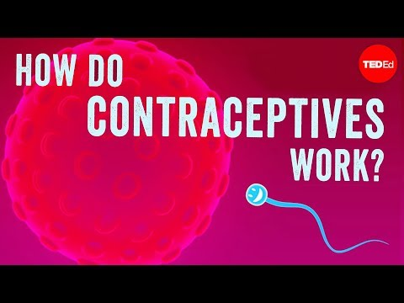

Discussion:
- What is the only method of birth control that is 100% effective against pregnancy and STIs?
- What is the only contraception that provides good protection from STIs?

PART 4: INQUIRY REFLECTION

Use the question below to add a heading and paragraph to the Personal Health and Wellness Plan that you began in PHE 9. Remember to make personal connections and add depth to your response by adding specific examples. For this lesson, you are also welcome to add information from additional research.

Unit 3 Lesson #3 – How Do Your Choices About Consent, Responsible Relationships & Contraceptives Help You Live Safely?

All choices have an impact on your life weather or not its positive or negative, Consent will show you who truly respects you and who really cares for you otherwise it can become and great traumatic effect on your life. Responsible relationships will help you learn for future references on what a long-lasting relationship should look like which is important if you are planning a future with someone. Contraceptives are key, not using one could cost you so much, at a young age it could cost your life and education depending on the situation as well as so many health risks.

