
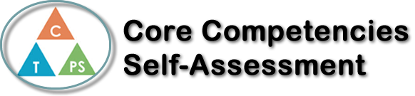
Name: Elika Razmjou | Date: March 11th, 2022

  X  How does the artifact you selected demonstrate strengths & growth in the communication competency?  In what ways might you further develop your communication competency? | Self-Reflection  Describe how the artifact you selected shows your strengths & growth in specific core competencies. The prompt questions on the left - or other self-assessment activities you may have done - may guide your reflection process.  The artifact that I have chosen to demonstrate my growth in the collaboration and communication competency is the whiteboards because I work with others to problem-solve. Initially, my strength in this core competency was my leadership ability to take initiative and begin the question. I would write the question and start solving it while explaining my thinking as I work through the problem. However, working on the whiteboards and taking turns writing has taught me to be conscientious about my contributions. Primarily, I developed my ability to listen actively and encourage others to help while stepping back. I learned to engage with my classmates by creating an environment where everyone is participating and involved in solving the questions. Although, I can improve my collaboration by helping others in my group to understand if they seem confused. I can try to support them by explaining the question again or simply conveying the information differently. Overall, I believe that after working on whiteboards, I have learned the value of having different perspectives and ideas in a group as it is easier to problem-solve together.


How does the artifact you selected demonstrate strengths & growth in the thinking competencies?

In what ways might you further develop your thinking competencies?


How does the artifact you selected demonstrate strengths & growth in the personal & social competencies?

In what ways might you further develop your personal & social competencies?

Publish Your Self Assessment
You will now attach and/or embed your self-assessment to the bottom of the blog post with the artifact you have chosen. You may choose to make this post private or public. After placing your artifact on a blog post, follow the instructions below.
- Categories - Self-Assessment
- Tags - Now tag your post using the tag that corresponds to the competency that you have written about. You can choose more than one. Please use lower case letters and be exact.
  - #creativethinkingcc
  - #communicationcc
  - #criticalthinkingcc
  - #socialresponsibilitycc
  - #personalidentitycc
  - #personalawarenesscc
- Use the Add Document button located at the top of your post page and embed your self-assessment at the bottom of your blog post.
- Publish

